CHAPTER 5 - attention and performance

# Visual search

Visual search, task that we do a lot

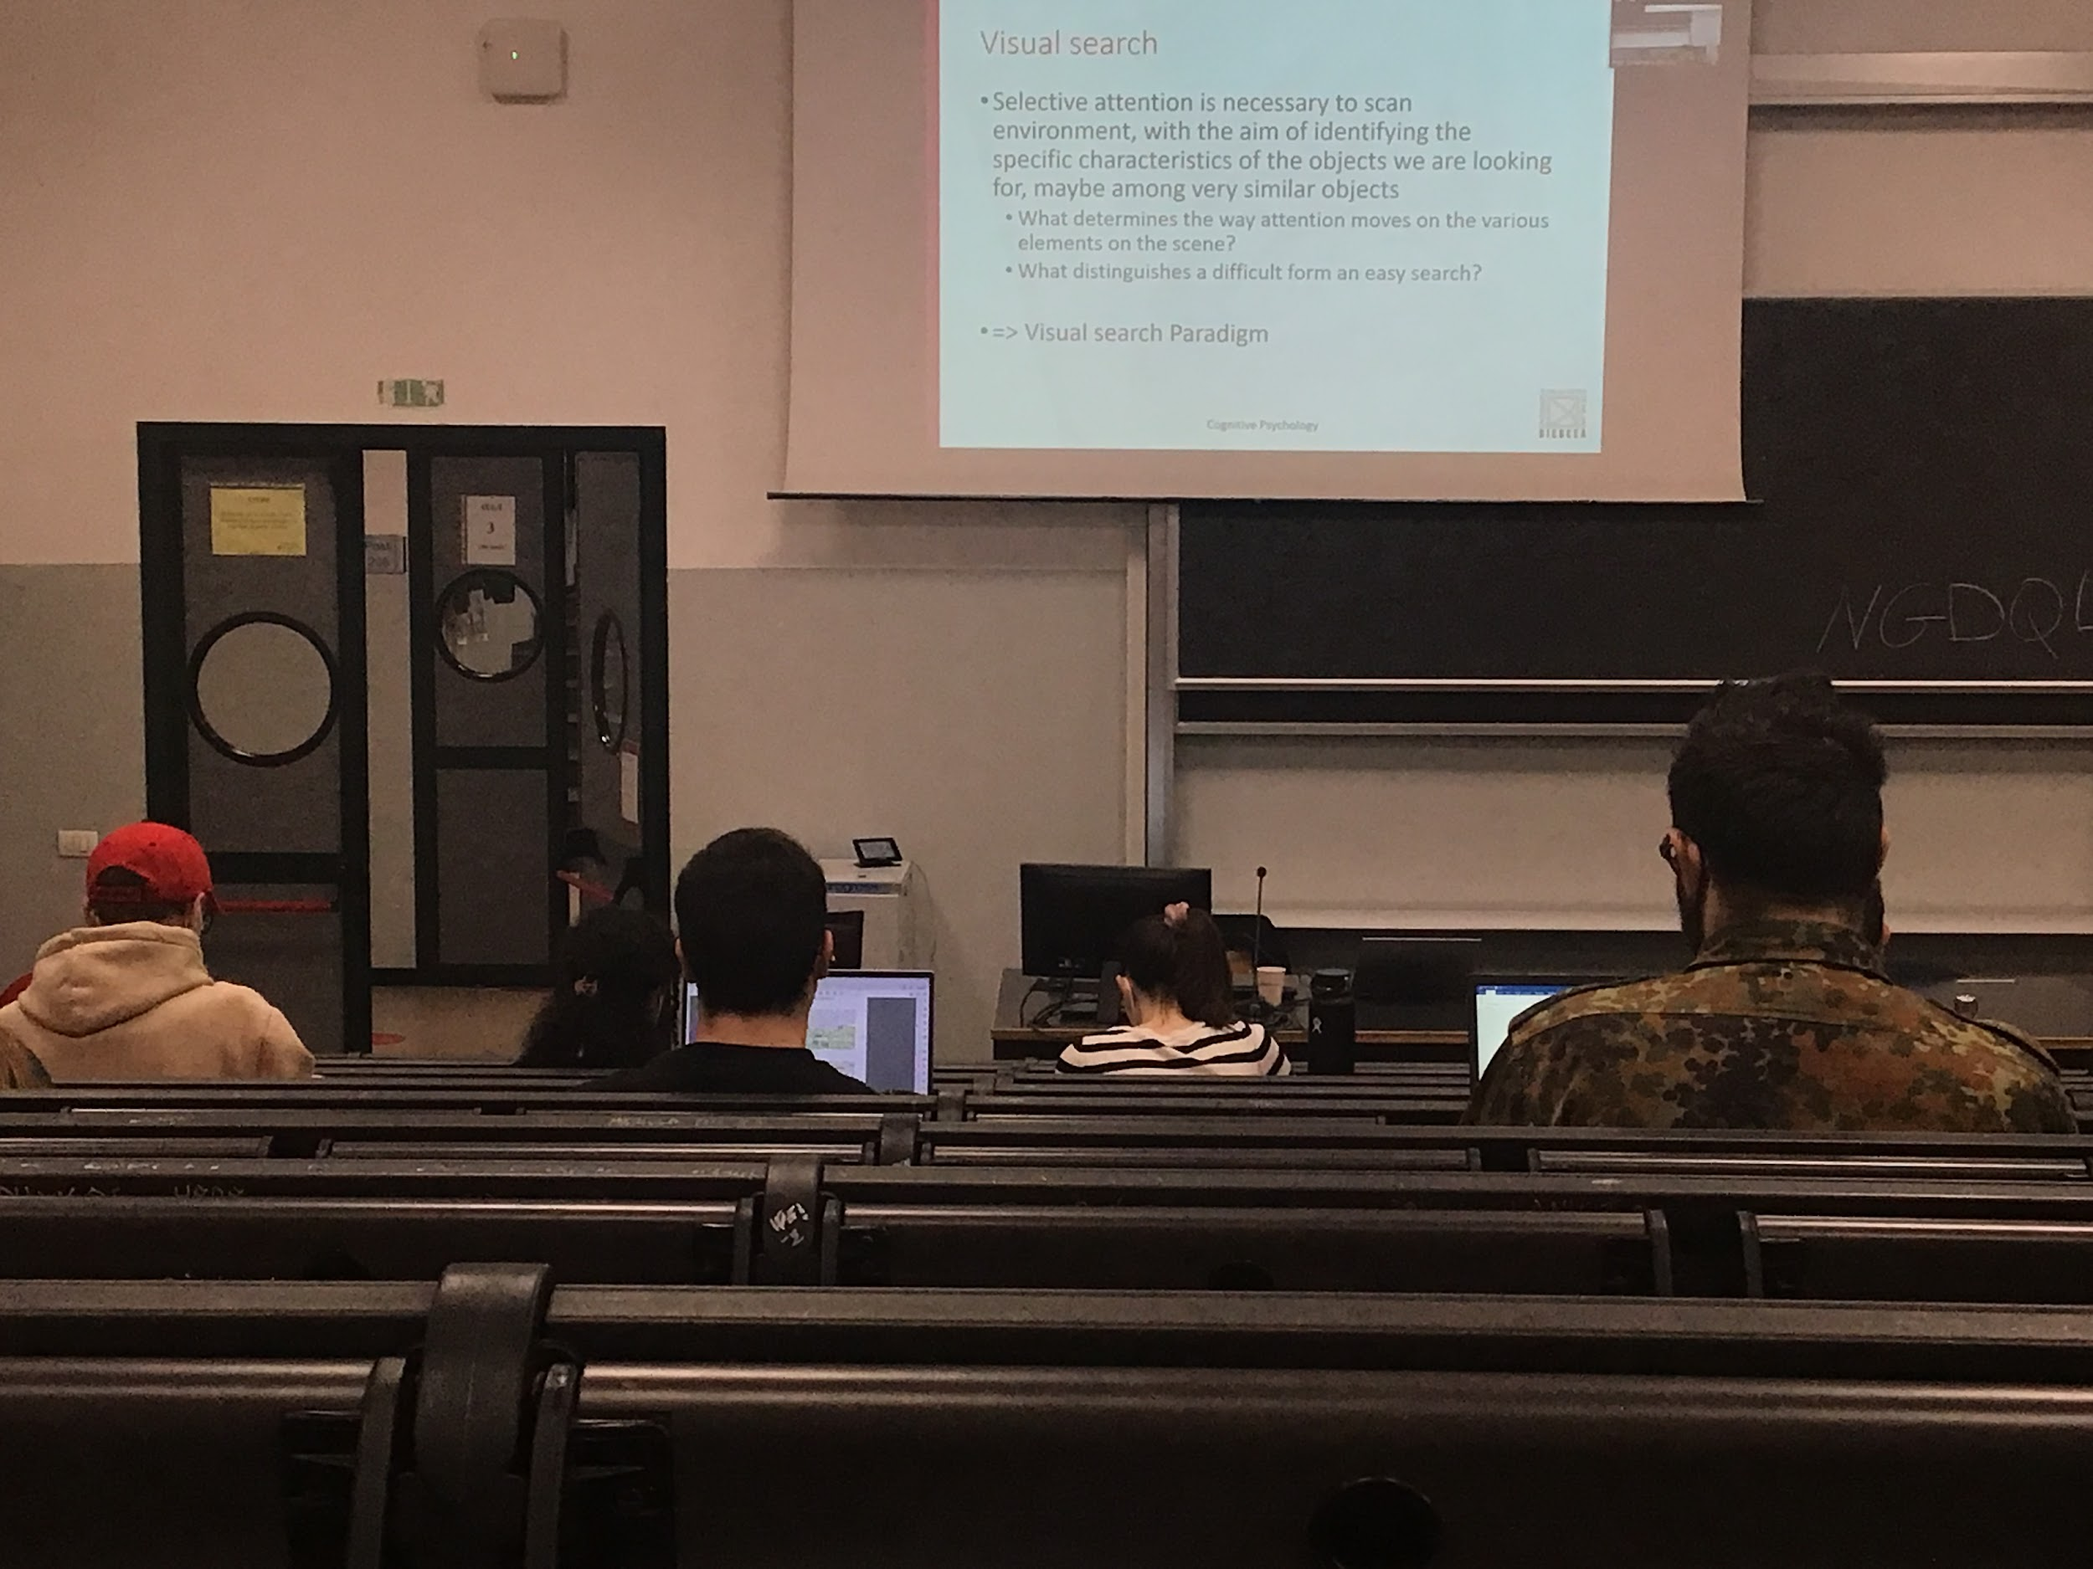

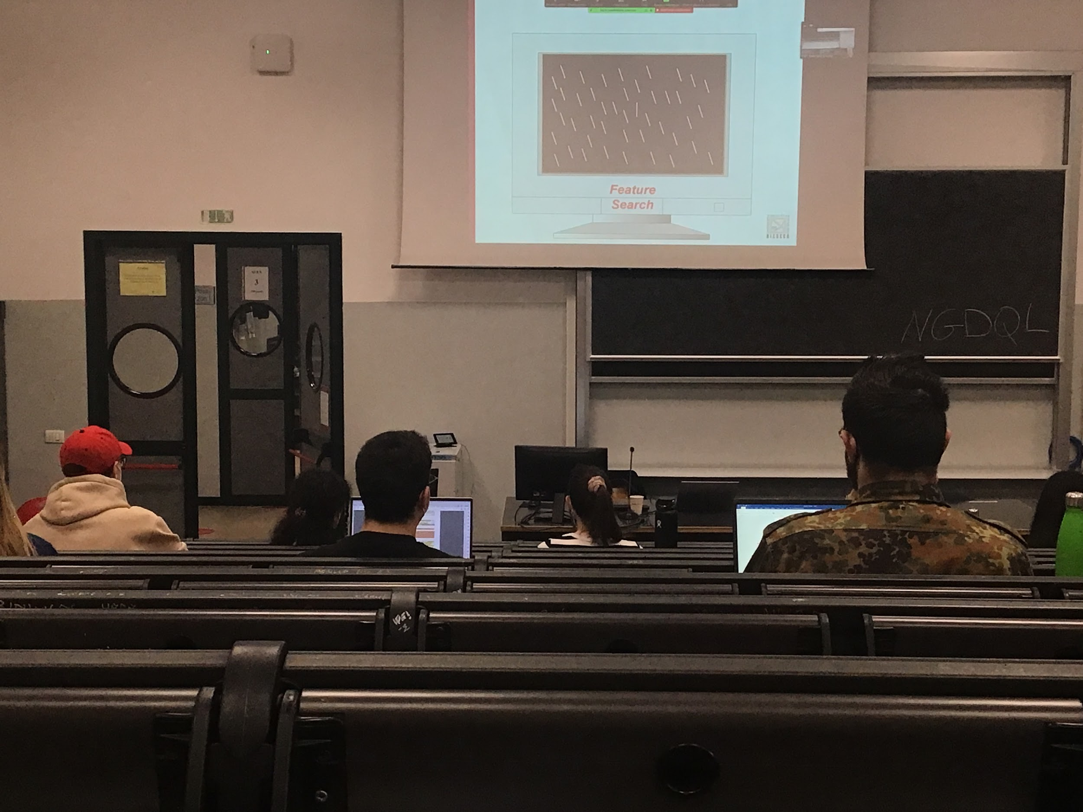

Artificial task: present a number of items in the visual scene and the items have different shape, colour, visual characteristic and we ask participants to select one item out of many.

**Target**: item that we ask the individuals to select

**Distractor**: others items in the scene

**Set size**: Target + distractor

To test visual search we have to present participants with different set size in the same experiment

Two different types of search

* **feature search**: there is only **one** feature that distinguish the target from the distractor (in the experiment before was the orientation of the bar); we measure the behaviour of participants, more specifically the time taking to distinguish the target
* **conjunction search**: the target is distinguish by the distractor by combination of features

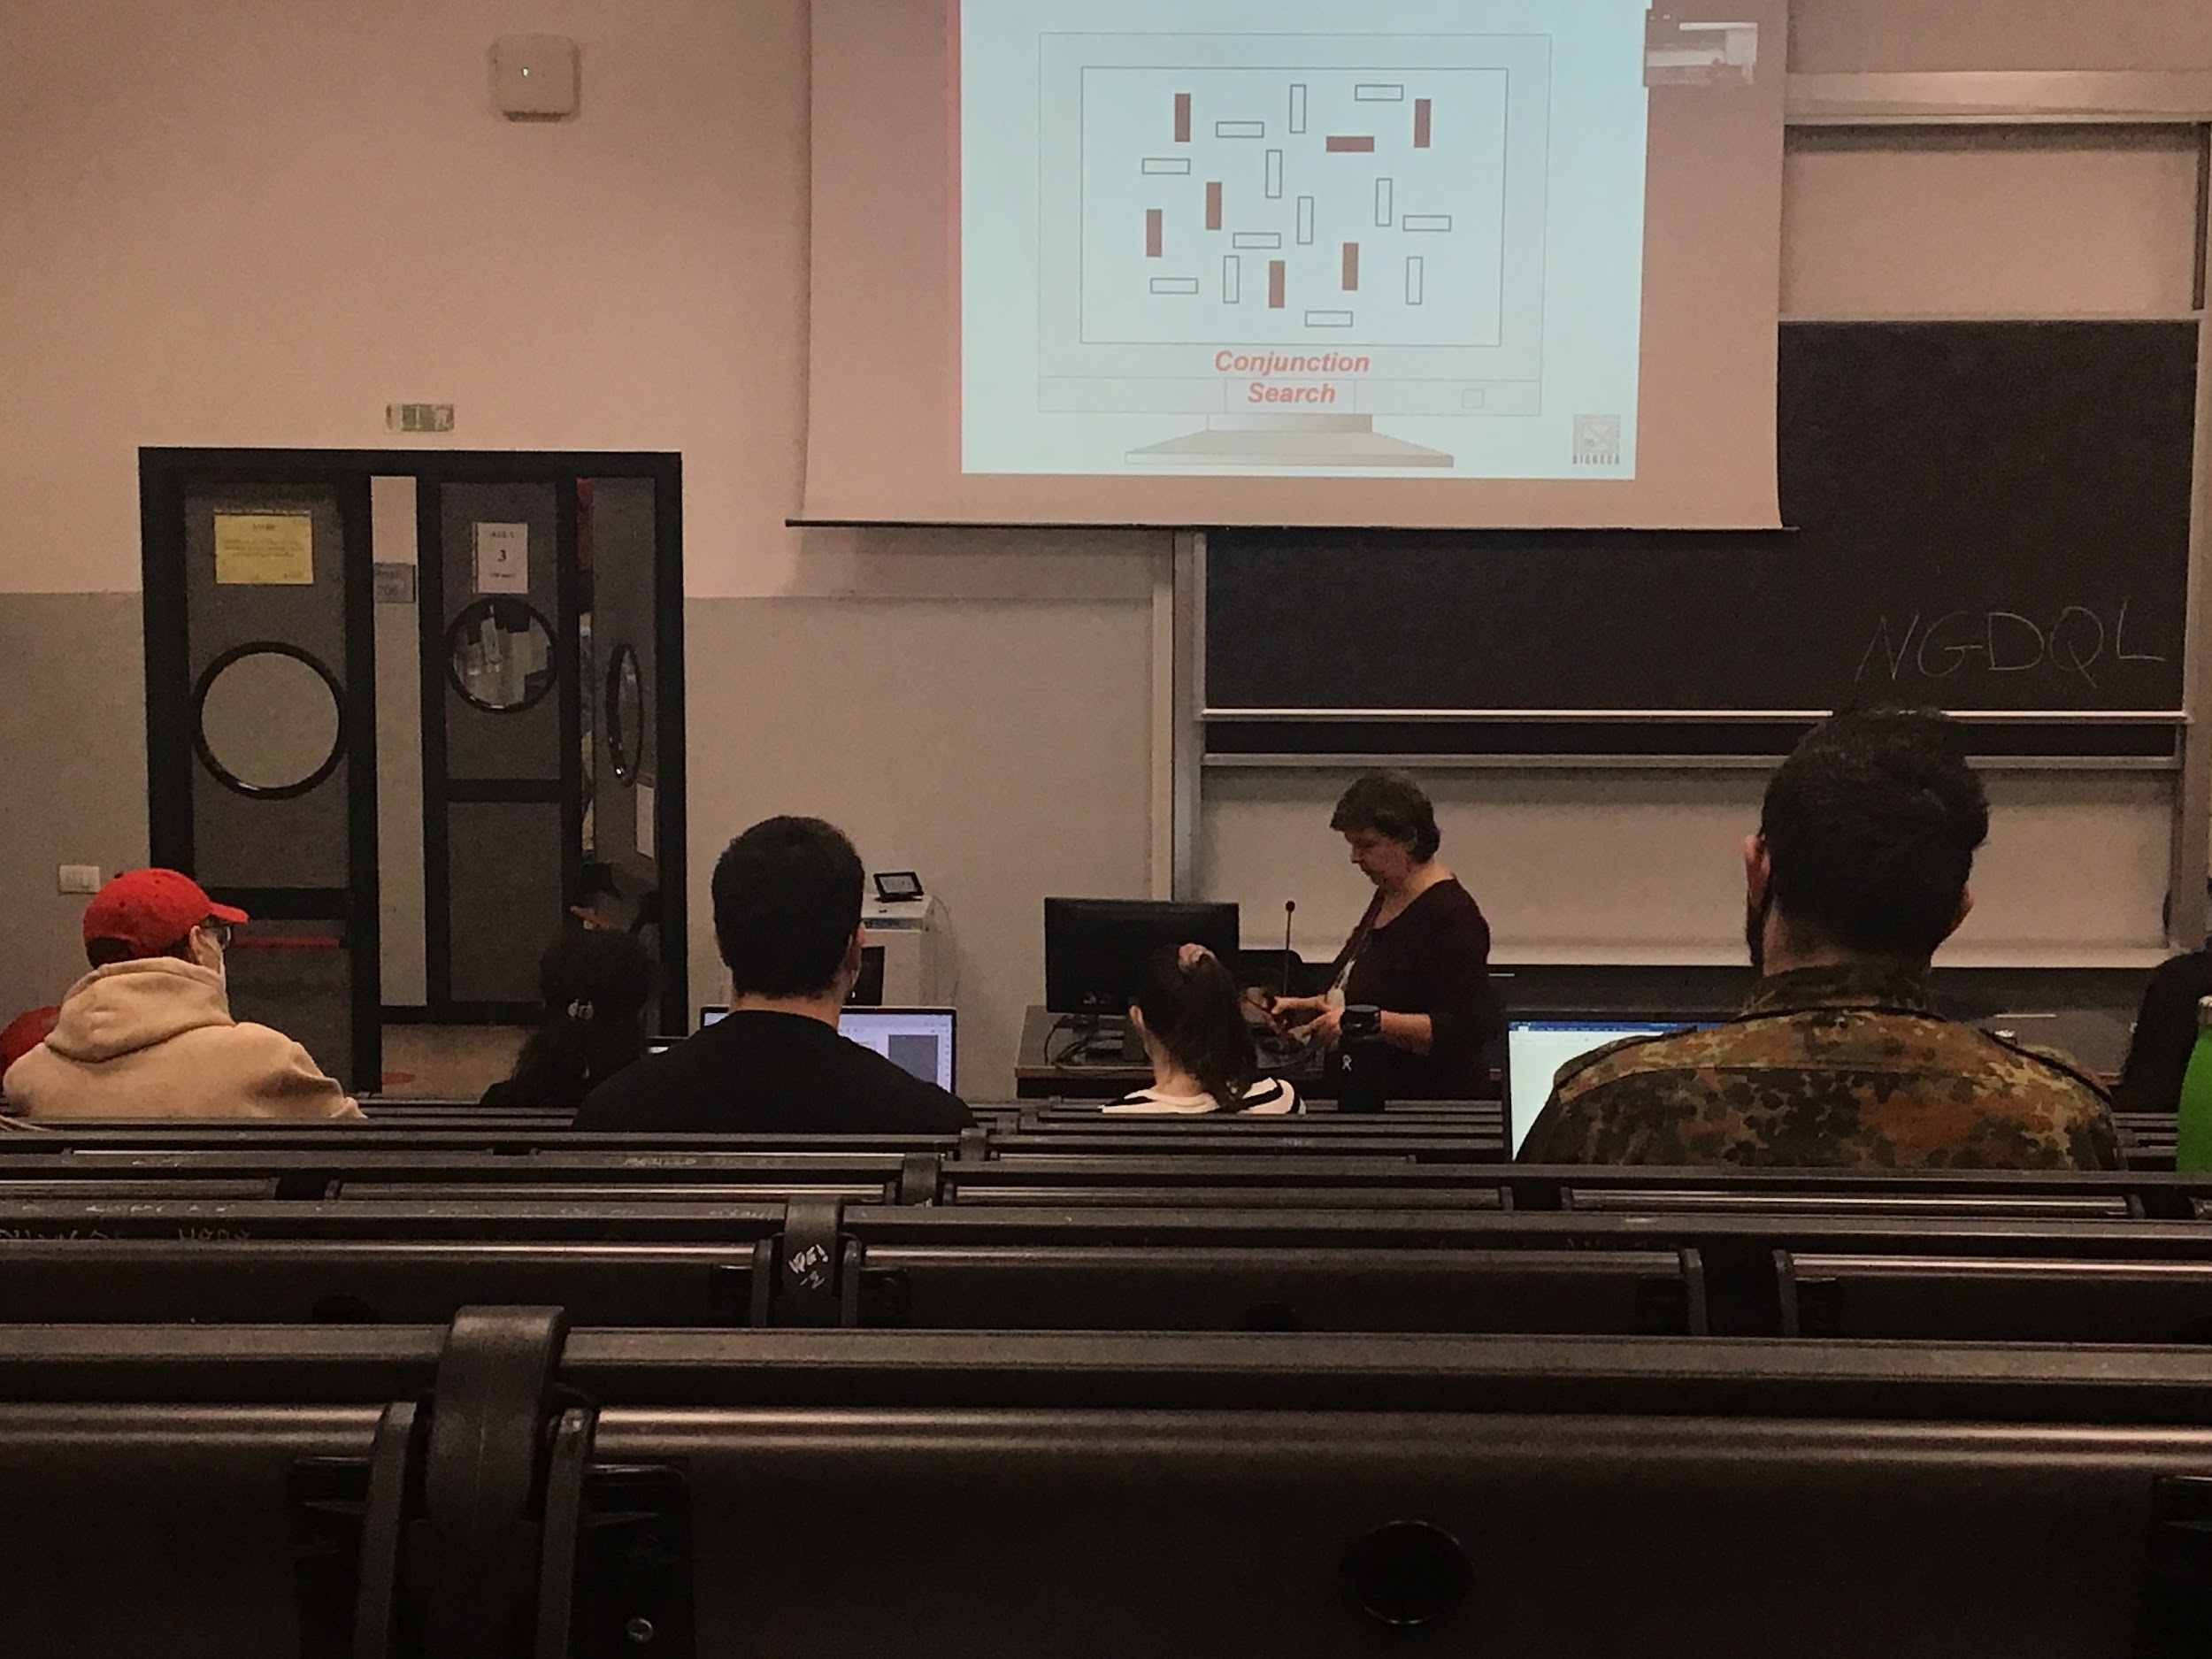

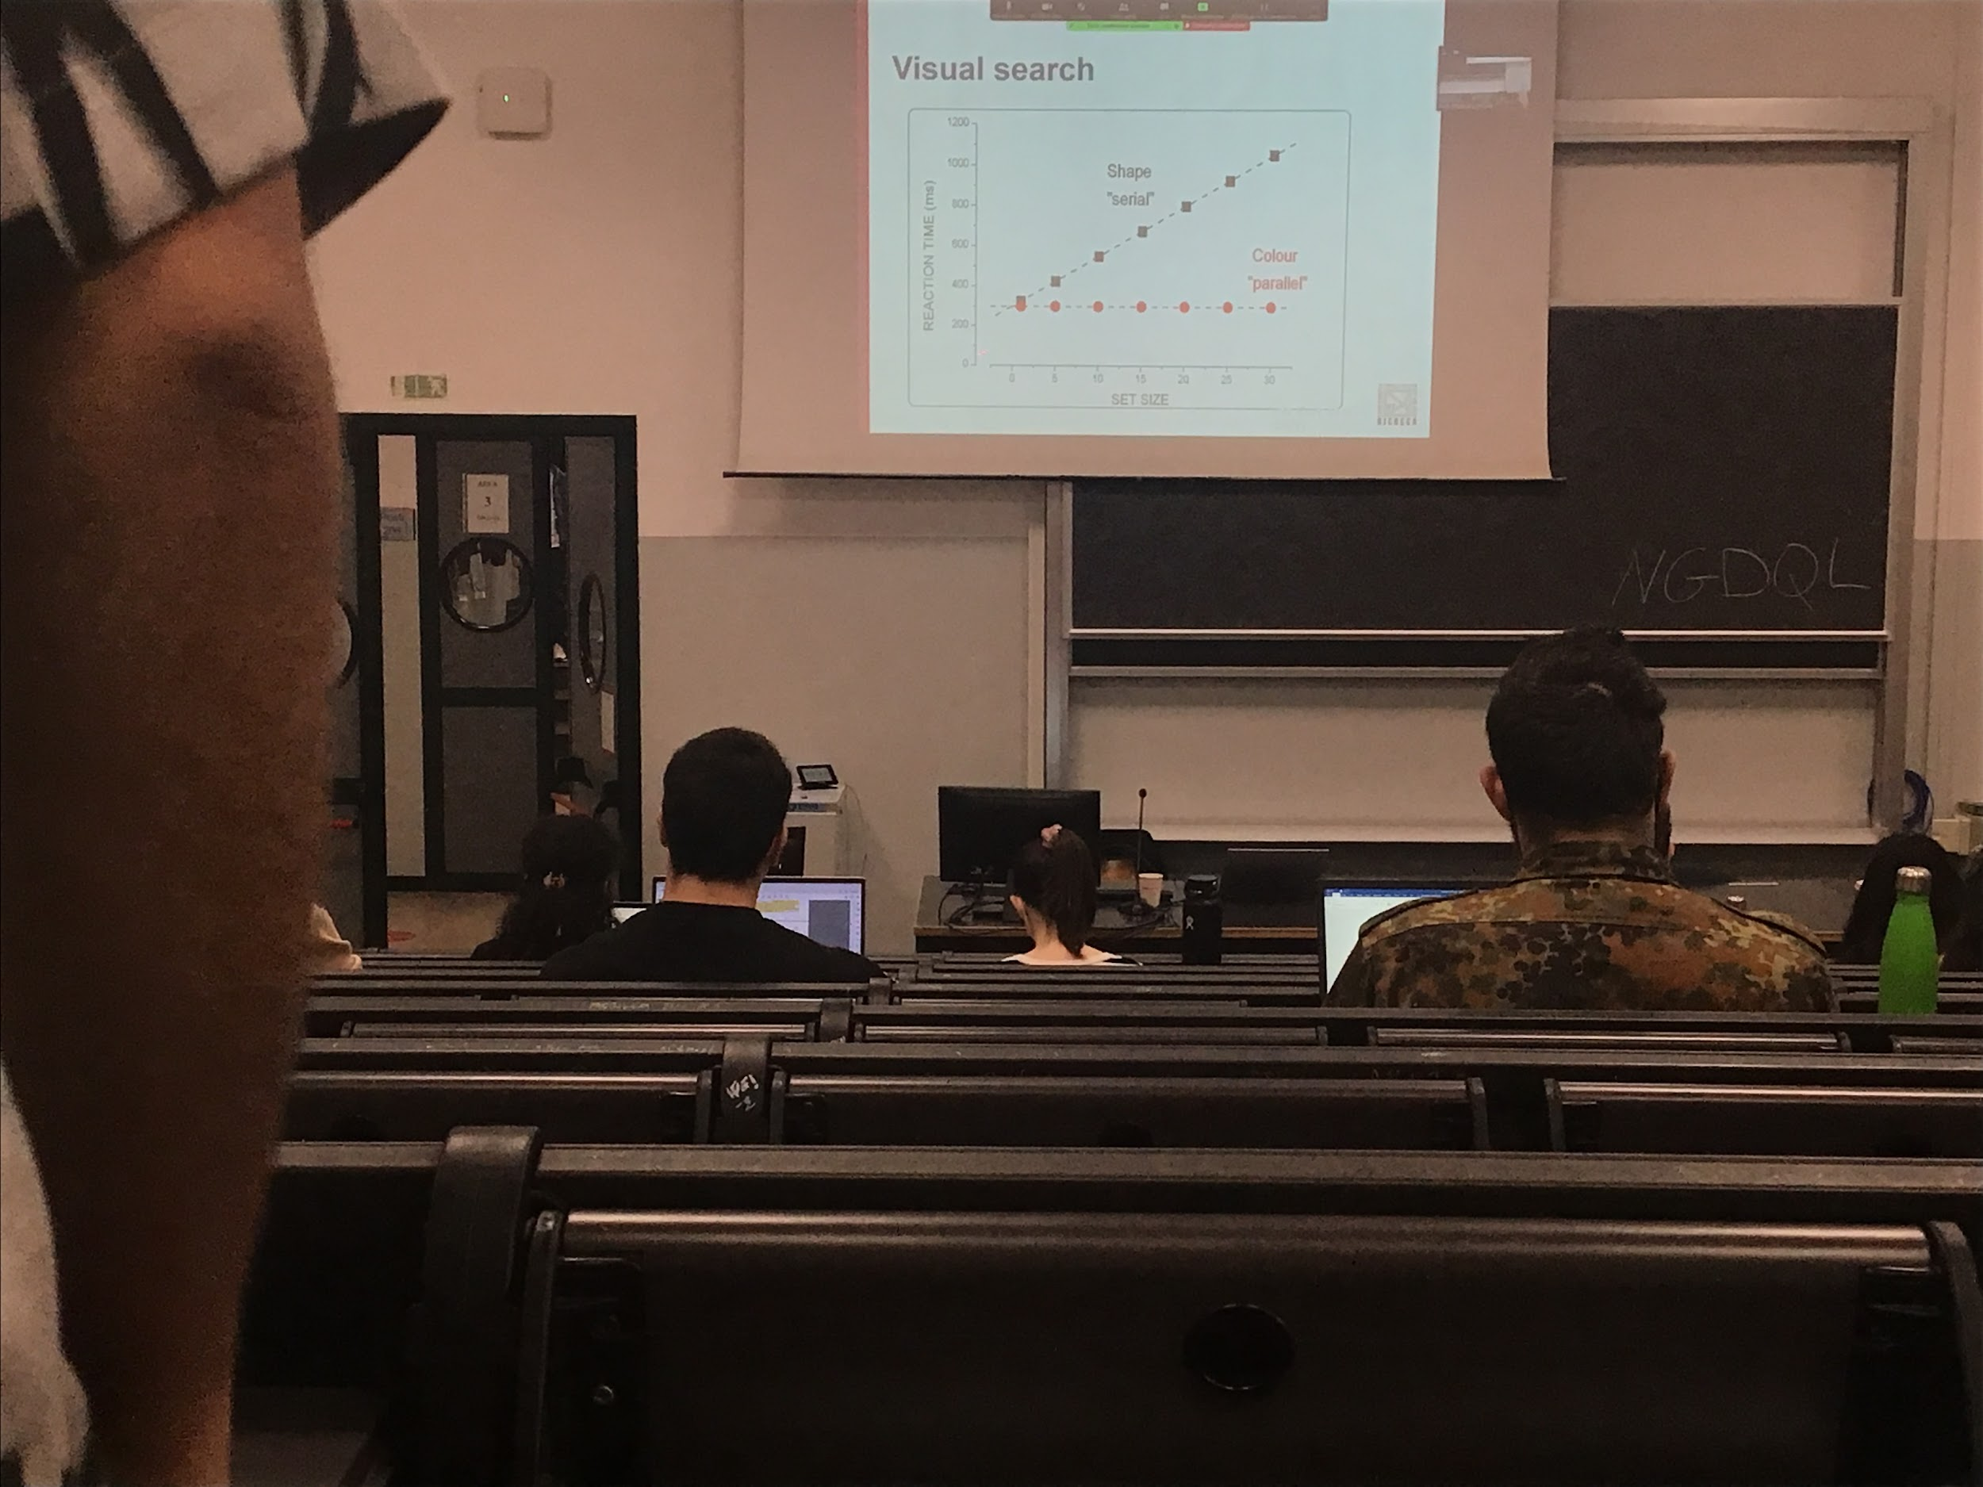

There is a difference in behaviour of participants depending on the type of search that they have to do

* In feature search does **not matter how big is the set size**, not care on how many distractors, to find the target it always take the same time always
* In conjunction search time increase when the number of distractors increases

**Parallel search**: system must compute everything at the same time, also called *pop-out* search, the target can be seen right away. Not care about the number of distractors

**Serial search**: times increases as we increase the number of items, looking at one item at the time the search is serial. Doing one thing at the time

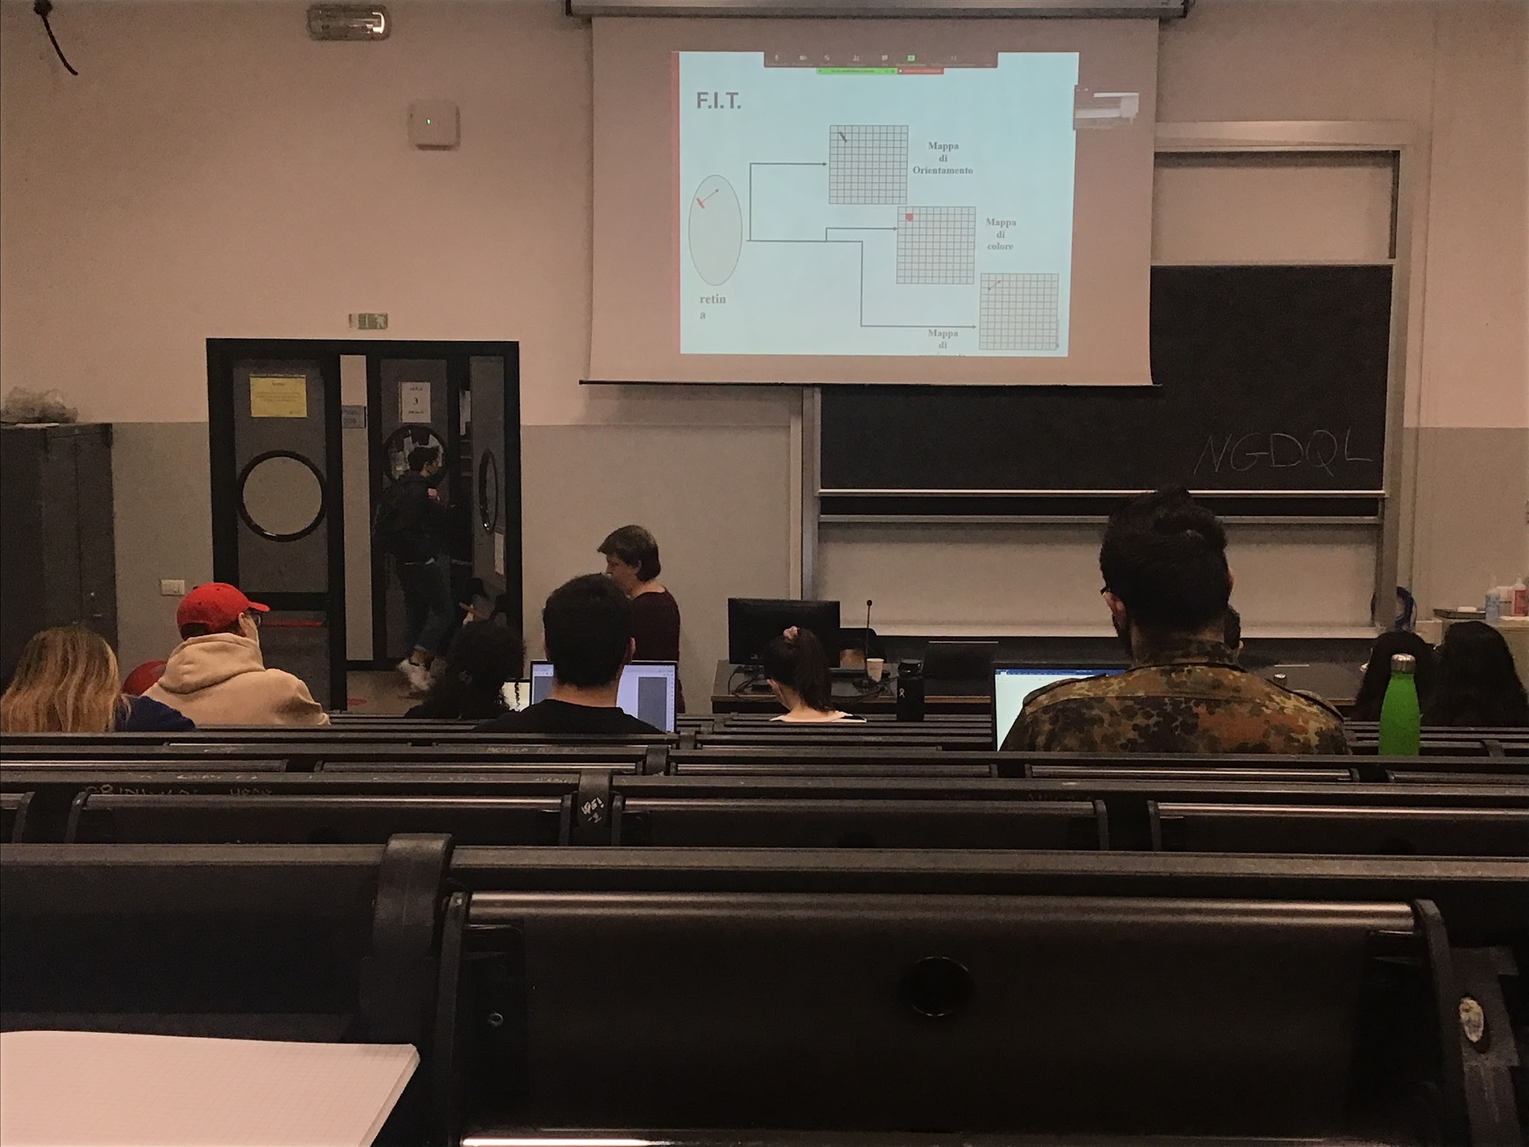

**Feature integration theory (FIT)**: most famous model of visual search

Steps of visual search:

1. No attention: Automatically, when there is a stimulus presentation a series of maps are activated, one for each different characteristic of features of the stimulus. If in one of the maps we can find the answer that we are looking for than we have the **pop-out effect** and we know the answer
2. Use attention: If we could not find the answer in the first step: If it is conjunction search, we need to go to the next level, need to **use attention** to focus on one specific item on the scene to bind together the information that are in the different maps to make our representation of the object and to decide if the object is a target

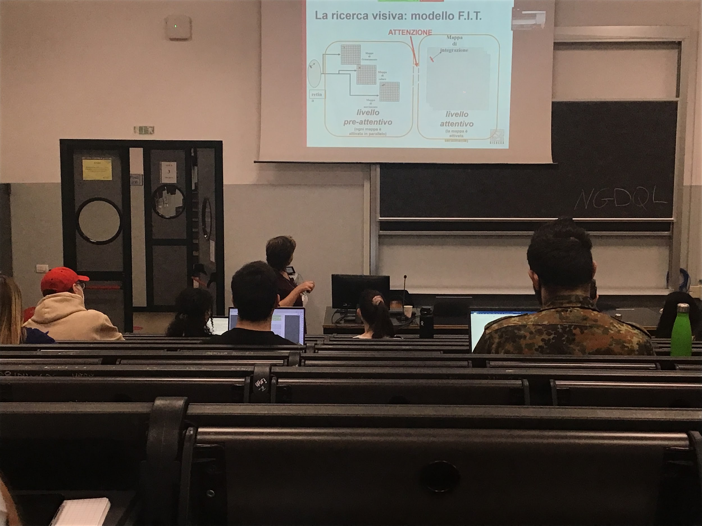

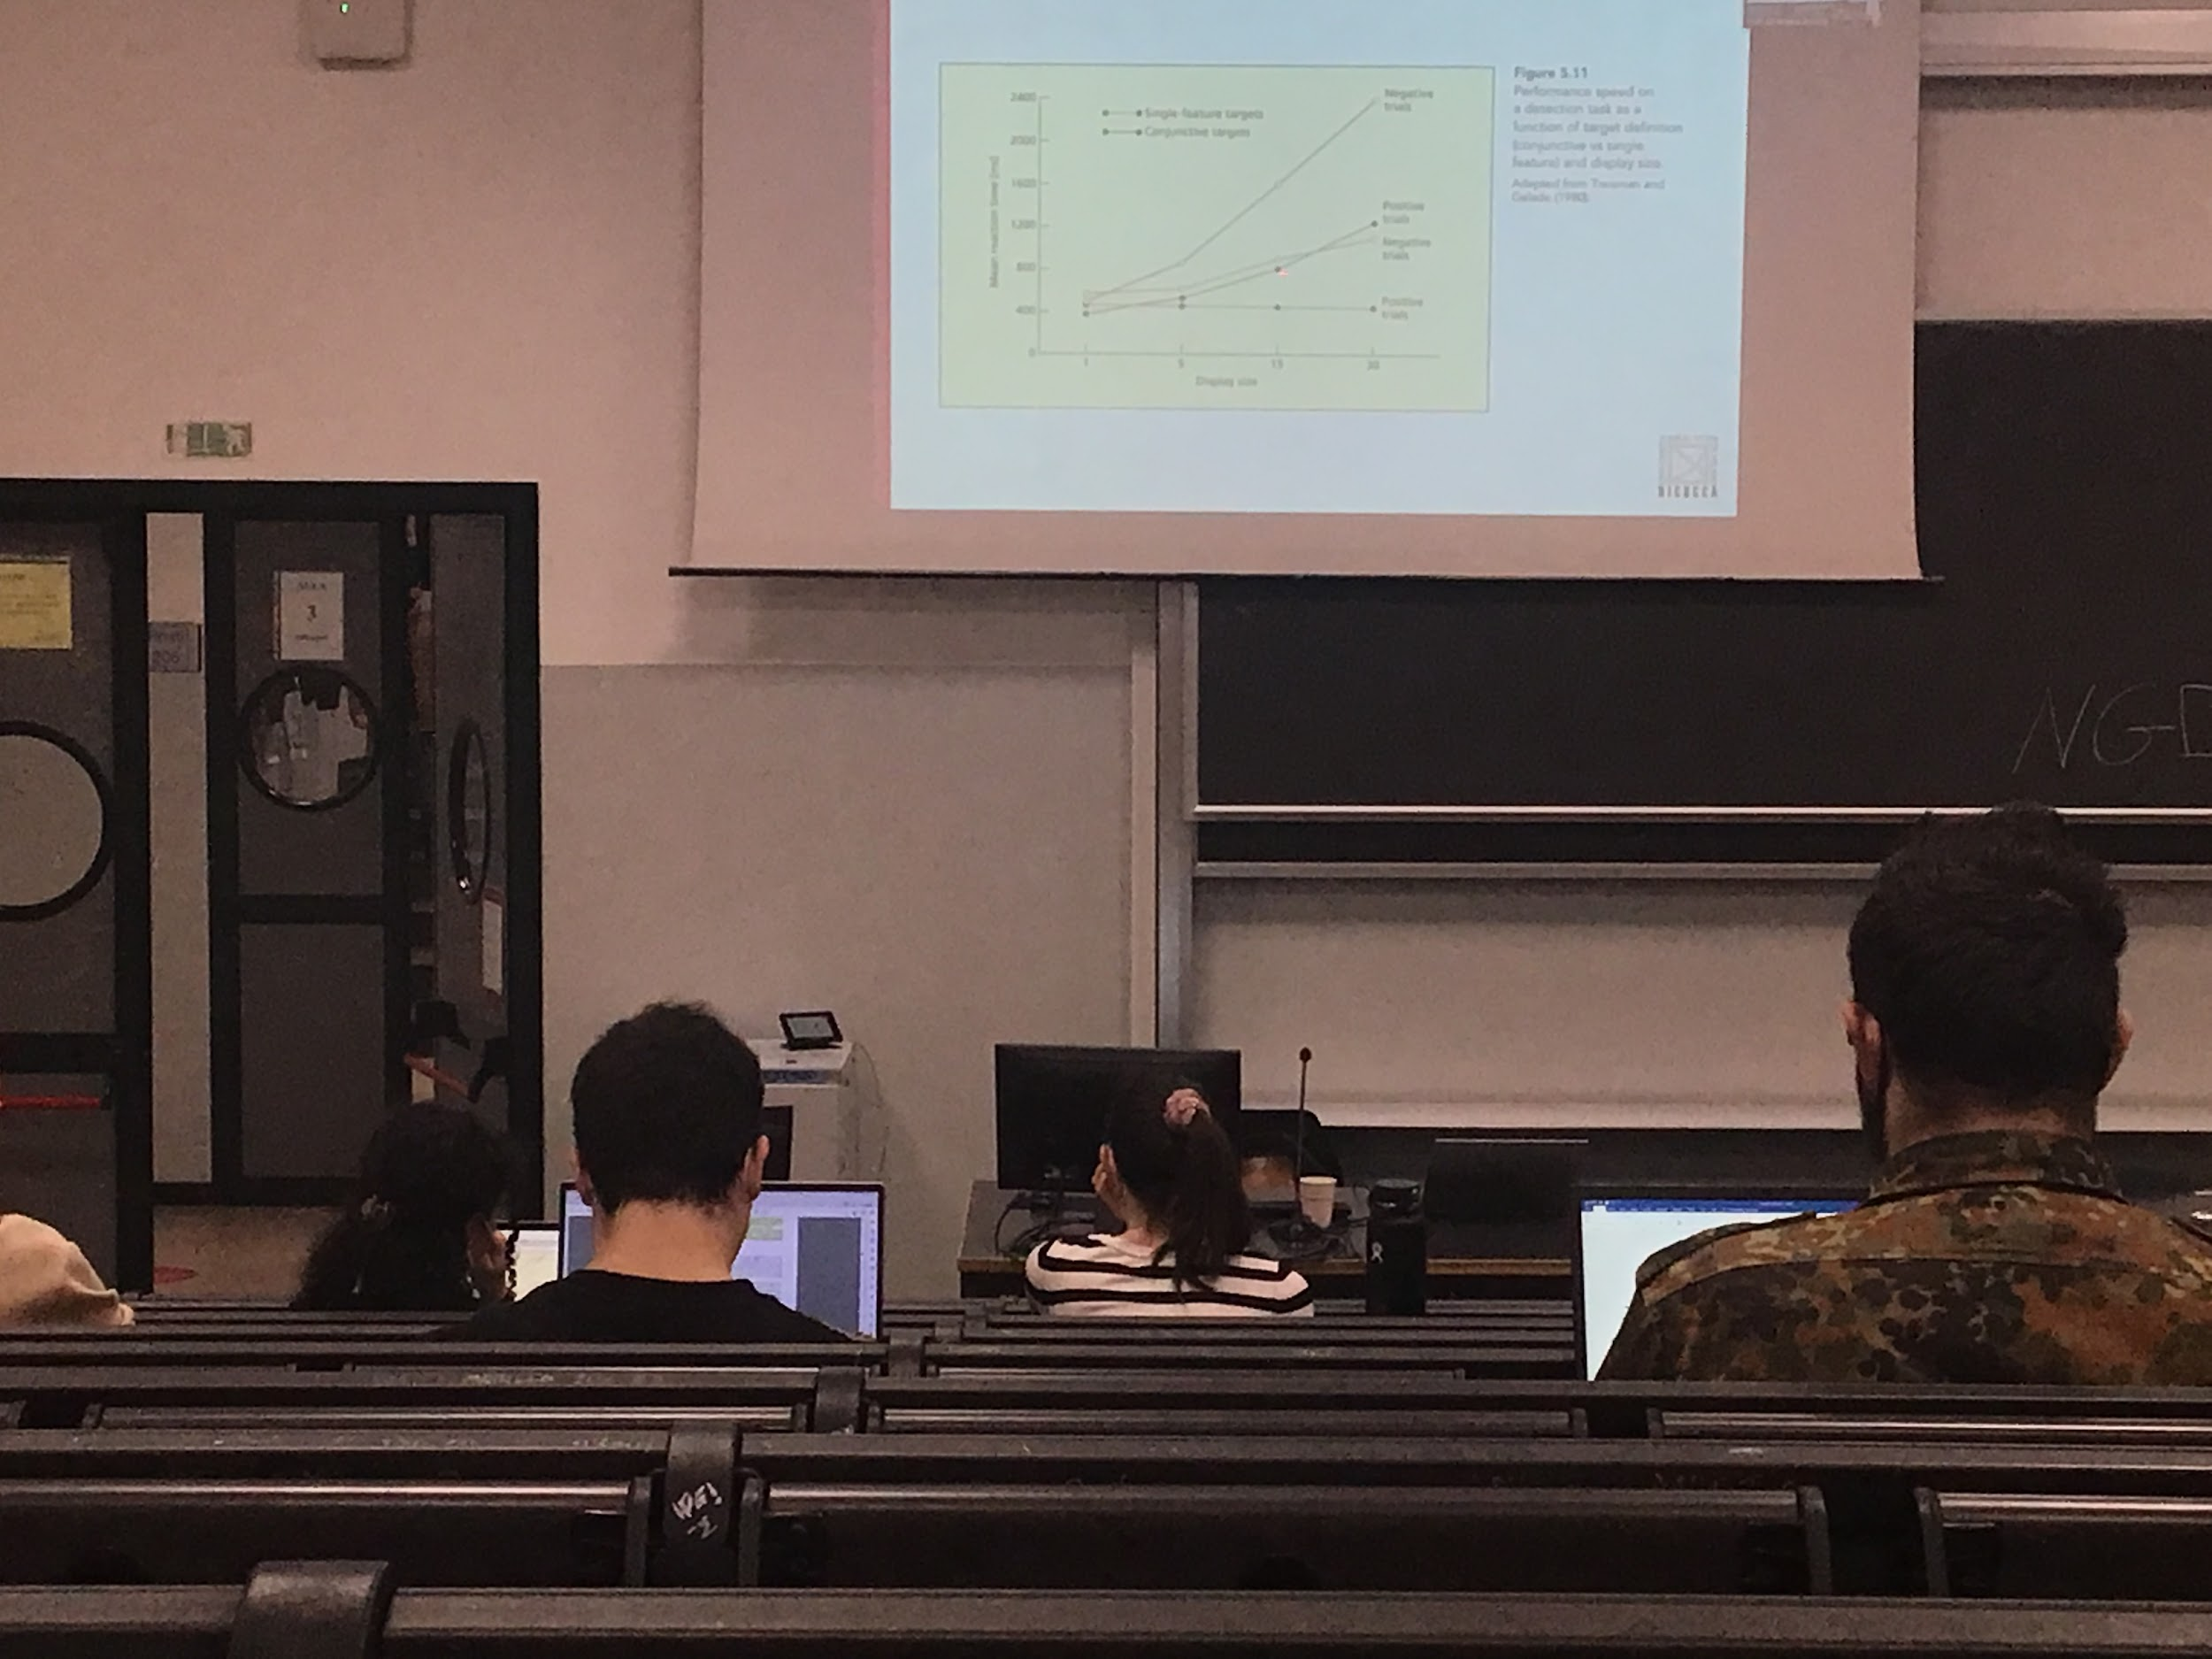

A data in favour of Treisman theory:

* the slope of the curve in the positive trials means that is a scene where the object is present and the negative trials (participant have to say no because there are no target) the slope is much or less double (takes more time)

Takes longer to say *no* instead of *yes*

No: we haven to search all the target to say no

Yes: we have to search only half of the items (on average) and then we find what we were looking for

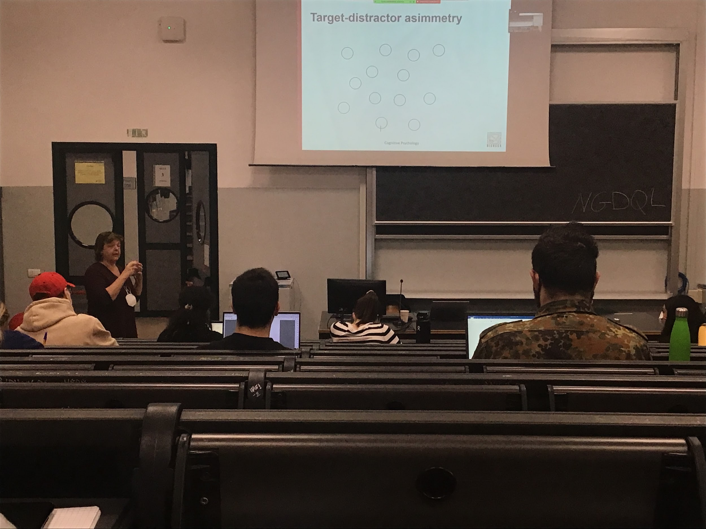

Target distractor asymmetry

This experiment is a **parallel search**: pop-out we can have two maps (one that codes circles, one that codes vertical bar) and in this case in the map of the vertical bar there is only one item. Find straight away the target, no need to use attention

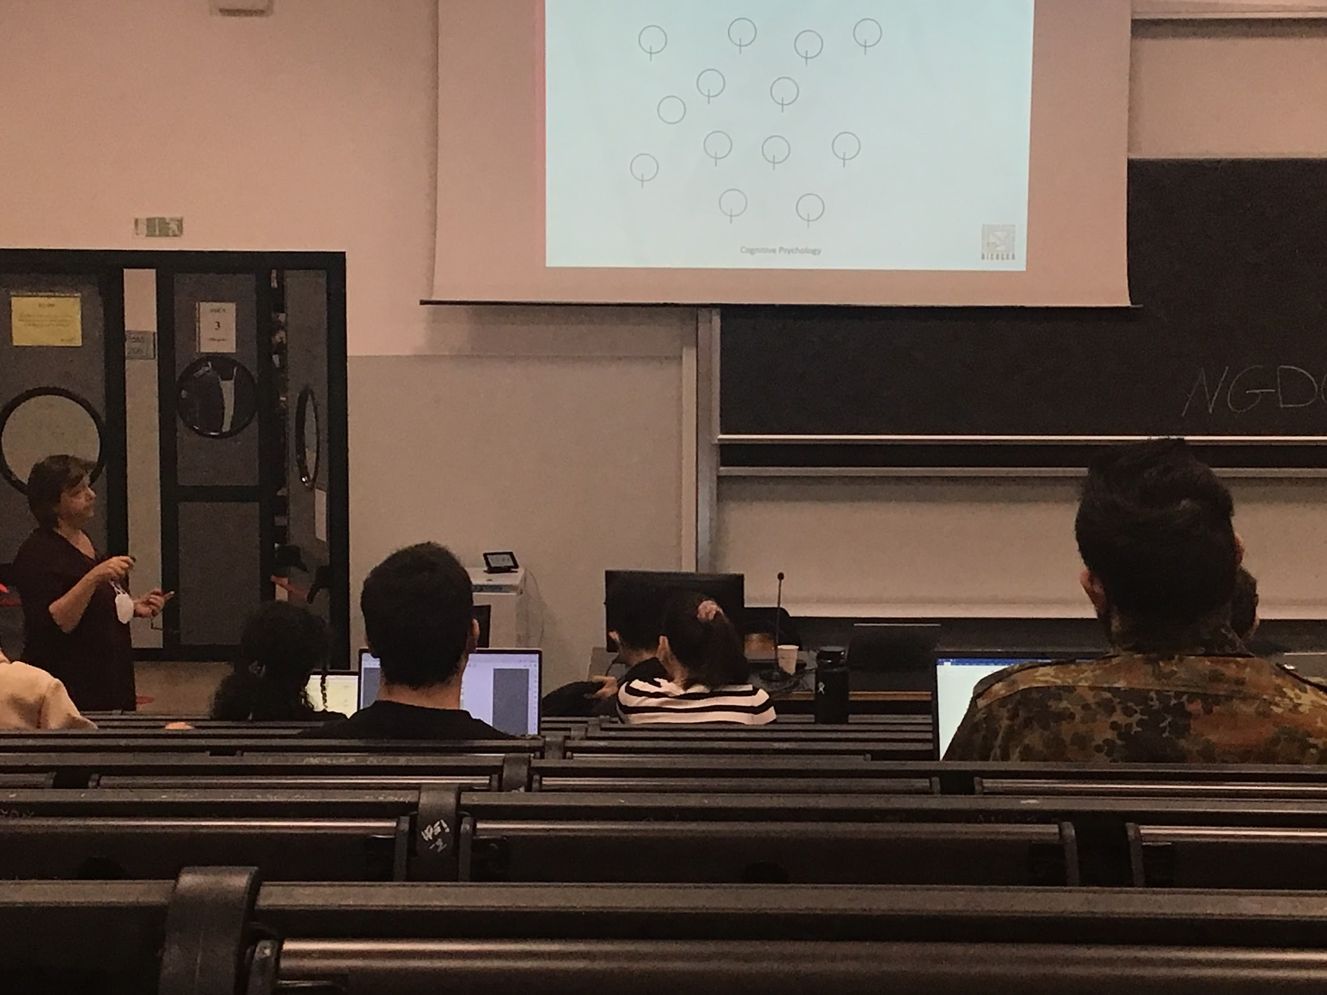

In this case instead even if the difference between target and distractor is the same as before this is a **serial search**. In the two maps we have a lot of vertical bars and a lot of circles, we must use attention to find the target

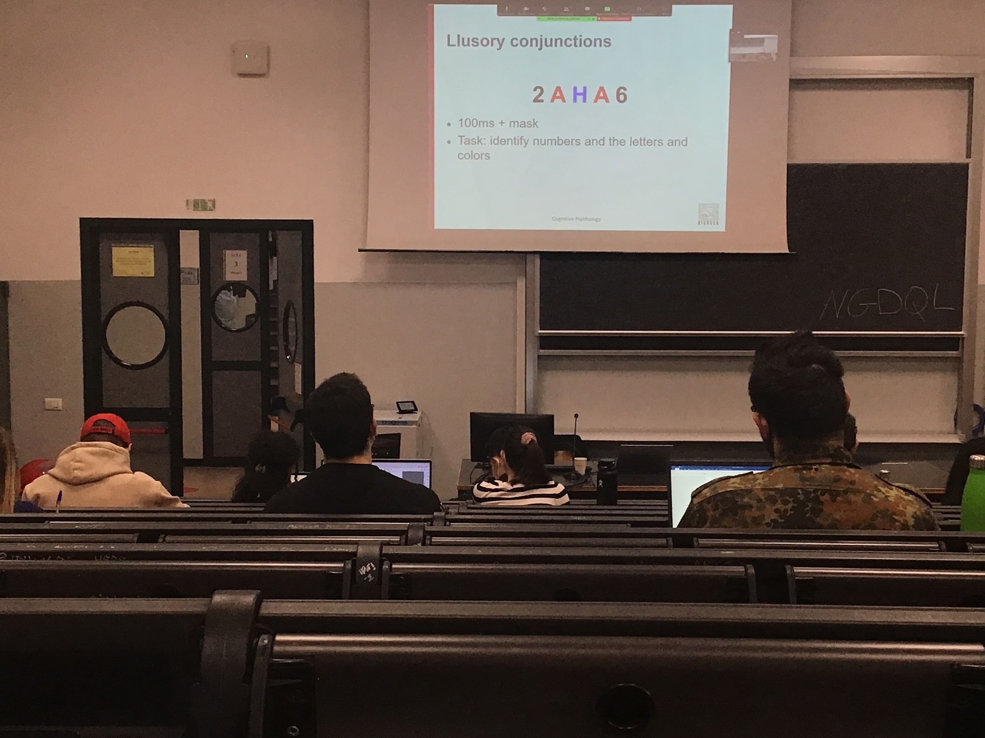

Data in favour of Treisman Feature Integration theory (FIT)

**Illusory conjunction**: the task is to identify numbers and letters and colours.

People with no deficit look for 100ms to the letters and the numbers, and then I mask it and you make the **wrong association**, you **conjunct features that are not together** and you make errors, you don’t have enough time to code the stimulus and attention cannot move from one position to the other

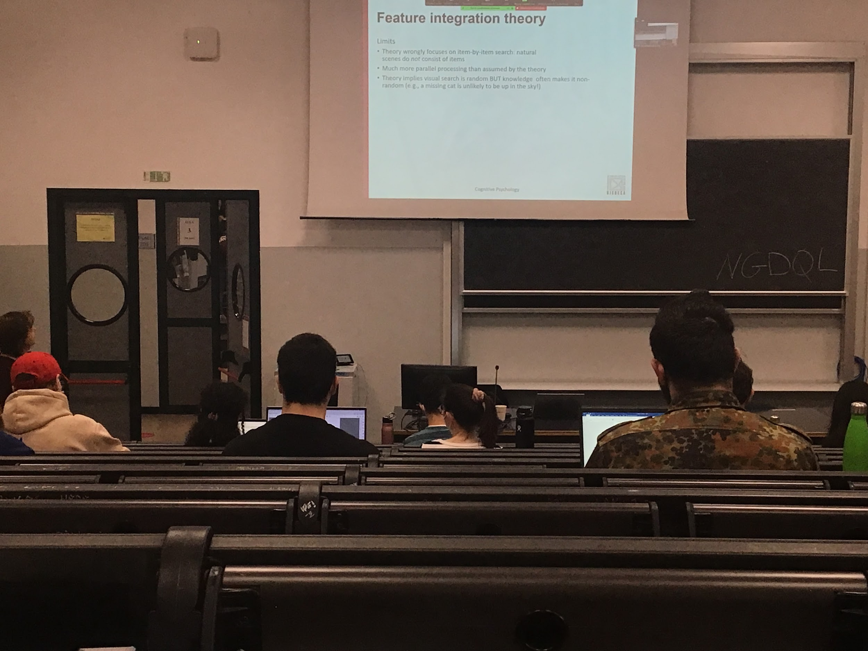

(FIT) limits:

* **Not ecological**, predicting correctly some types of stimulus but in reality is different
* If you test the theory with a lot of different stimuli, you find **much more parallel processing** that what you predicted
* theory predicts that there’s no use of knowledge in search, but **in reality most of the time we use previous information that we have**

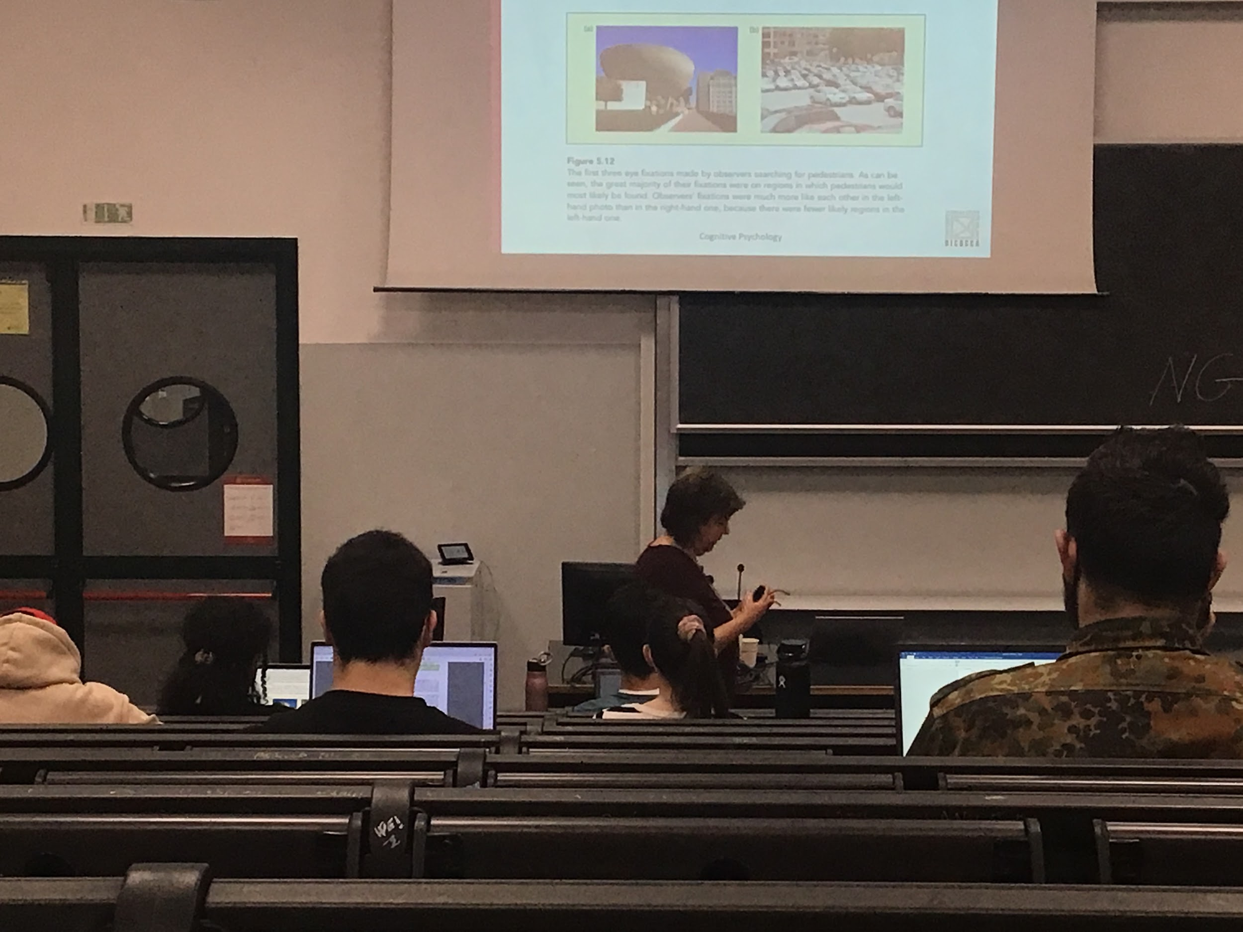

In these two pictures of a street and a car parking place people are looking for pedestrians, the dots are eye movement, **people look in places where pedestrians should be**, not look for pedestrians in the sky. Look in places where pedestrians are supposed to be

**Search is not completely random**, use stored informations to search

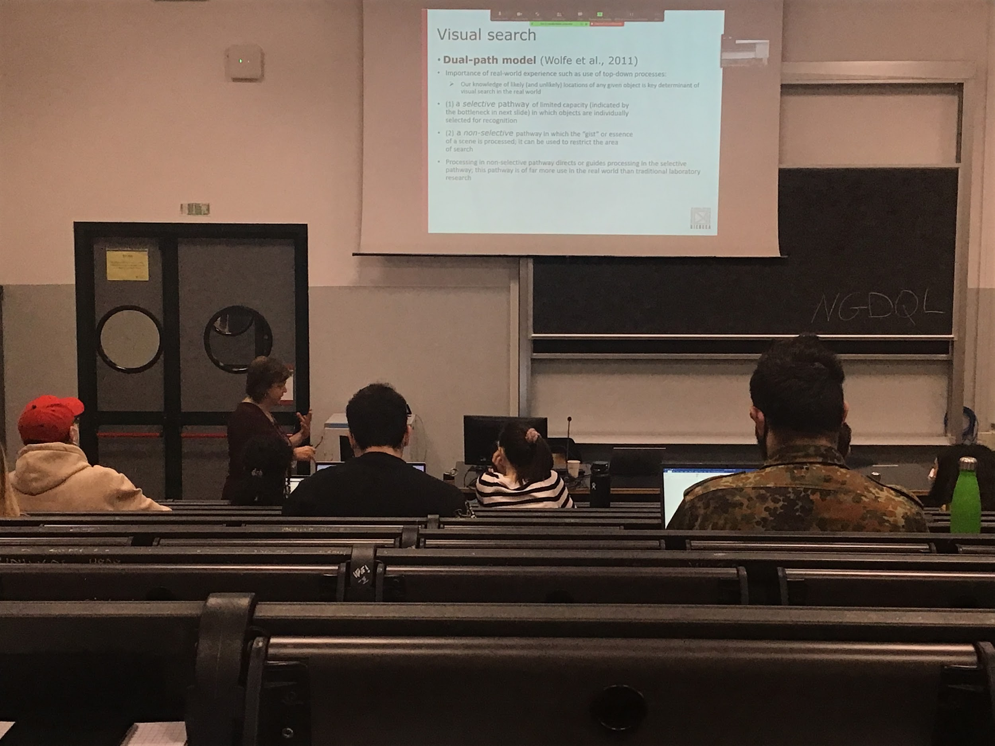

Wolfe student of Treisman presented a different model

**Dual-path model**: keeps some characteristics of Treisman but in reality we do use our information, we **use top-down processing when we do search**. Use knowledge and tells us the likely or unlikely location of what we are looking for

Two parallel pathway

* **Selective pathway**: similar to the features integration theory of Treisman. Limited capacity: can analyse one item (or a little more) at the time and when we select object recognition we do the binding problem. Need to select objects to understand if they are our target
* **Non-selective pathway**: takes the gist of the scene (general and very fast information and coding of what we have in front of us) and we use this information to restrict the area of interest. Select some part of the search and guide the selective pathway. Much more useful in the real word

**Selective and non-selective pathway acts together in parallel**

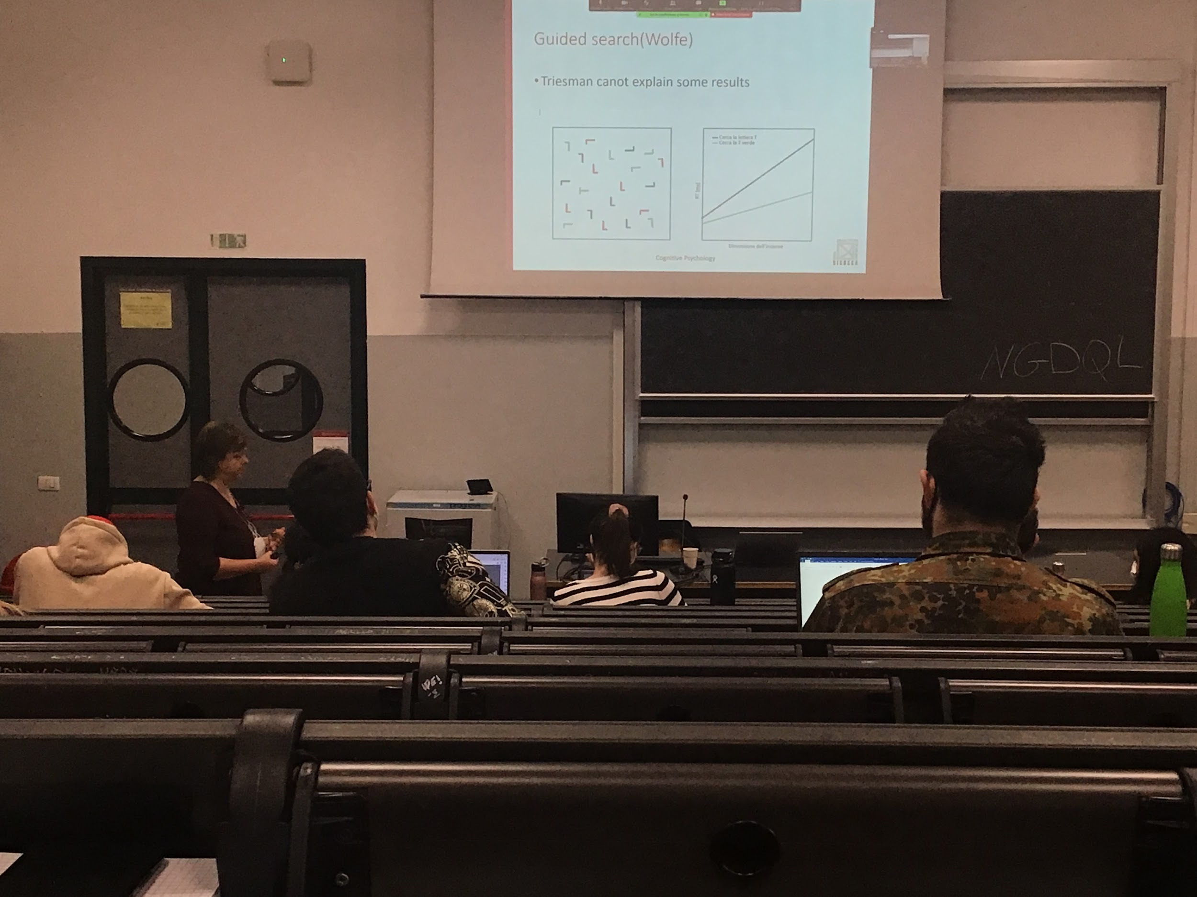

One of the first examples that tries to test this theory. The theory works also with artificial stimuli

If in the first stimulus you have to *find the letter T* or *find the green T,* you have **different time of responses**

If asked to find the green T you don’t look at the red and black stimulus, you select part of the scene using top-down observation.

According to **Treisman: looking for the T and for the green T** should have given the same identical response at the **same time**. But in reality is not true

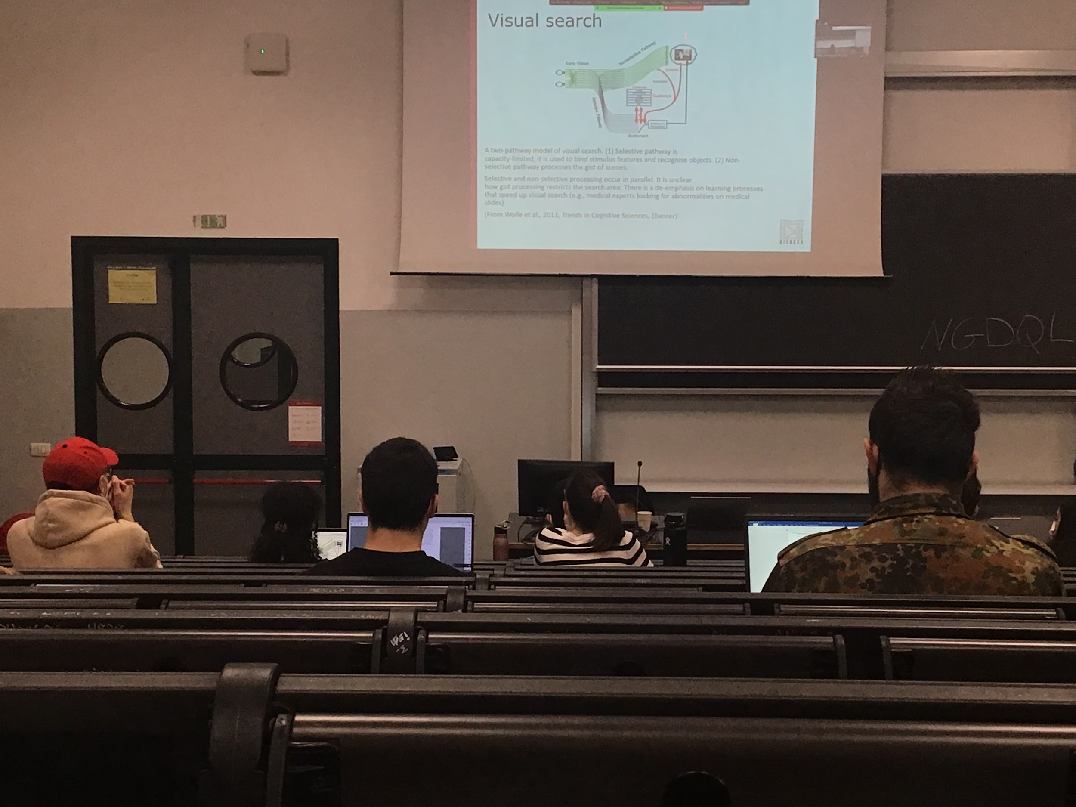

Model of Wolfe:

**Non selective pathway**: go fast into memory, processes the gist of the scene and then guides where the other pathway should go look for the object

The two pathway work at the same time and restrict the search area

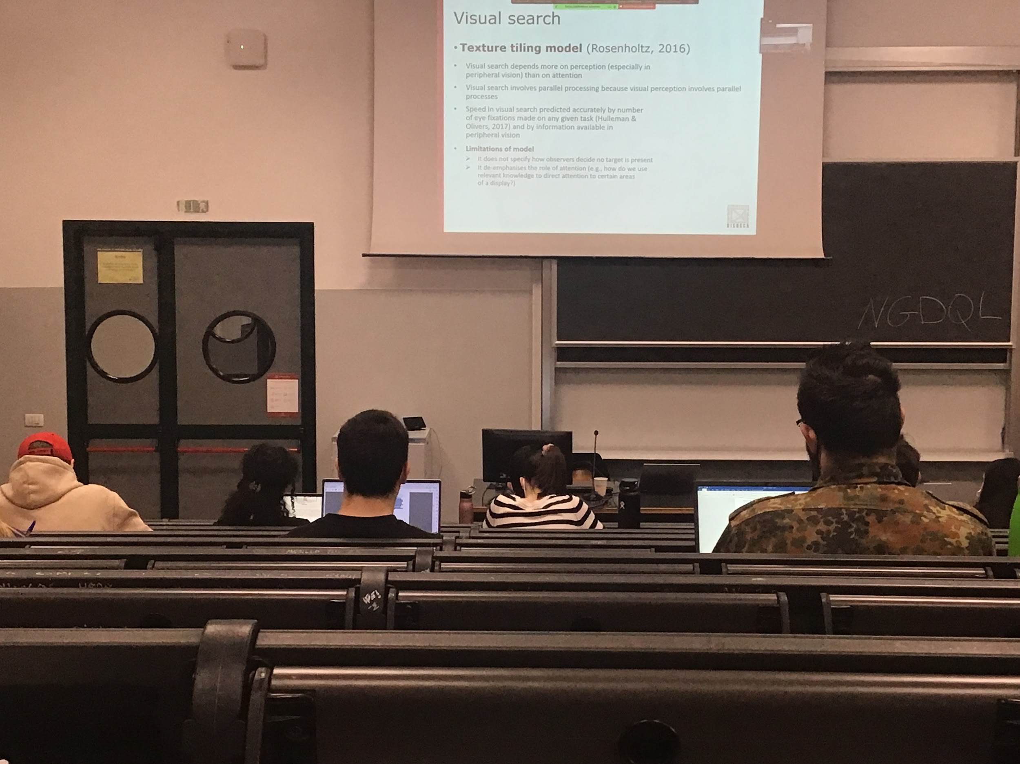

Wolfe and treisman theory are similar, relay on attention a lot

**Treisman** opinion of attention: attention needed to bind the information together

**Wolfe** opinion of attention: the selective pathway does the same identical thing and puts attention on some part of the scene

**Rosenholtz** proposed another theory: we have to consider not simply attention but also perception, we have to consider the fact that we are able to do some kind of task with our periphery of the visual field

Visual perception works in parallel, everything that comes in our eyes is elaborated

When I am looking at some specific position I am coding not only the object that is there but everything that is around

I am **selecting an area around the object**, you are not looking item by item but areas by areas.

If instead of measuring visual search as your reaction time you measure them by the number of eye movements that you make, the prediction is very good. Every eye movement inglobates a number of items

Not clear when people decides that no target is present, not clear when the process need to stop

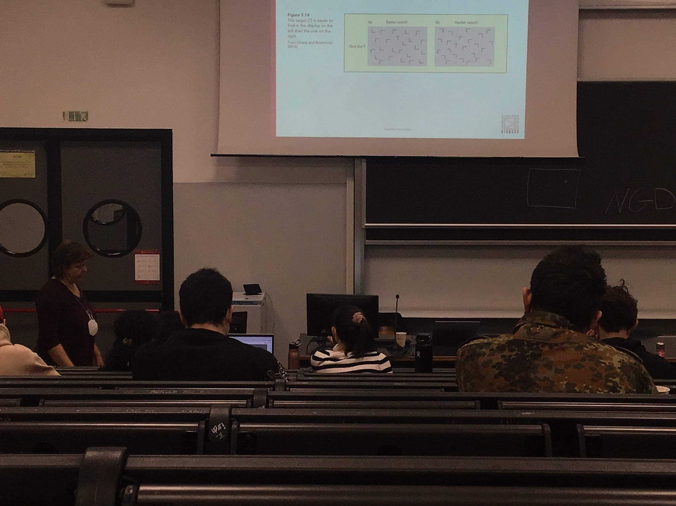

T among L

In the first image the search is much easier, if you look at the T and select the items around in the first image it is easier to understand the T, while in the other is much more difficult. In the second image they look much more like a T, more confused than the other image.

Not explainable by others models

**CHAPTER 5 - Attention and Performance**

**Cross modal effect**

Everything comes in our senses, different information comes from different senses (eyes, ear, touch…)

The things are put tougher, each object has characteristics that come from visual information, auditory information…

The system at a certain put together all the information

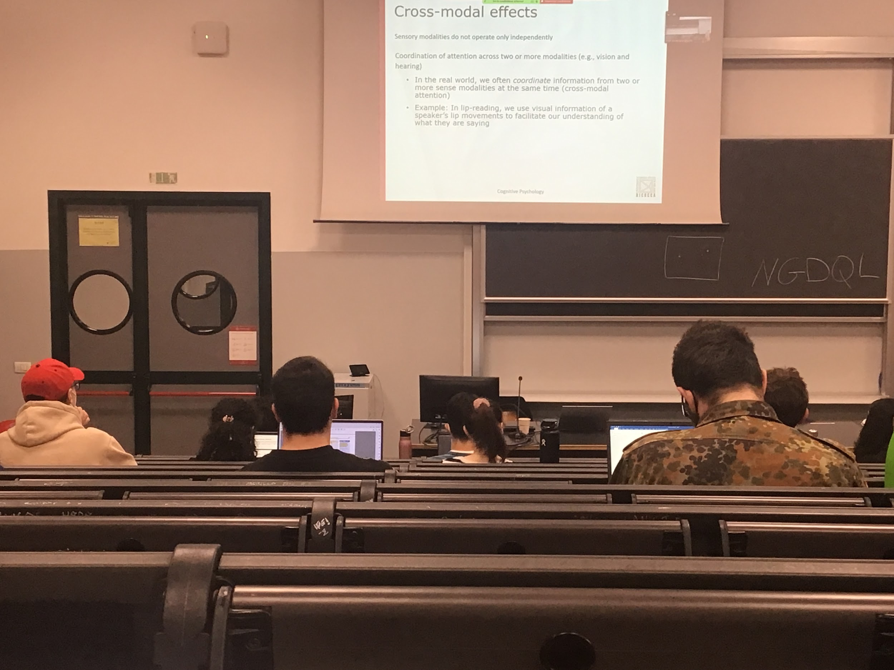

**Crossmodal effect**

Sensory modality does work separately for a little bit (for the analysis of very basic information), but then everything interacts.

Attention that can select something in the auditory stream, vision can focus on one object, attention need to ordinate the information that comes from the different modalities

Most of the times automatically coordinate information, when we do **lip reading**, if I can lip reading I can understand much better what you are talking about

We use informations about the movement of the mouth to understand better what you are saying

Paying attention on the visual modality can helps us interpret auditory information

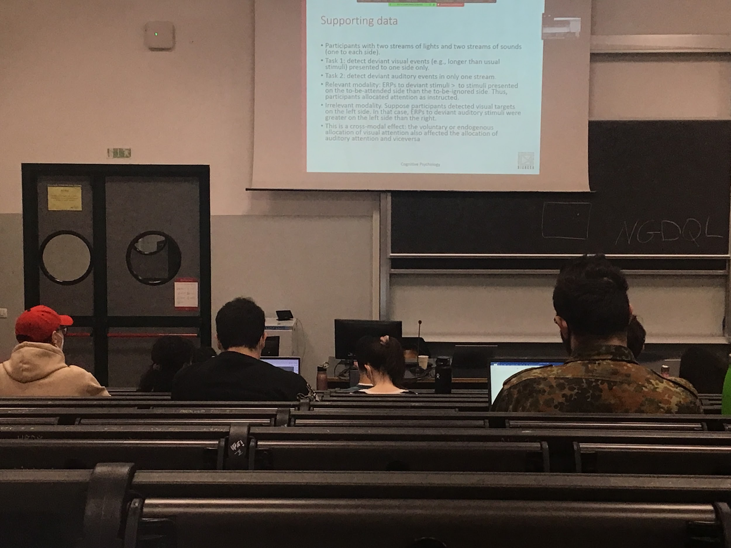

Data supporting cross modal interaction: attention can be induces visually but select auditory information and vice versa

**Experiment**: Two streams of light (one on the left one on the right) and two clicking sounds (left and right) your task is to tell when on the left there is a flash that is a little bit longer. Have to pay attention on the left side and tell if the flash is longer than the other. Or another experiment can be to find the sound that is a little bit longer then the other

We allocate attention to the right position, when I am looking for a visual stimulus I actually move attention to the left side in the visual modality

Even if your task is to look for visual automatically you put more attention to the same side in the auditory stream

**When you move your attention you move it for both modalities**. When you voluntarily move attention to one side you do for all the modalities together. So in some kind of sense **attention interacts across modalities**

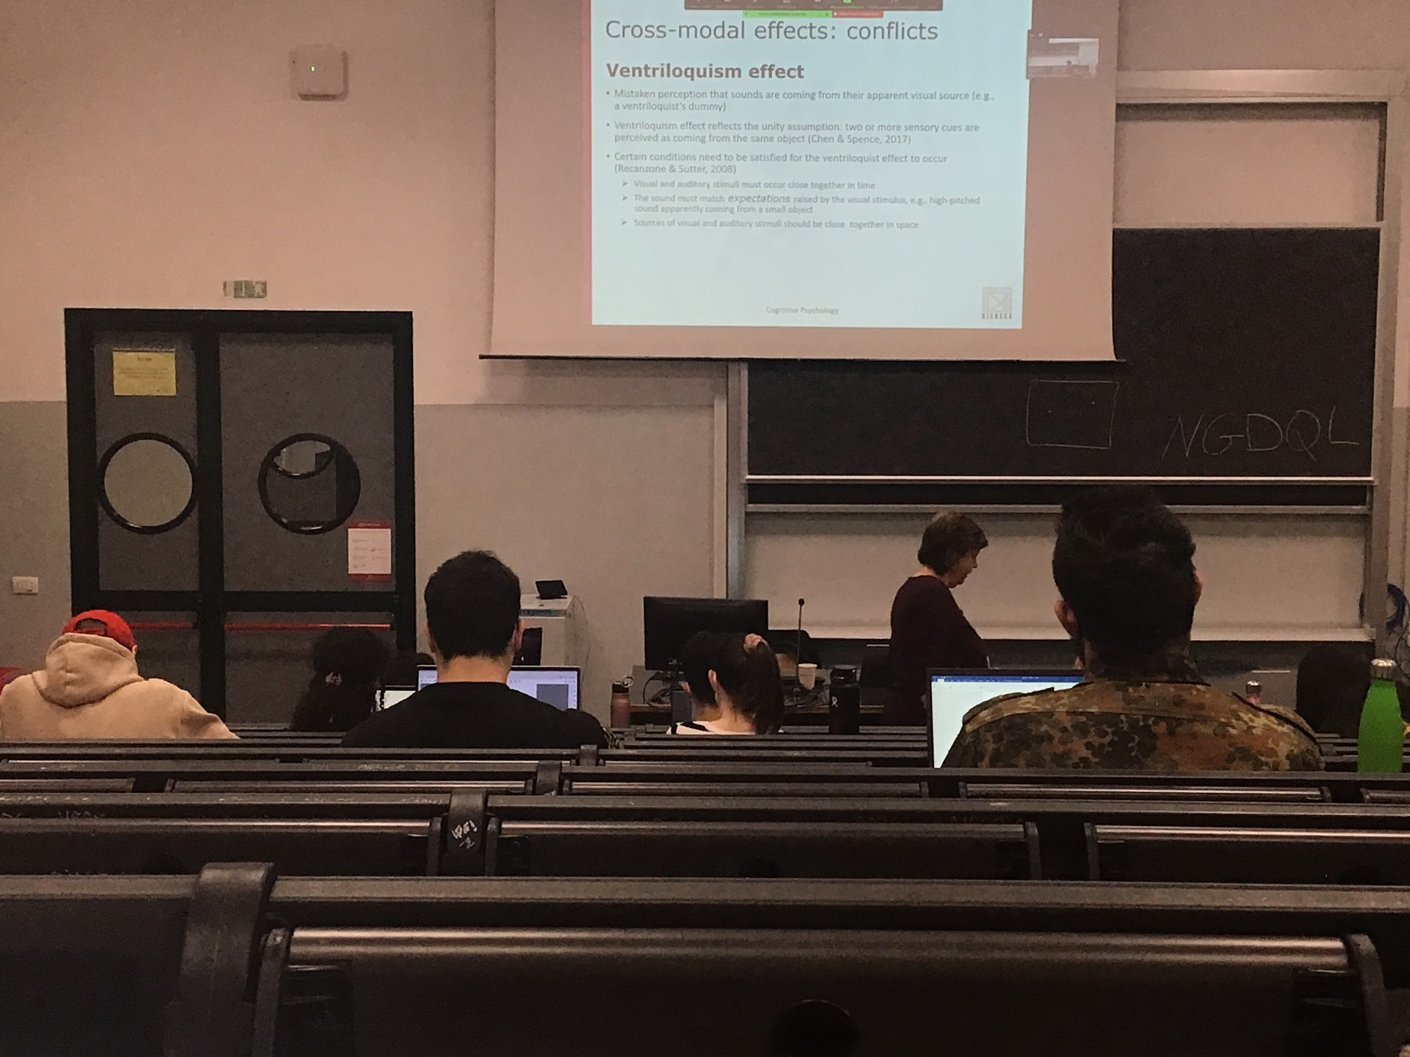

Proof that attention try to put together information from the visual and the auditory field: **Ventriloquism effect**

When we see someone with a puppet, the feeling is that the puppet is talking, not the person

Your perception is mistaken because you think that the sound is coming out from the puppy mouth

The system when it try to interpret informations coming in uses the **unit assumption** (two pulses present in the scene we try to check if they are associated, in this case we associate the sound and the movements)

There are some critical for which the effect works:

* the **visual and the auditory stimulus** should be almost **synchronous**, if they are not we understand that there is a dissociation
* The **sound must match the expectation**. When there is something small it should have a different voice in respect to something that is big. Also the gender
* The **sources of visual and auditory should be close together in space**. The speaker must have the puppet in his hand, can’t be somewhere else, otherwise the auditory system will realise that the sound is coming from somewhere else. The displacement of the sources of the voice and the visual position should not be too large. If there is too much discrepancy the system understand the trick

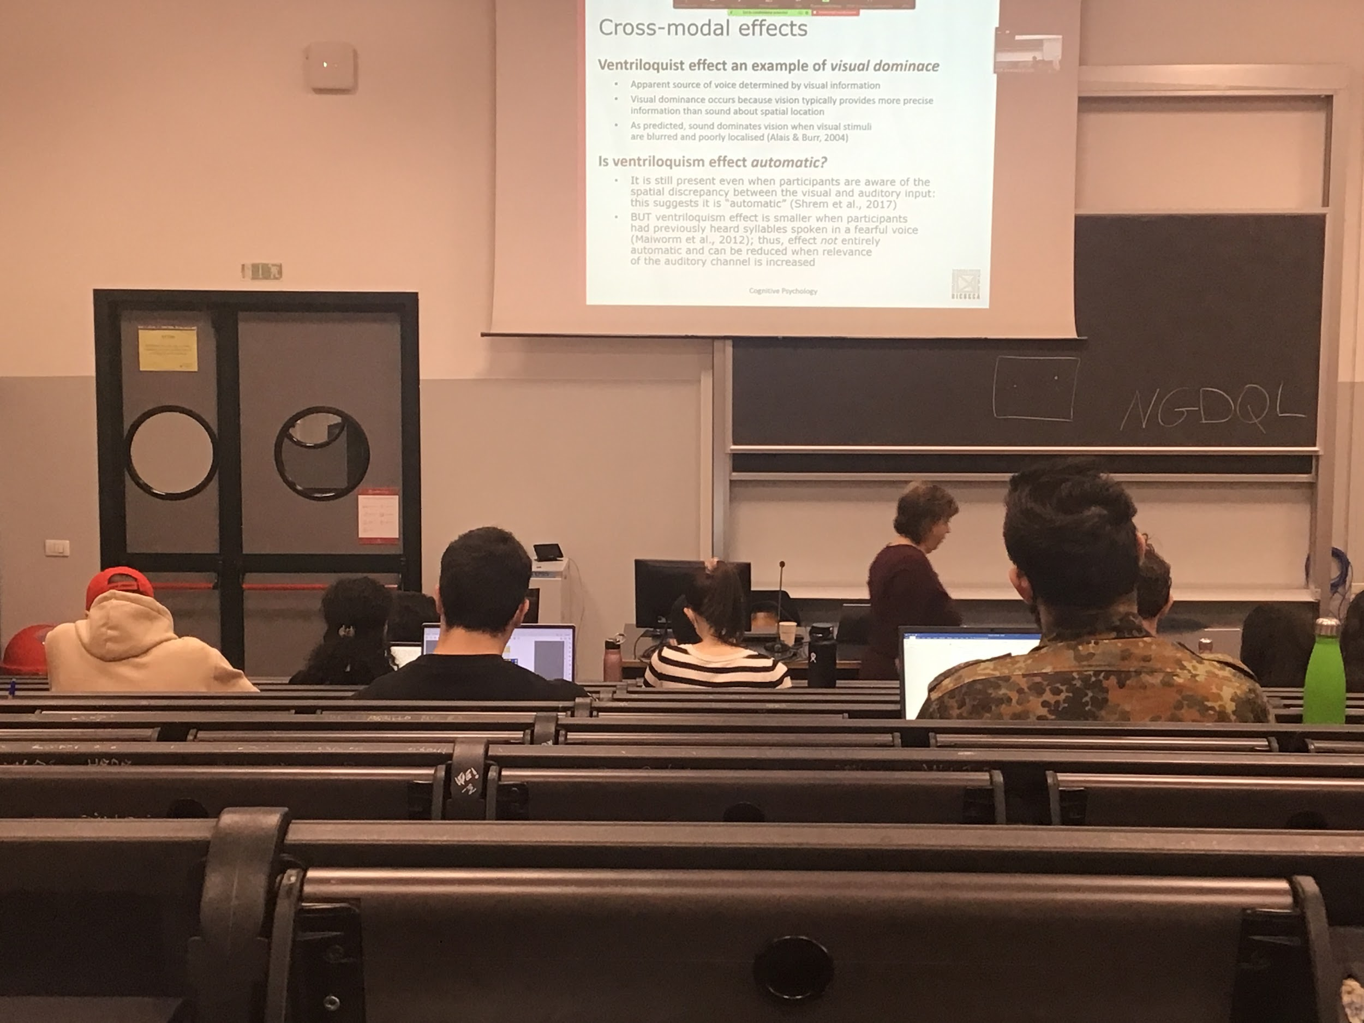

**Visual dominance**: we have two stimulus (one auditory, it can not place very well we know it comes from some position but localization in the auditory stream is not very precise) and visual information (very precise, we are very good at visual detection)

**In this case vision dominates**. Vision dictate the auditory system where the sound is coming to because it sees movement

This happens most of the time with visual dominance. Vision wins over the other senses

Experiment of a person touching your hand and a plastic one, you feel your being touched because vision dominates, even if the other person is not touching your hand but the plastic one

**Vision dominance is not true all the time**, vision is more precise than audition. But when I show you a **blurred stimulus** it means that vision is **not very clear**, the audition wins, the **system does not select vision above everything select the sense that gives more informations and that we can rely more on**

The system forces us to do this association

The association sees to be automatic, the system have a modality to select which is the sense that is more strong, but in reality there are some mutations of the experiment that shows that is not always the case

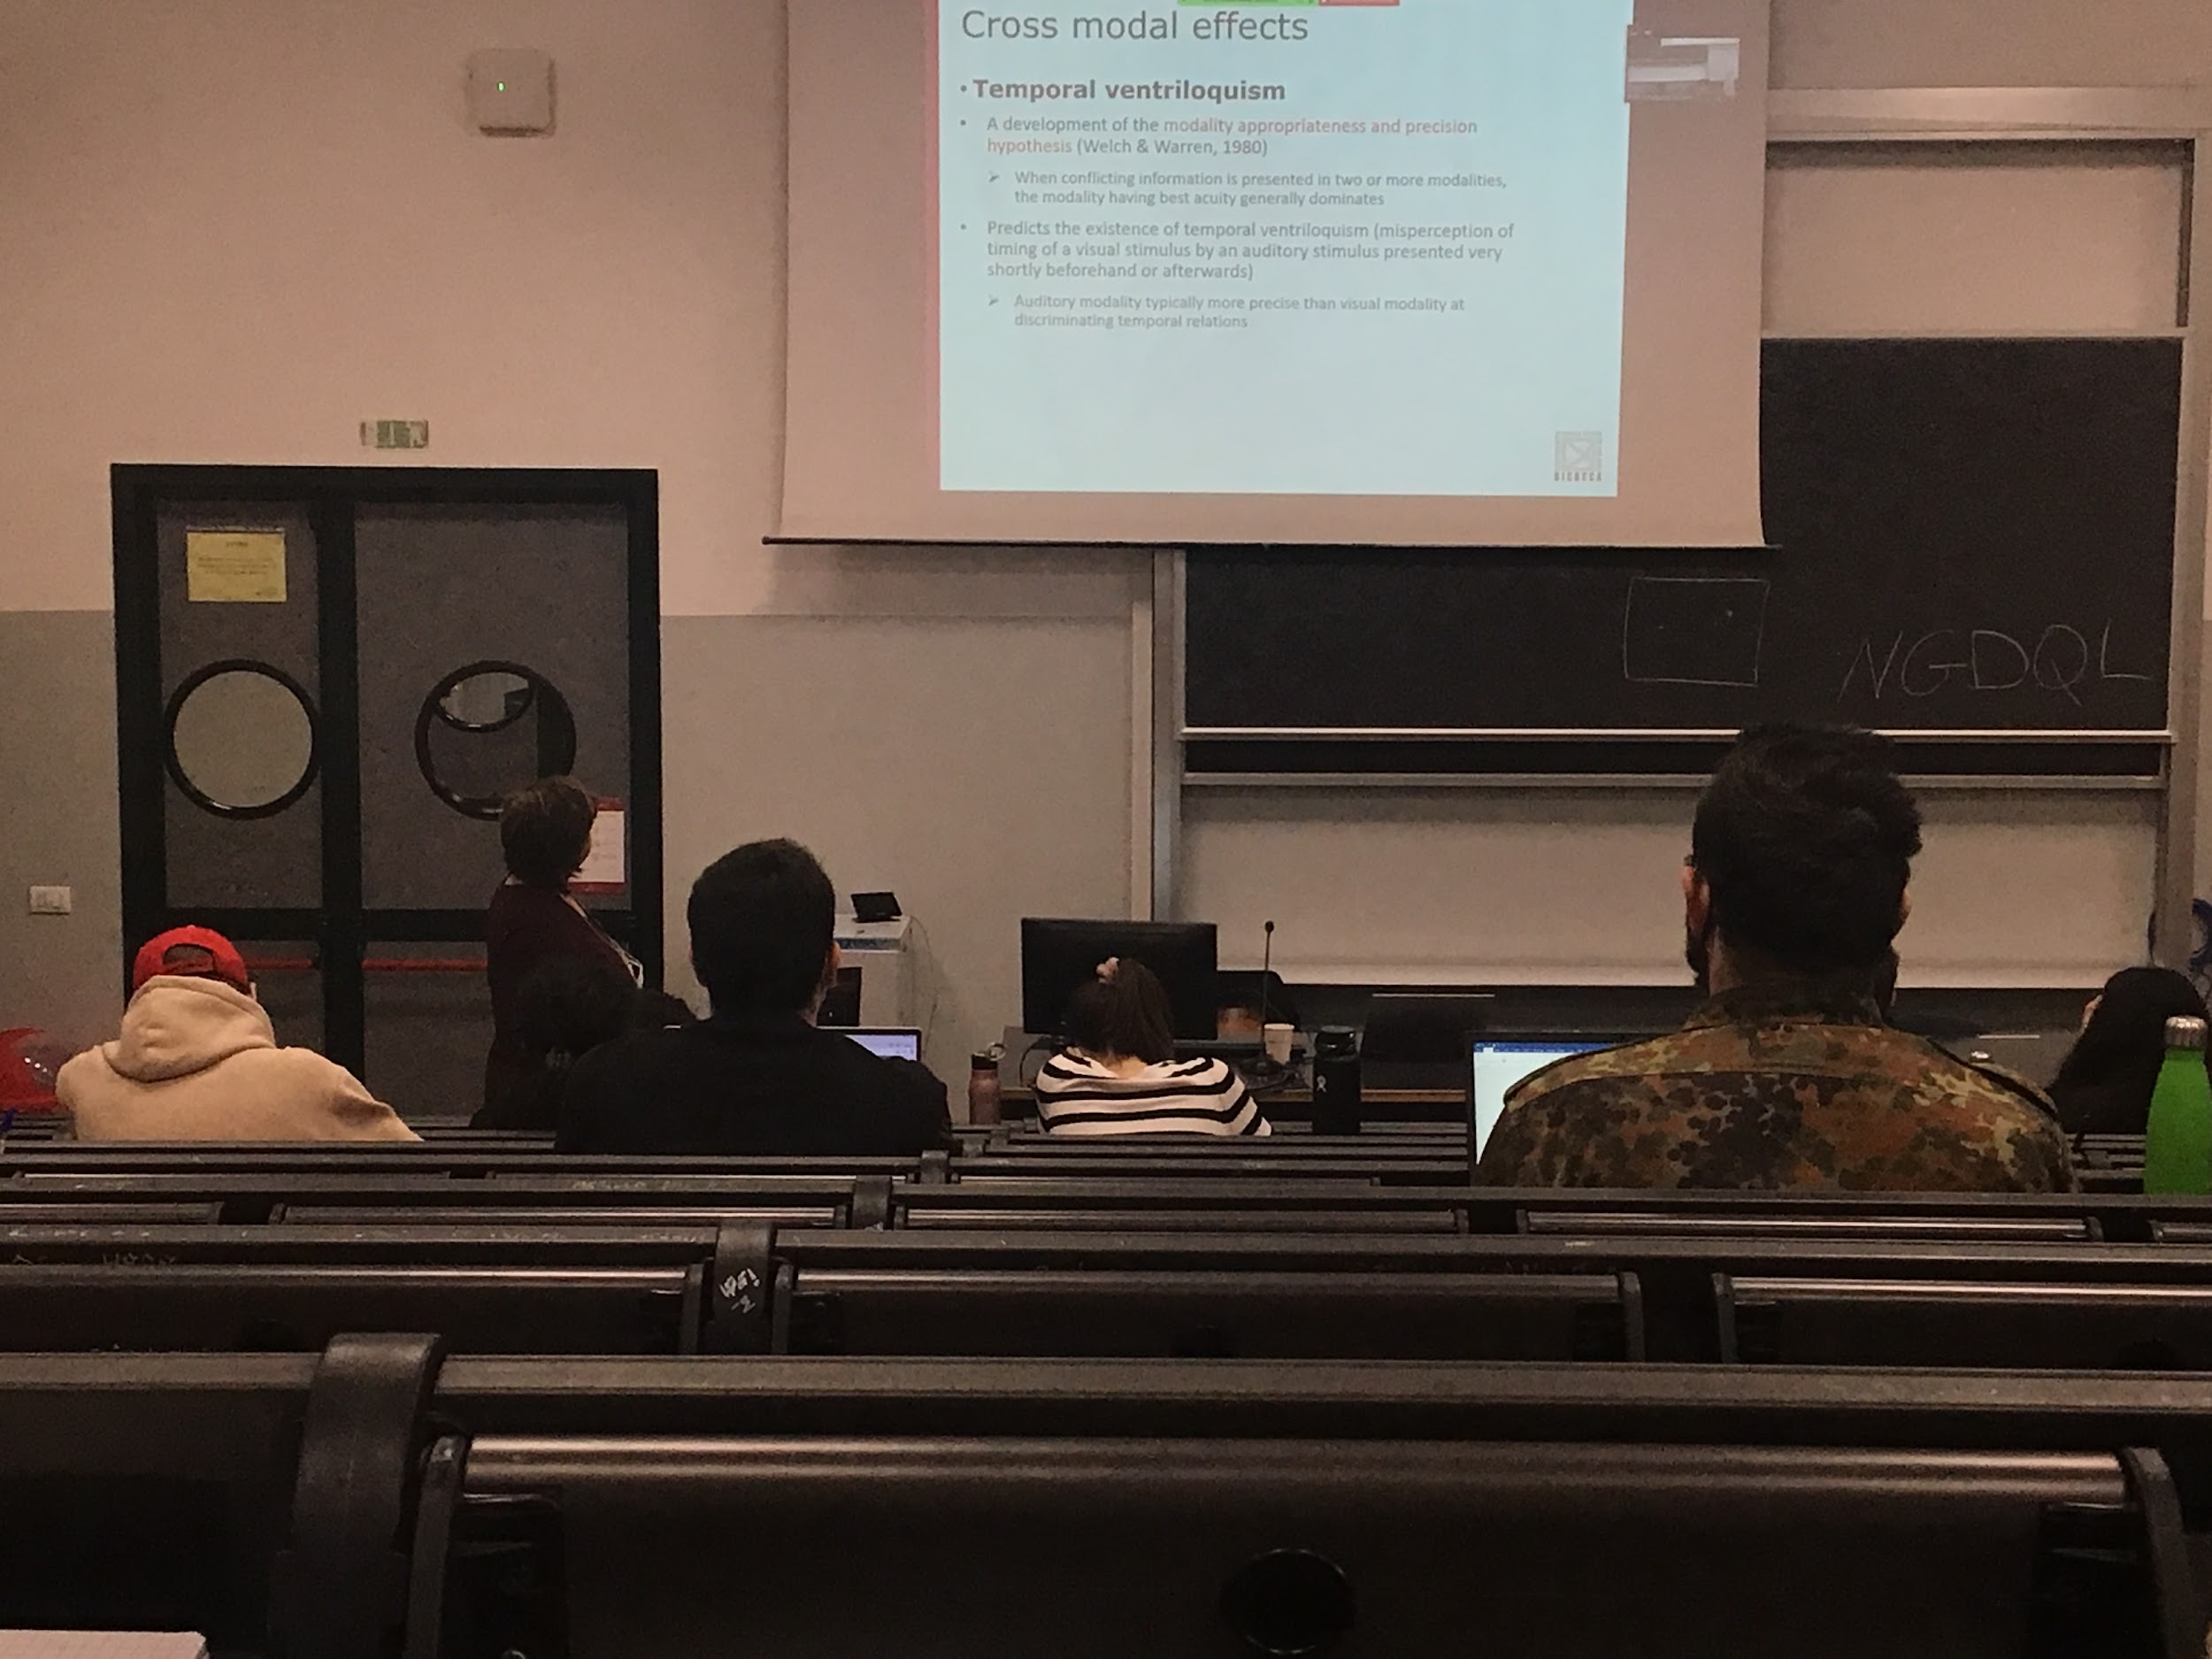

**Cross Modal effect**

We can have the temporal ventriloquist: when I show you information that is presented at different timing, offset of timing between the vision presentation and the auditory presentation, you rely more in this case on audition rather than vision. **Audition is much more precise with timing that vision is**

When you have to judge at what time a stimulus came up you really more at the sound that is associated with

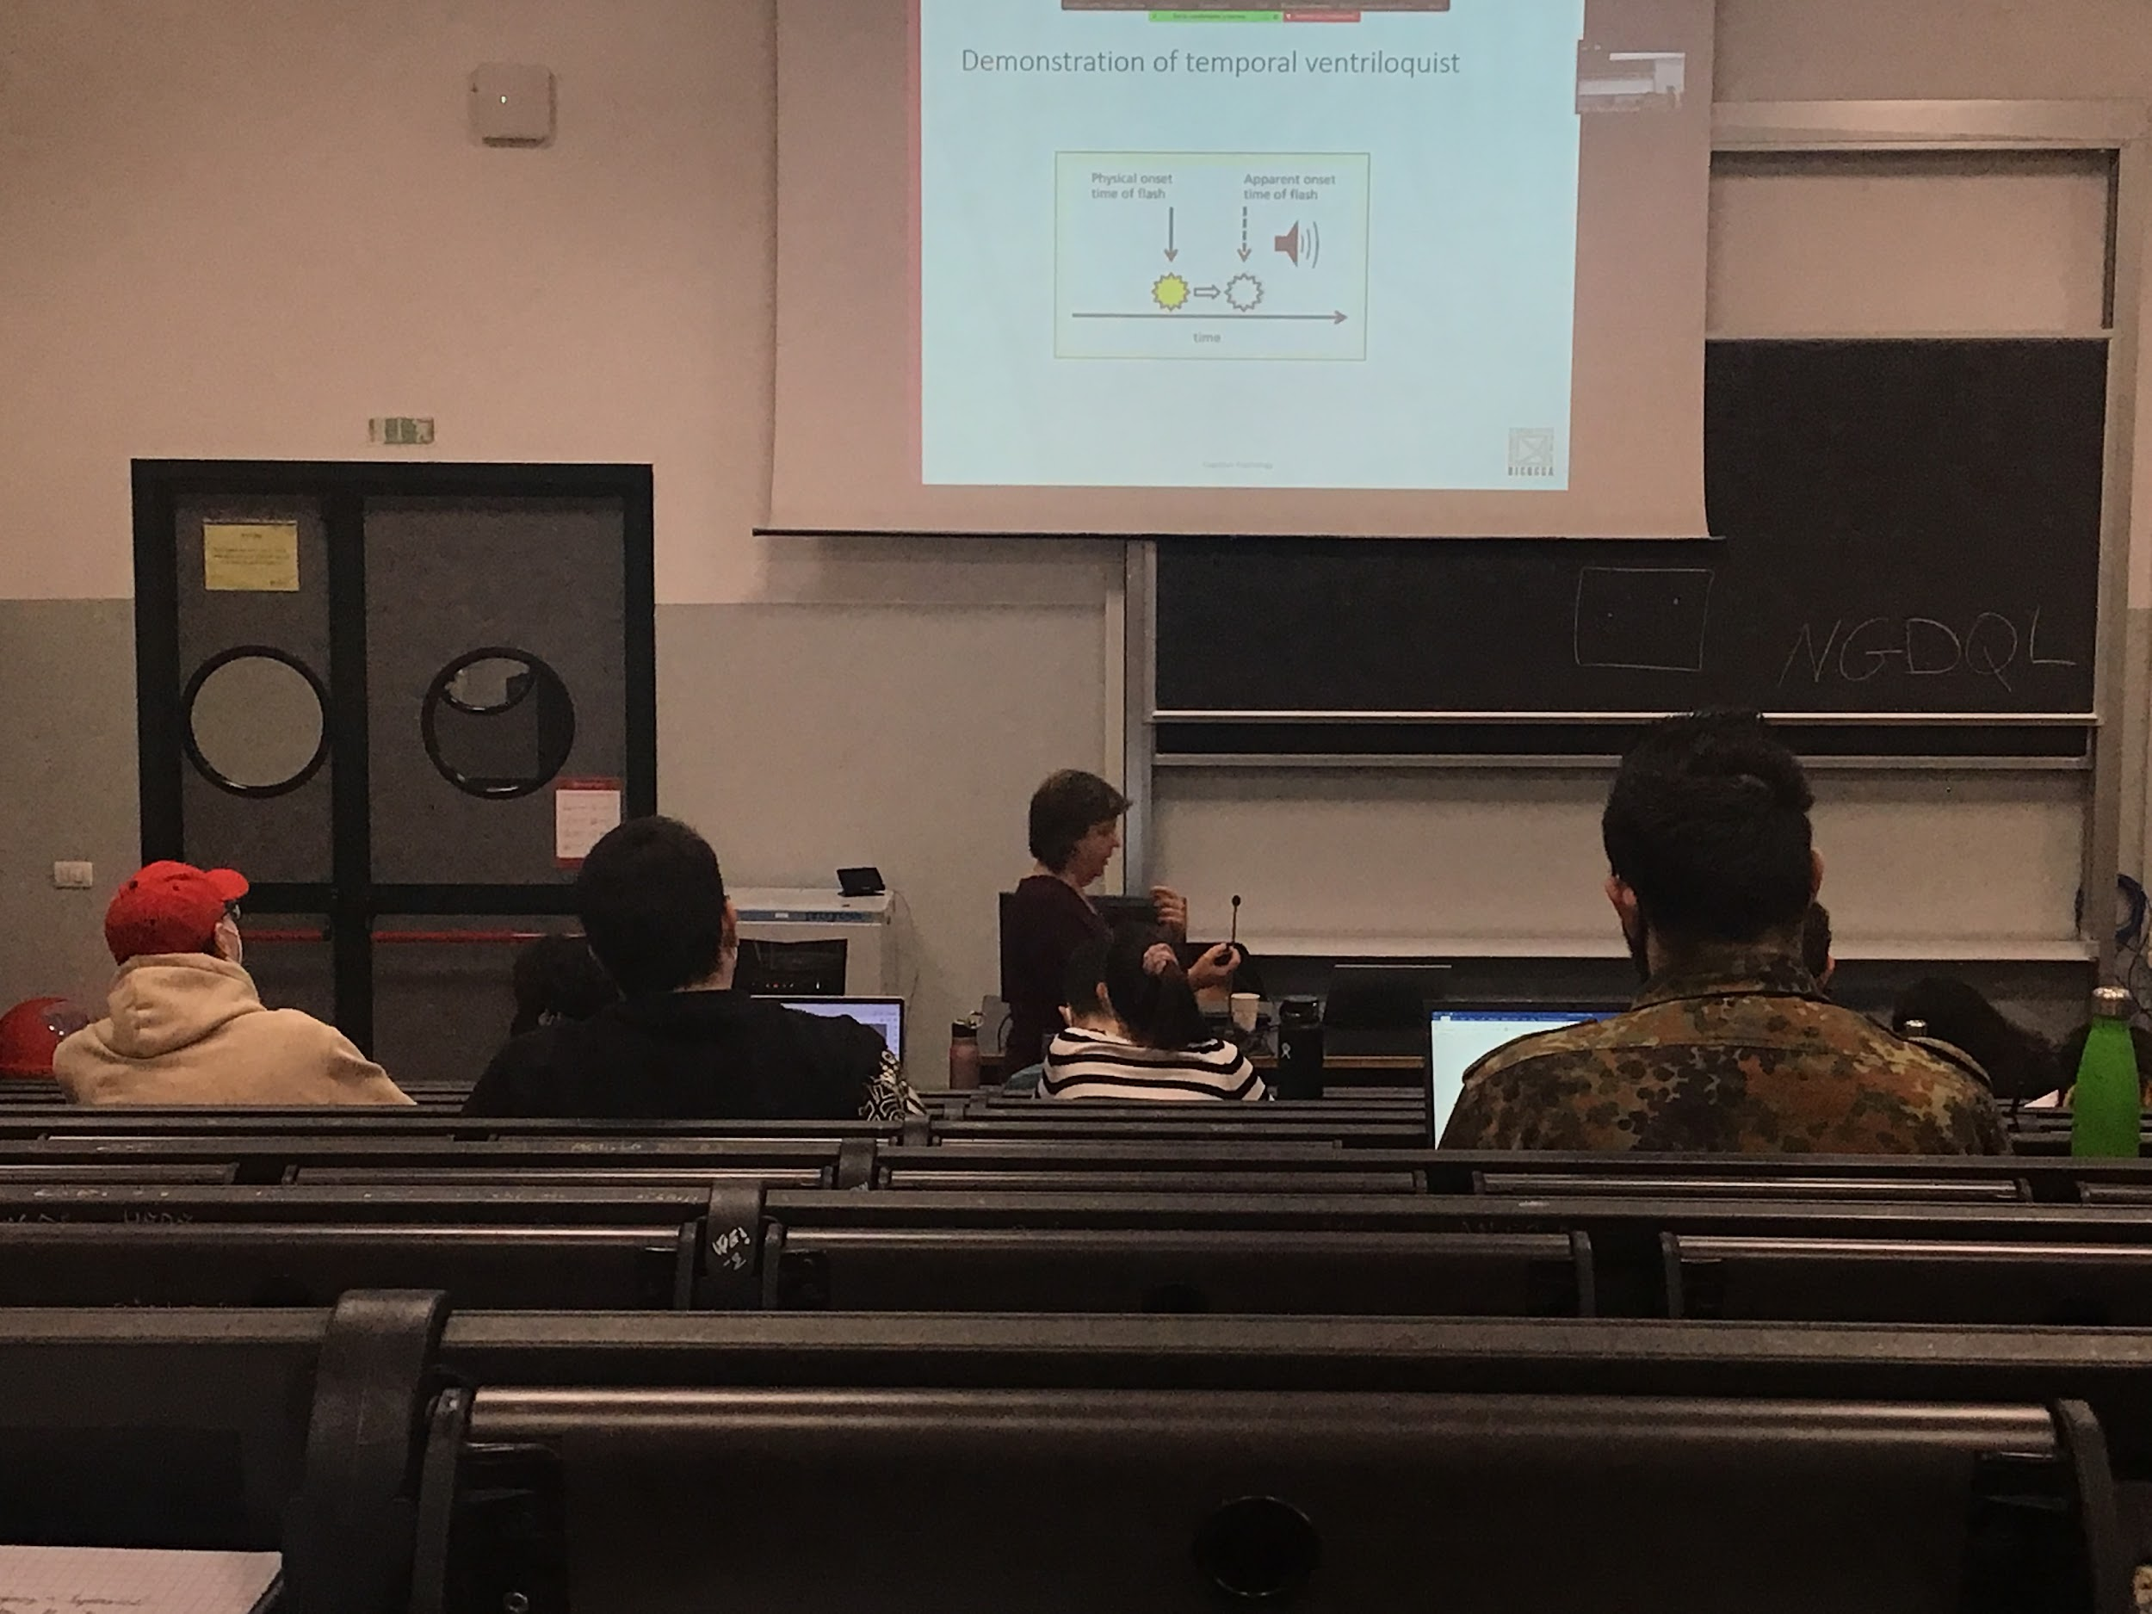

Experiment to prove temporal ventriloquist: on a screen you are presented with a flash of light and a sound. You have to tell when the flash happens.

When you see the flash alone you perfectly response (given some reaction time of around 100ms)

But if also the sound is presented together with the sound that is a little bit afterwards I misplace the visual stimulus as happening afterwards when the sound came up.

**Since the auditory modality is more precise with timing, when I present coming cross modelling information vision and audition audition wins**

When we present people with stimuli presented in different modalities even if they are not properly synchronised the system try to put all the informations together

We always try to put together the information from the two streams and even if there is no perfect synchronism it does not matter. If there is a huge one one it matters. The system can deal with little un-syncorism

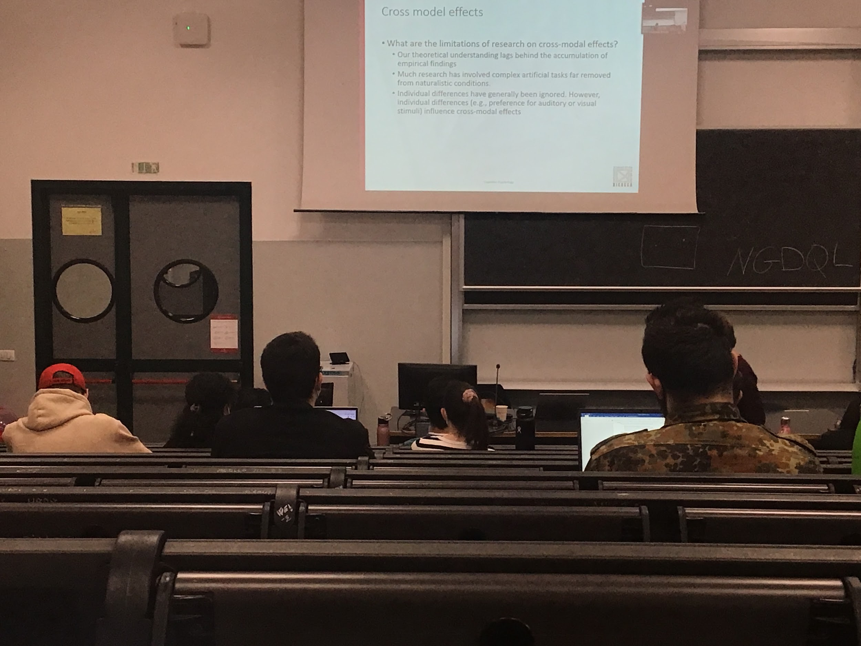

Cross modal effect not being study for a long time

We come up with theories when the experiment shows us something, we don’t know enough to make an experiment, still learningalong cross model effect. Very difficult to find naturalist situation where there is a synchronism, most of the time informations comes up all together

Very little research done in individual differences but in reality we know that each one of us have differences

Chapter 5 attention and performances

# Divided attention, dual task, performance

**Divided attention**: do different things at the same time. Try to performs different tasks at the same time

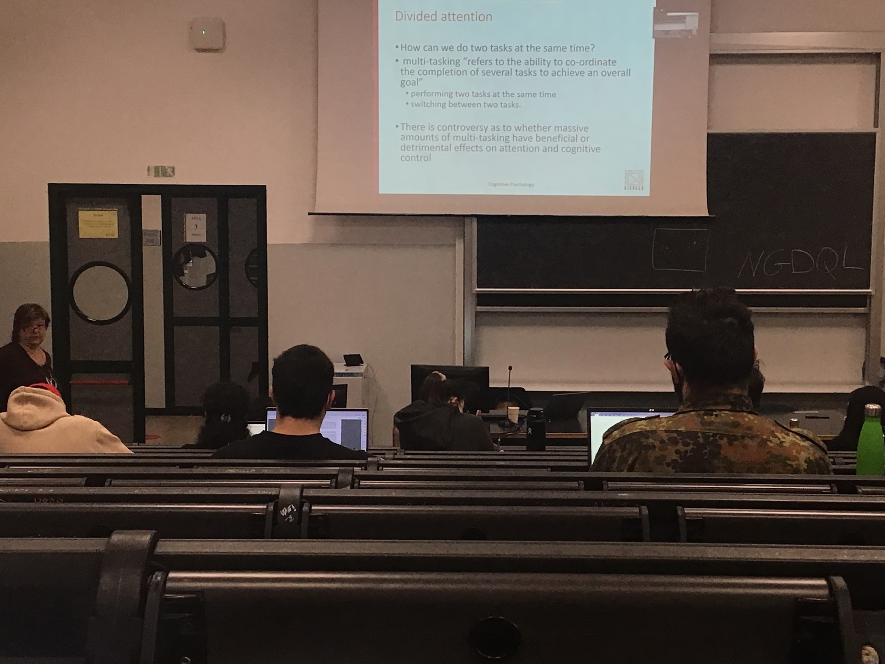

Multitasking: ability to coordinates the completion of several task to achieve an overall goal

When we have to do two tasks:

* do we **perform the tasks fluidly at the same time** or
* do we **switch between two tasks** (a little bit one, a little bit the other)

We can definitely do multitasking, in some situation is needed for our survival

If we are able to do massive multitasking are we better of? Or is it reducing our ability to obtain the goal that we are looking for?

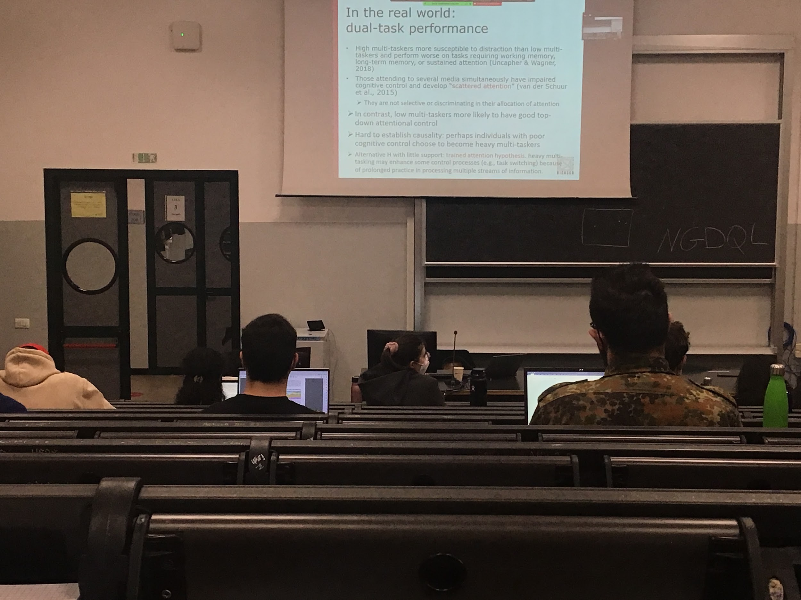

People that are able to do many things at the same time (called *high multi-taskers)* are more distracted by the stimuli, can not focus the attention very fast, and have to divide the attention over different tasks.

The interpretation is that we have **scattered attention**, attention si distributed in different parts and you are not very good if you are an high multitasked to concentrate on a given task

*Low-multitasker* (they still do multitasking, but less tasks at the same time): they have a much better top down control

Another hypothesis: if you are a very high multitasker then it means that you are very good at training our attention to move fast across tasks, so you are better. There is very little support on this hypothesis

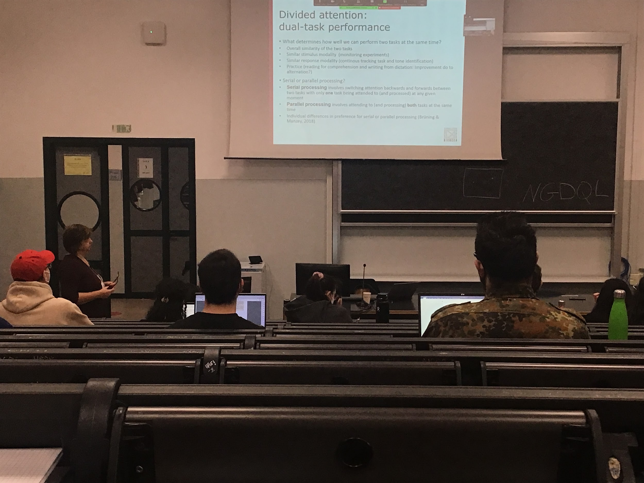

The more that two tasks are **similar** the **more difficult** it is to do them together. More dissimilar they are easier it is to do multitasking

If we have to monitor stimuli that change (visual stimuli and have to detect the longer one). If you use two streams in the visual system and you have to detect a change in both streams or a change in the visual and auditory separately, when the modality are different you are much better in respect to when the modalities are the same

**When I can discriminate the two tasks (one only auditory one only visual) I can do it best together then when both are visual**

When they have the same modalities it is more difficult.

* one hand have to track an object, follow it with your finger
* Identify a high pitched tone in the auditory stream

If you track and you answer verbally when you are the high pitched tone then you are relatively good at doing the experiment

But if I ask you to track with your finger and press the bottom with the other hand when you hear the auditory tone (I use the same modalities for responding) then you are much worse. When you try to combine together in the same modality the response you perform worst

Can improve dual task performances with practice

experiment:

You have to read a text for compression (then you have to answer some questions) and at the same time follow a dictation, after some weeks the person tested improves very well. Are they actually better at doing the task together or they become better at alternating between the two tasks?

This experiment shows two hypotheses on how we can do a dual task. Do we do it serially or parallel?

* **Serial**: listen and they you write, do two things separately, pause one task
* **Parallel**: real divided attention, splitting the resources

Also there are individual differences

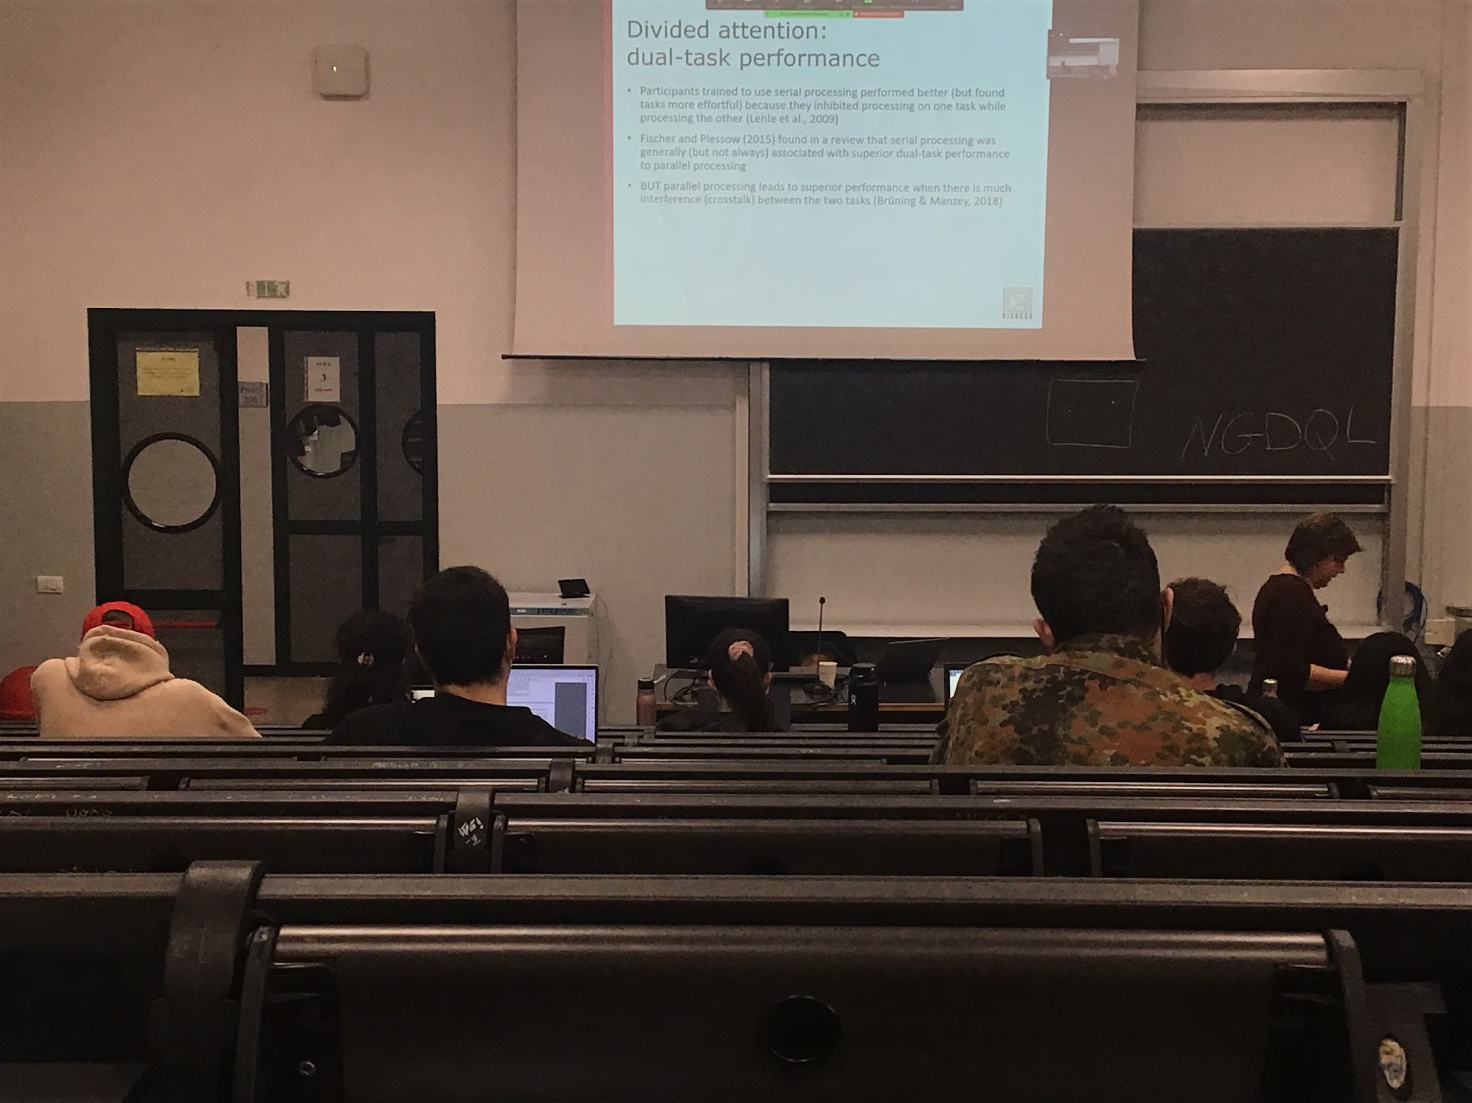

Probably both are there at the same time, you have preference for one but I can force you to use one or the other one.

We see that serial processing actually helps you to do things better. Helps you do much better, you have less interference

Usually serial processing is better than parallel processing, unless the two task are very similar (they interfere) is better to do them parallel

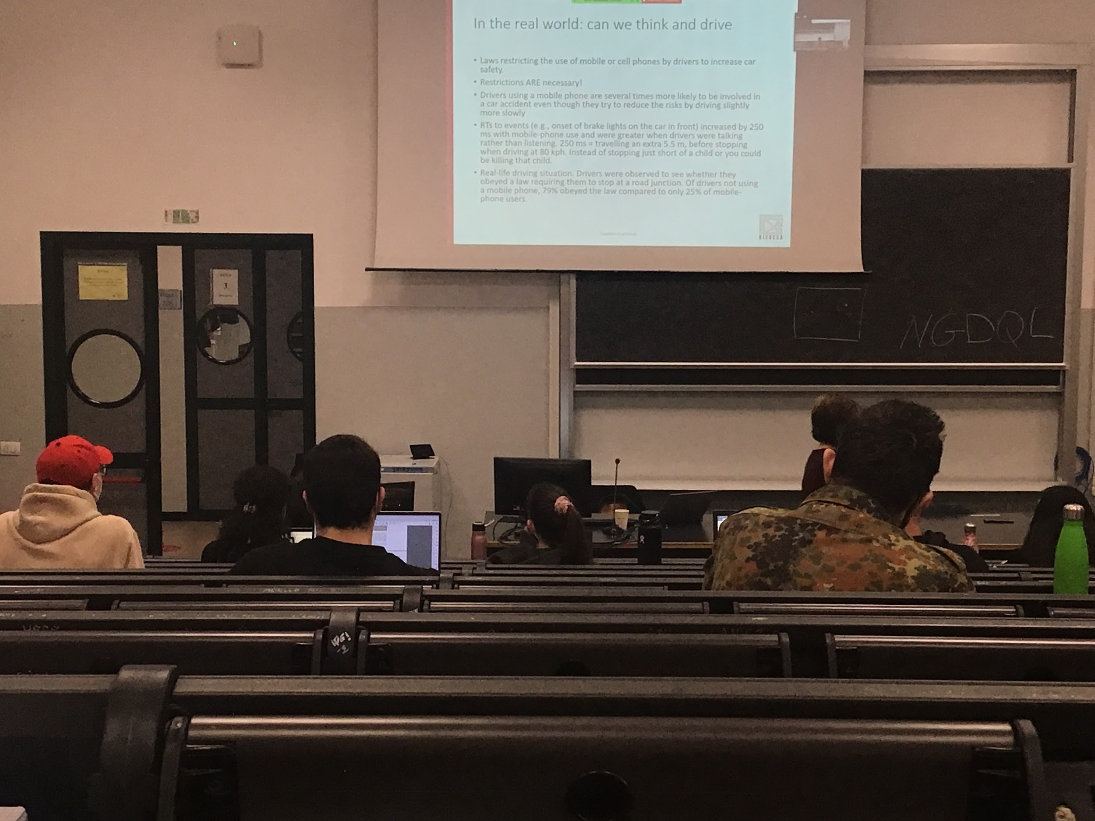

Driving and mobile cell use

Using the phone interfere with driving, even if you think you are very good

The data from research shows that there is a big problem when you try to do this type of multitasking

When you are using the phone you automatically slow down. The system understand that they can not keep going 80km/h

If I put you in a driving simulation and your task is to follow the car in front of you and to break when the car in front of you breaks. Ask people to use or not to use their phone. **The experiment shows that the reaction time to break when you have your phone is 250ms more than when you are not using your phone**, in 80km/h you make 6m

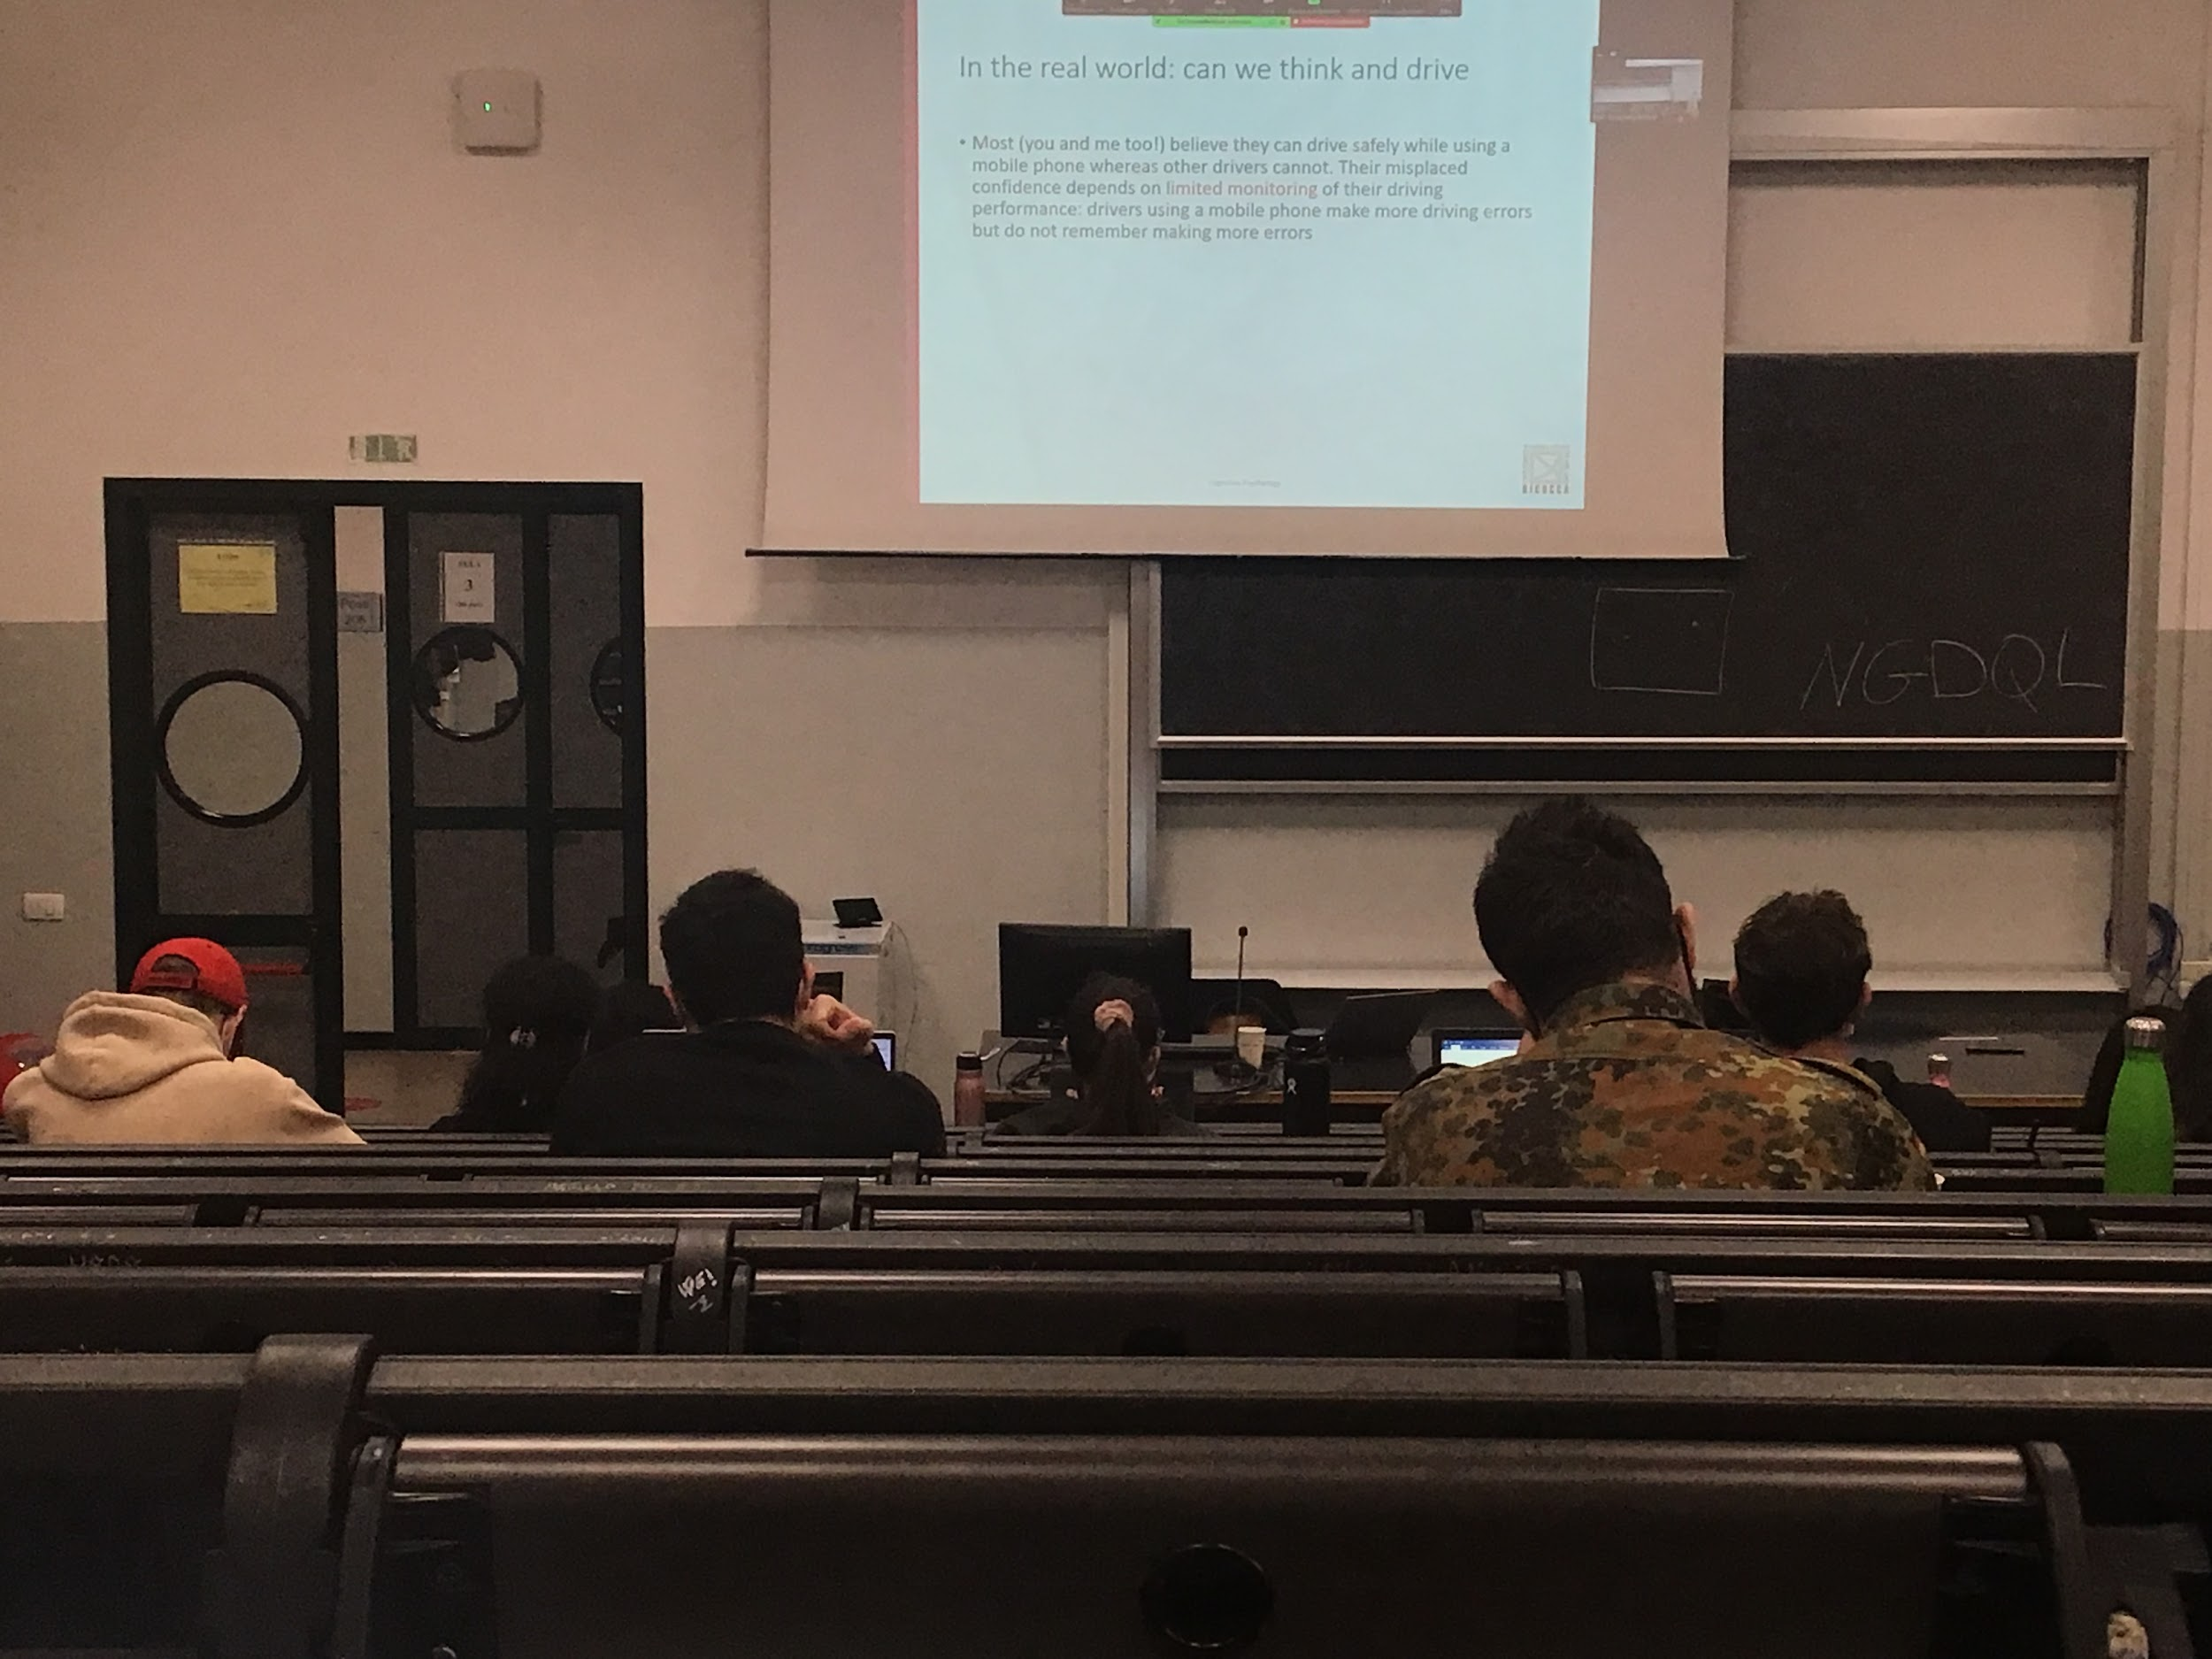

Limited monitoring: **we think you are different, we believe that we can watch the phone and ride the car**, if you are tested your **results are worse than the average**

No correspond between what you think of yourself and what you are actually doing

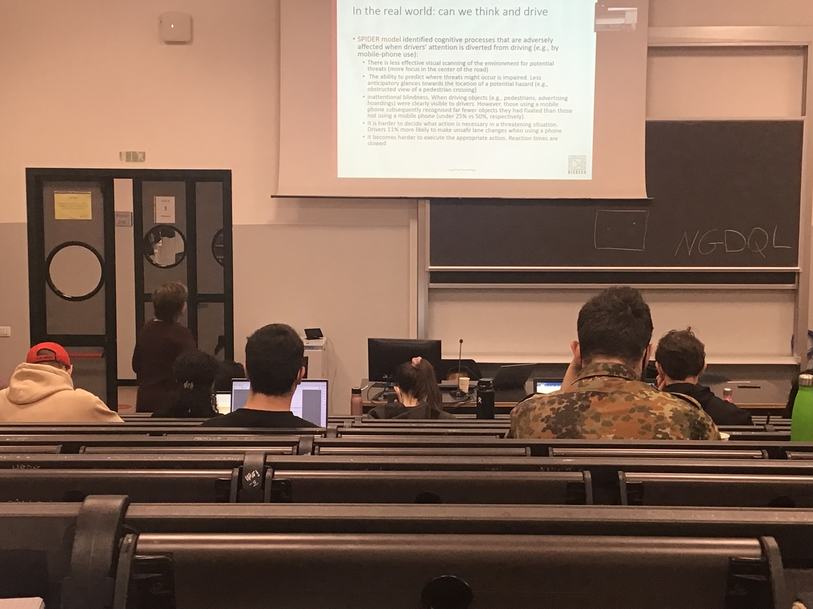

SPIDER model

You are worst in visual scanning. One way to distinguish an experienced driver from a standard driver is the way they scan the environment

Difference in how you scan the environment

If you confront the eye tracking of a 40 years experience of driving it keep scanning left and right the scene in front of you, this is essential because **we don’t have a very good peripheral vision** and we need to understand what is going on

While if you at the eye movement of someone that just started driving they focus more in the centre, they try to understand where they are going

If **using the mobile phone** we **check only in the centre**, we **don’t do lateral scanning**, this increases the possibility of an accident. Also we are much worse at predicting where something bad could happen. If you are looking at your phone you don’t monitor the position where treats could come up.

**Inattentional blindness**: if I am driving you don’t remember what you saw, even if you position your eyes on the object you didn’t realise it, if you are using your phone you did not remember you looked at your phone, your attention was on your phone

**If somethings happens you don’t have enough mental energy (or resources) to take the correct decision**, sometimes you don’t have enough time to elaborate possible solutions

Slower reaction time, have to take it away from the phone to put it somewhere else

Doing something else while you are driving creates a problem. True not only for mobile phone

The big advantage of talking to a passenger with respect of using the phone is that the passer is with you in the car, can also tell to look at one something or stop talking when you are in a complex situation

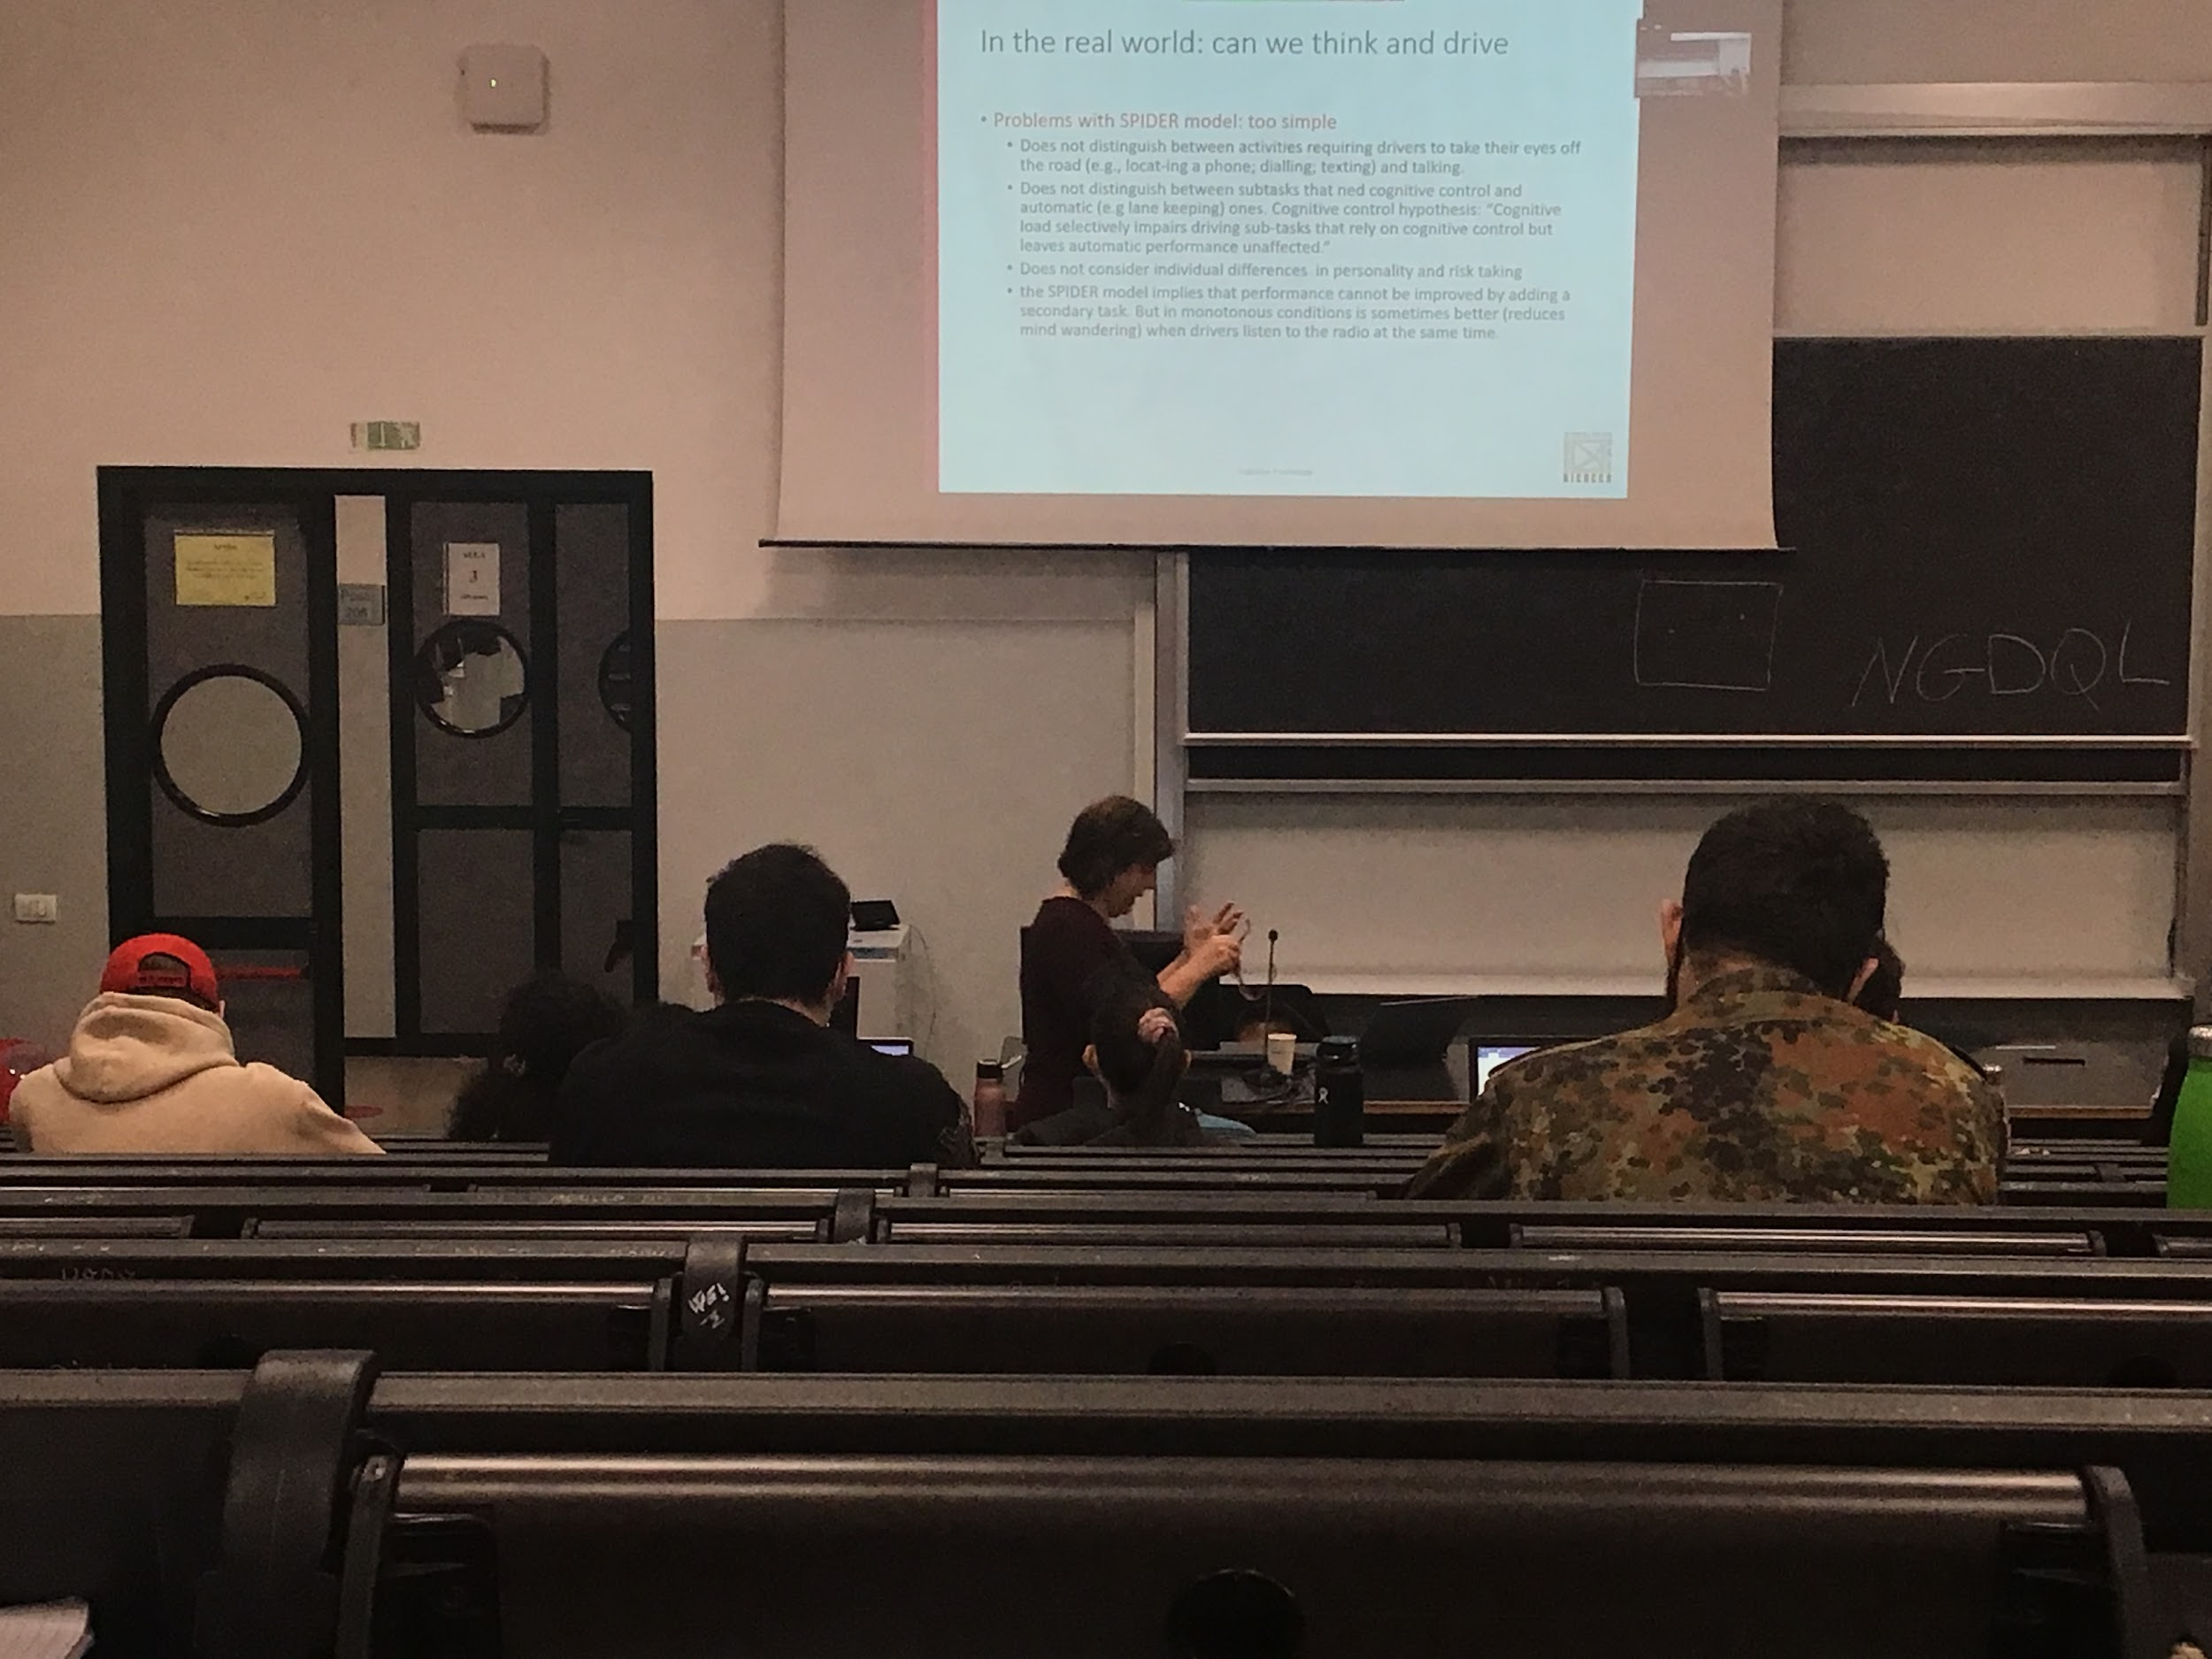

Spider model select a lot of informations that can be problematic during driving

In reality different level of interference finding the phone, diling, texting… can be more dangerous that simply talking

There are tasks that are influenced by mobile uses and others are not. We can drive while talking on the phone, the automatic actions (breaking, steering…) can be done with no problem when talking on the phone, the problem is when something dangerous happens

Anything is detrimental for our performance, in reality one double task that helps us is when we drive during the night on a monotonous road, in that case you get bored or sleepy, in this situation having the music (especially high temp music) keeps you awake, activates your system. Sometimes doing something else is useful (but in very specific condition)

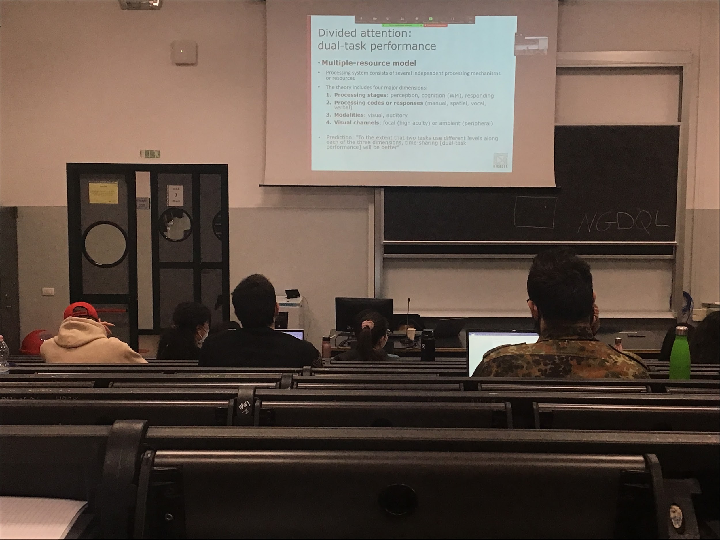

Model proposed for the way we do dual-task:

**Multiple resource model**:

More similar the tasks are more interference there is, so it becomes more difficult

There are 4 measure dimensions that you should consider, different processing states. We start from perception, the we use working memory (cognition, to elaborate informations), then we responds

3 steps when you perform a task, different and sequential

If we are in one strange in one task and in another stage in a different task it is easier to make them together, because we are using different resources.

Differences also in the processing responses

The information that comes in can be either spatial or verbal. **Easy to do tasks that requires one spatial and one verbal informations**. If the responses are different easier to discriminate

In the visual channel we have two different areas

* **central**: high acuity
* **peripheral**: low acuity

If the tasks are one in the central and one in the peripheral it can be very easy.

Multiple resources model: the extend of to tasks in different level along each of the 3 dimensions (perception, spatial, auditory) then we have better time sharing

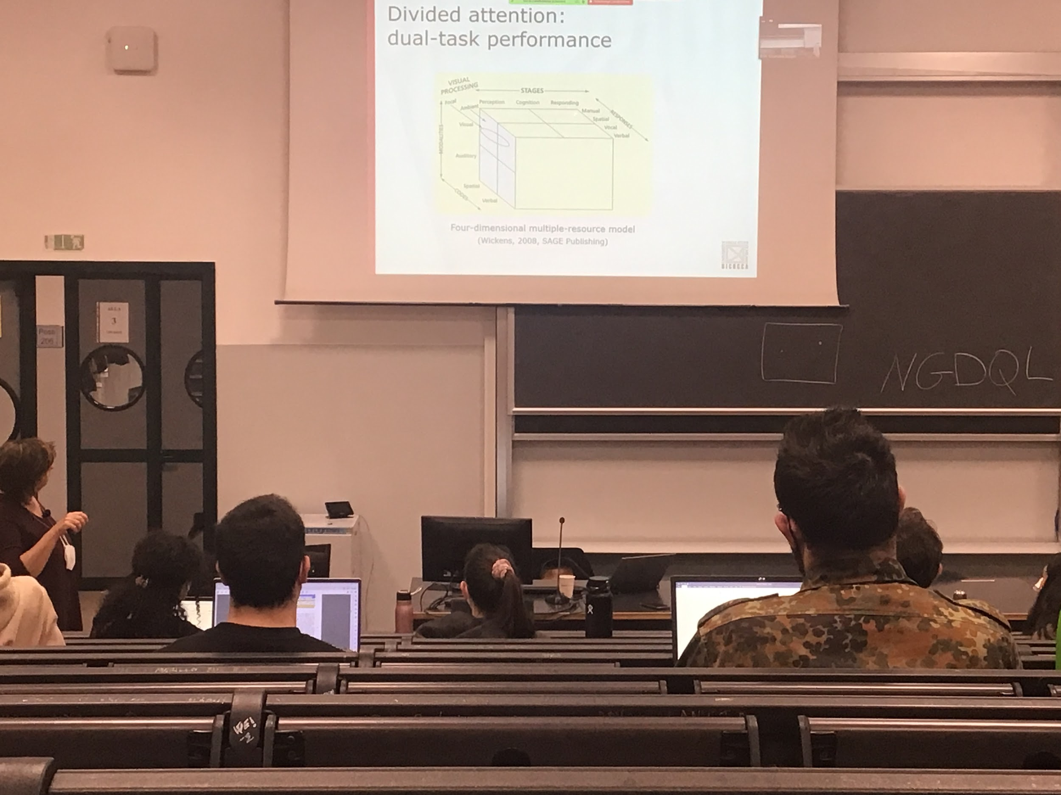

When one task occupies one part of the queue and another task occupy another part, we can do the task well together we are using completely different resources

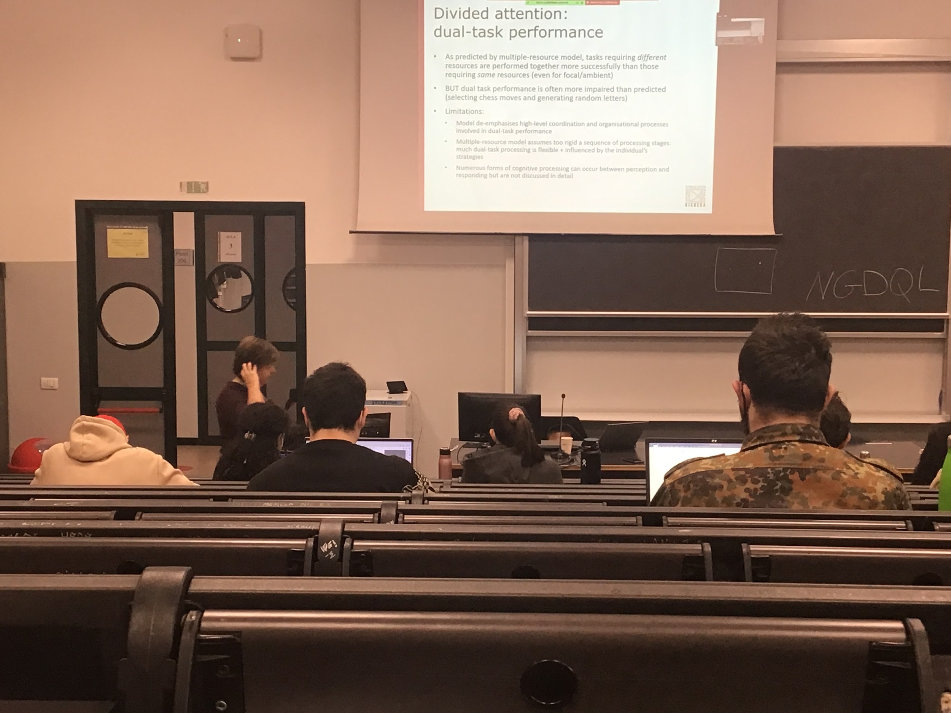

Data in favour of this model: tasks that requires different resources are performed together better then those that requires the same resources

Not always true, there are some exception

If you have to decide to do a chess move and manually perform it, and at the same time generate random letters. It should not have anything that interferes. But we are very bad

If the two things are separated we can do it well together. **Idea that the stages are completely different but it is actually not true**

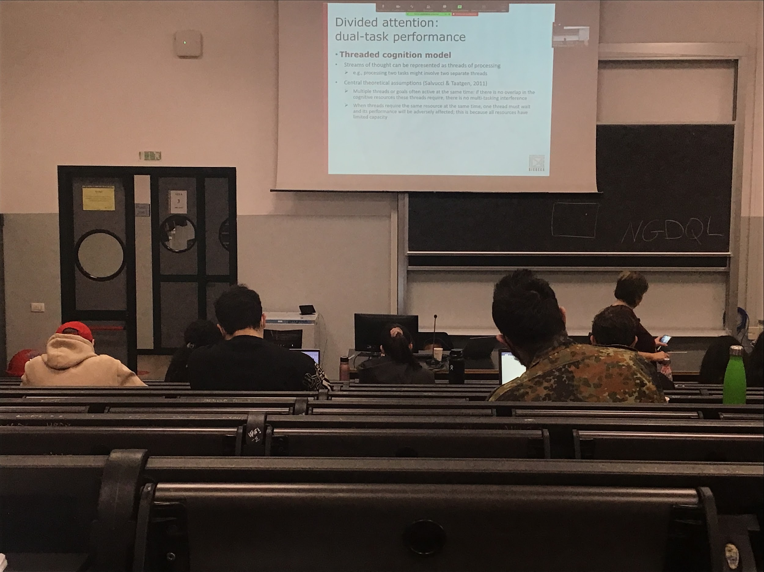

**Threaded cognition model**:

Each task is associated to the stream of thoughts

If there is **no overlap of what these two threads need, we can do them at the same time**. When we need for the two treats the same resources we have to stop one and wait for the other to complete

More details instead of the other model. We can use and work in parallel but each can be used by only tread. If one treats uses visual perception the other have to stop

It associates to the different resources brain areas. It is so specific that we can make simulations

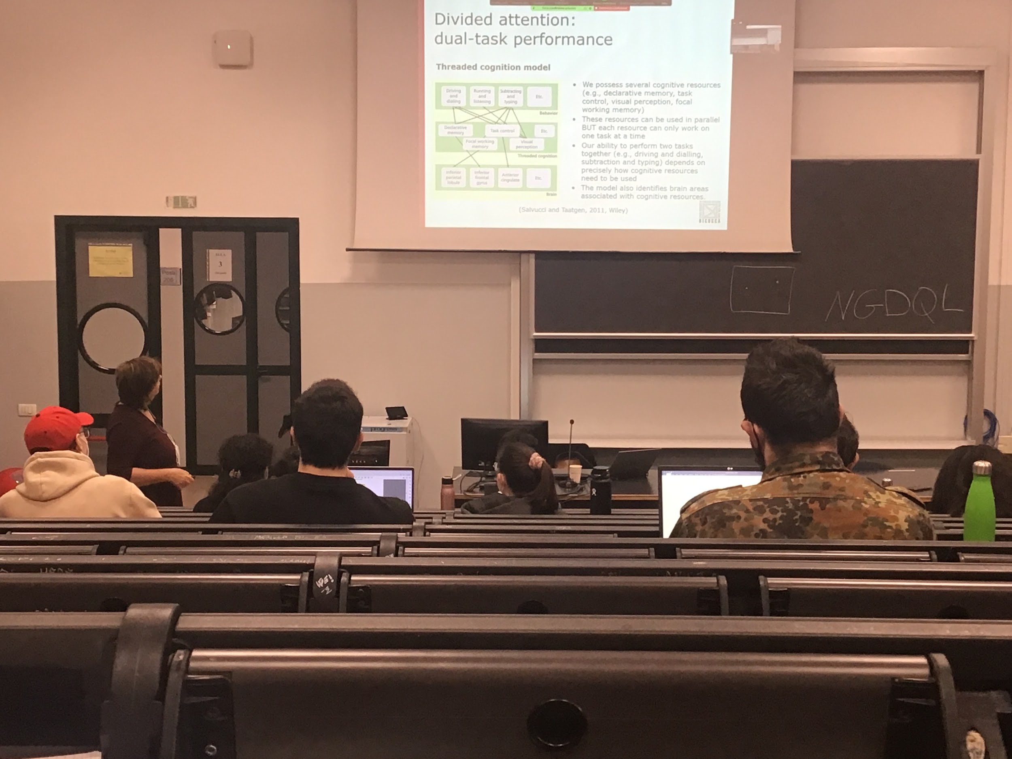

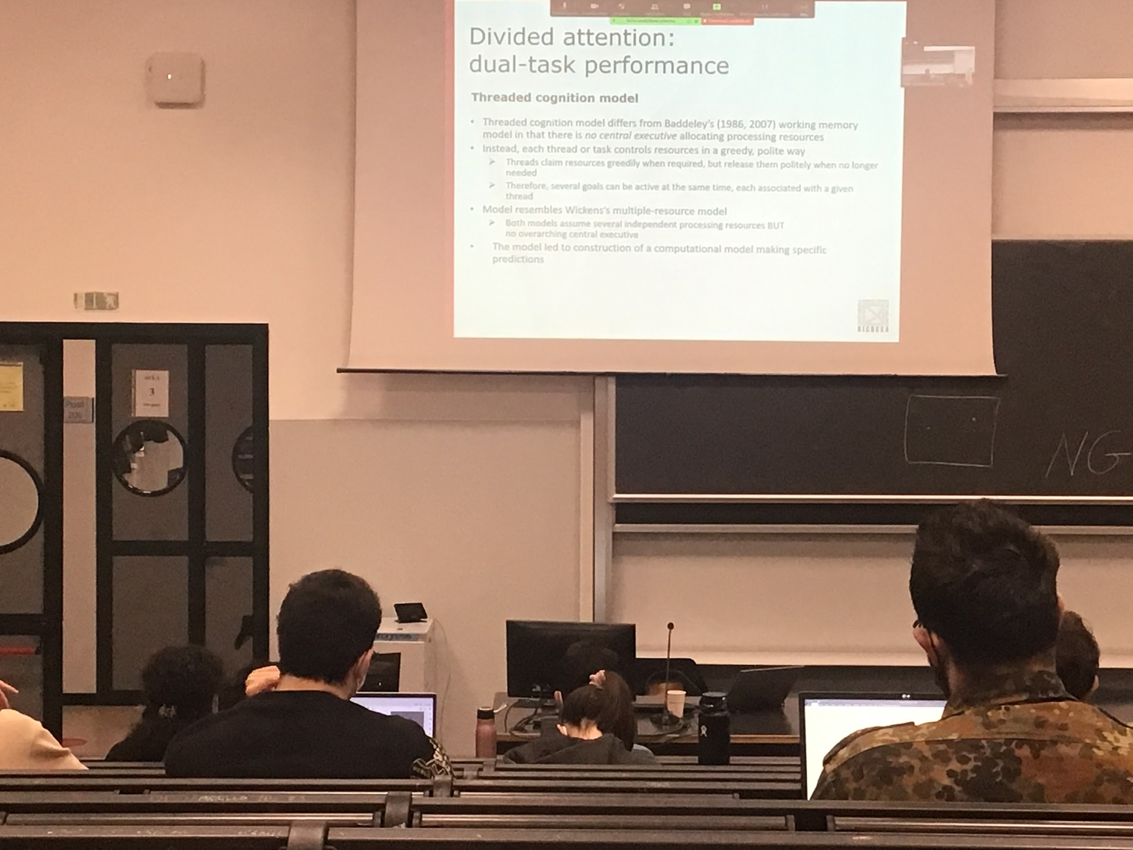

Each tread works in a threaded and polite way. When I need resources I use it and I take everything for me, don’t give space to another tread. But as soon as I use it is free for the others treats

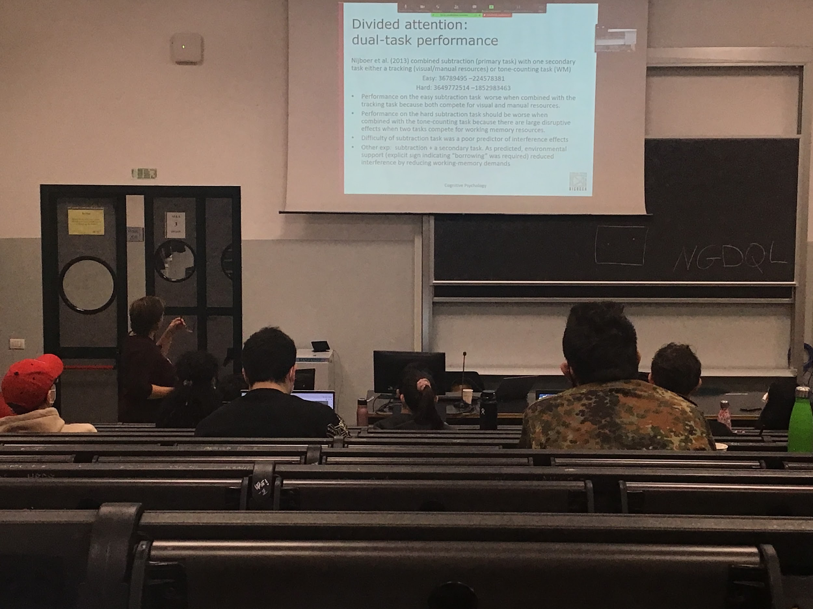

Easy task subtraction does not require the *riporto*.

There is a completion of some kind of resources and is in favour of the tread model task

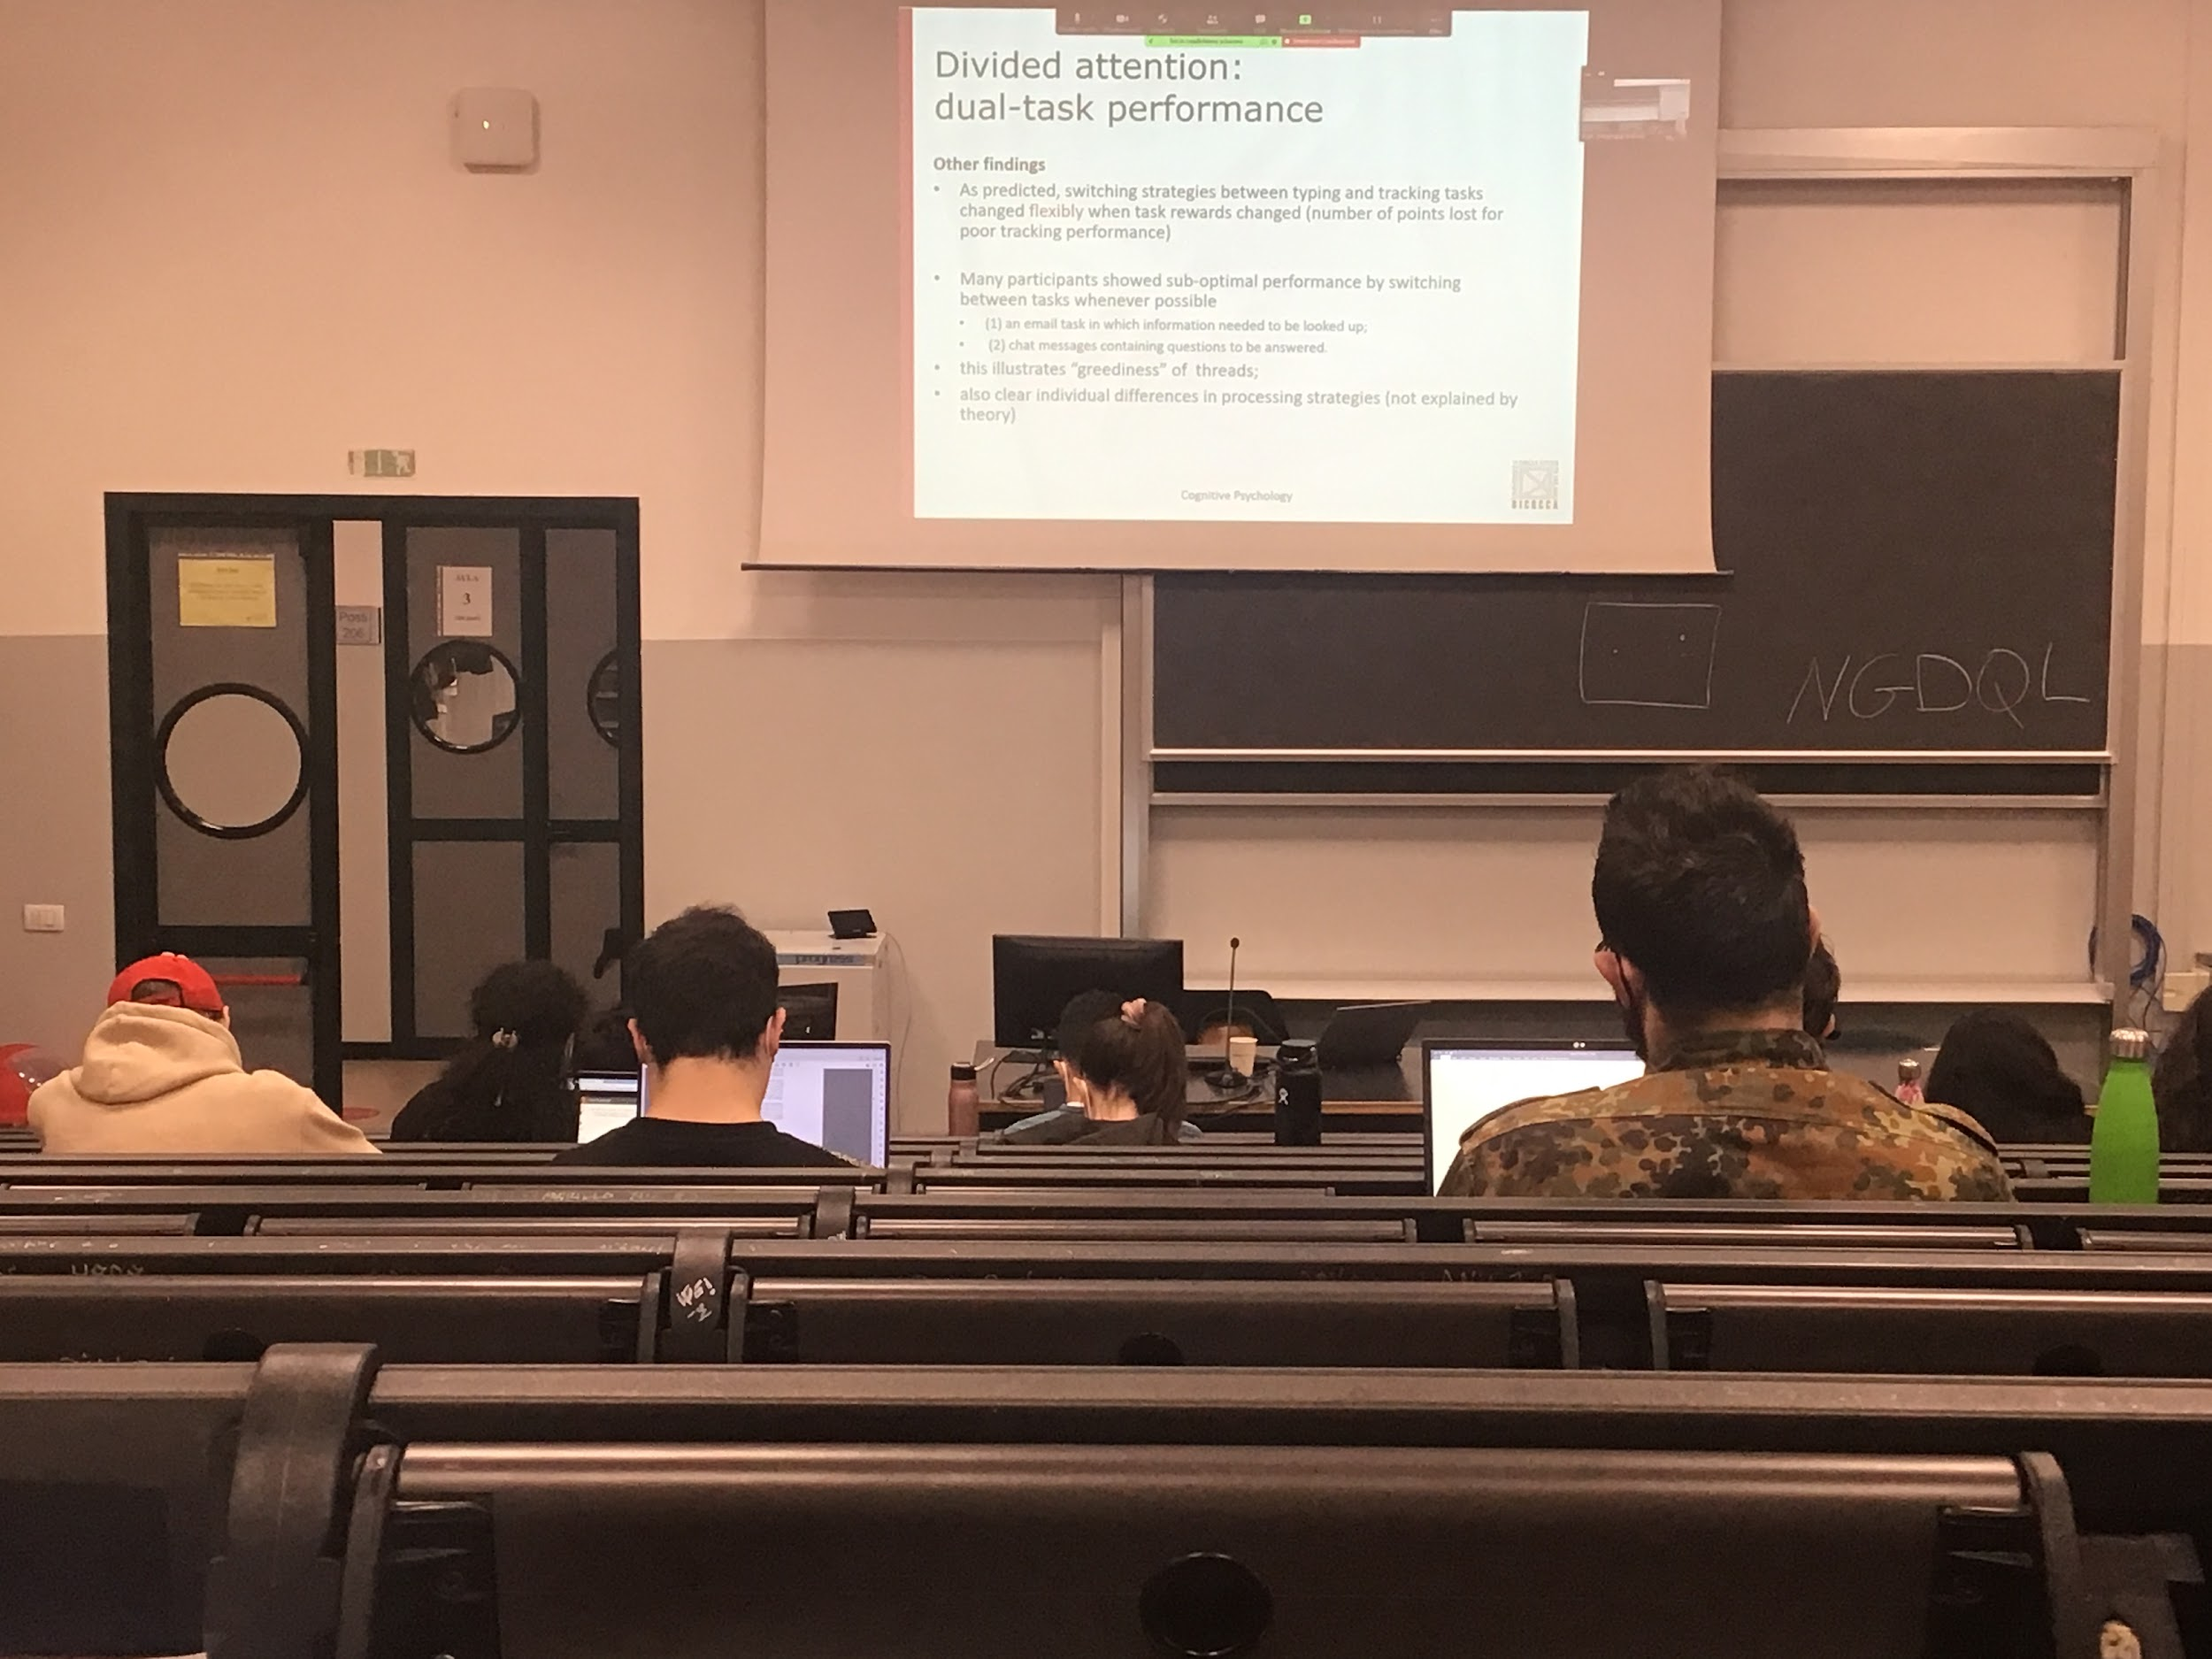

switching strategies between typing and tracking can be done depending on what I give you as a reinforcement. If I give you a prize when you do a task with respect to another one you can change, you **can decide where to assign the resources to work more on one task with respect to another**.

If I ask you to do two task at the same time (reading emails and answer with messages are in alternation, requires the same responses) when you switch to the other task every possible moment your performance is worst, you **lose some informations** (but there are some personal differences)

Model successful, help to identify what are the important resources and it associate brain areas, enable us to test whether some specific brain areas are needed in some specific tasks

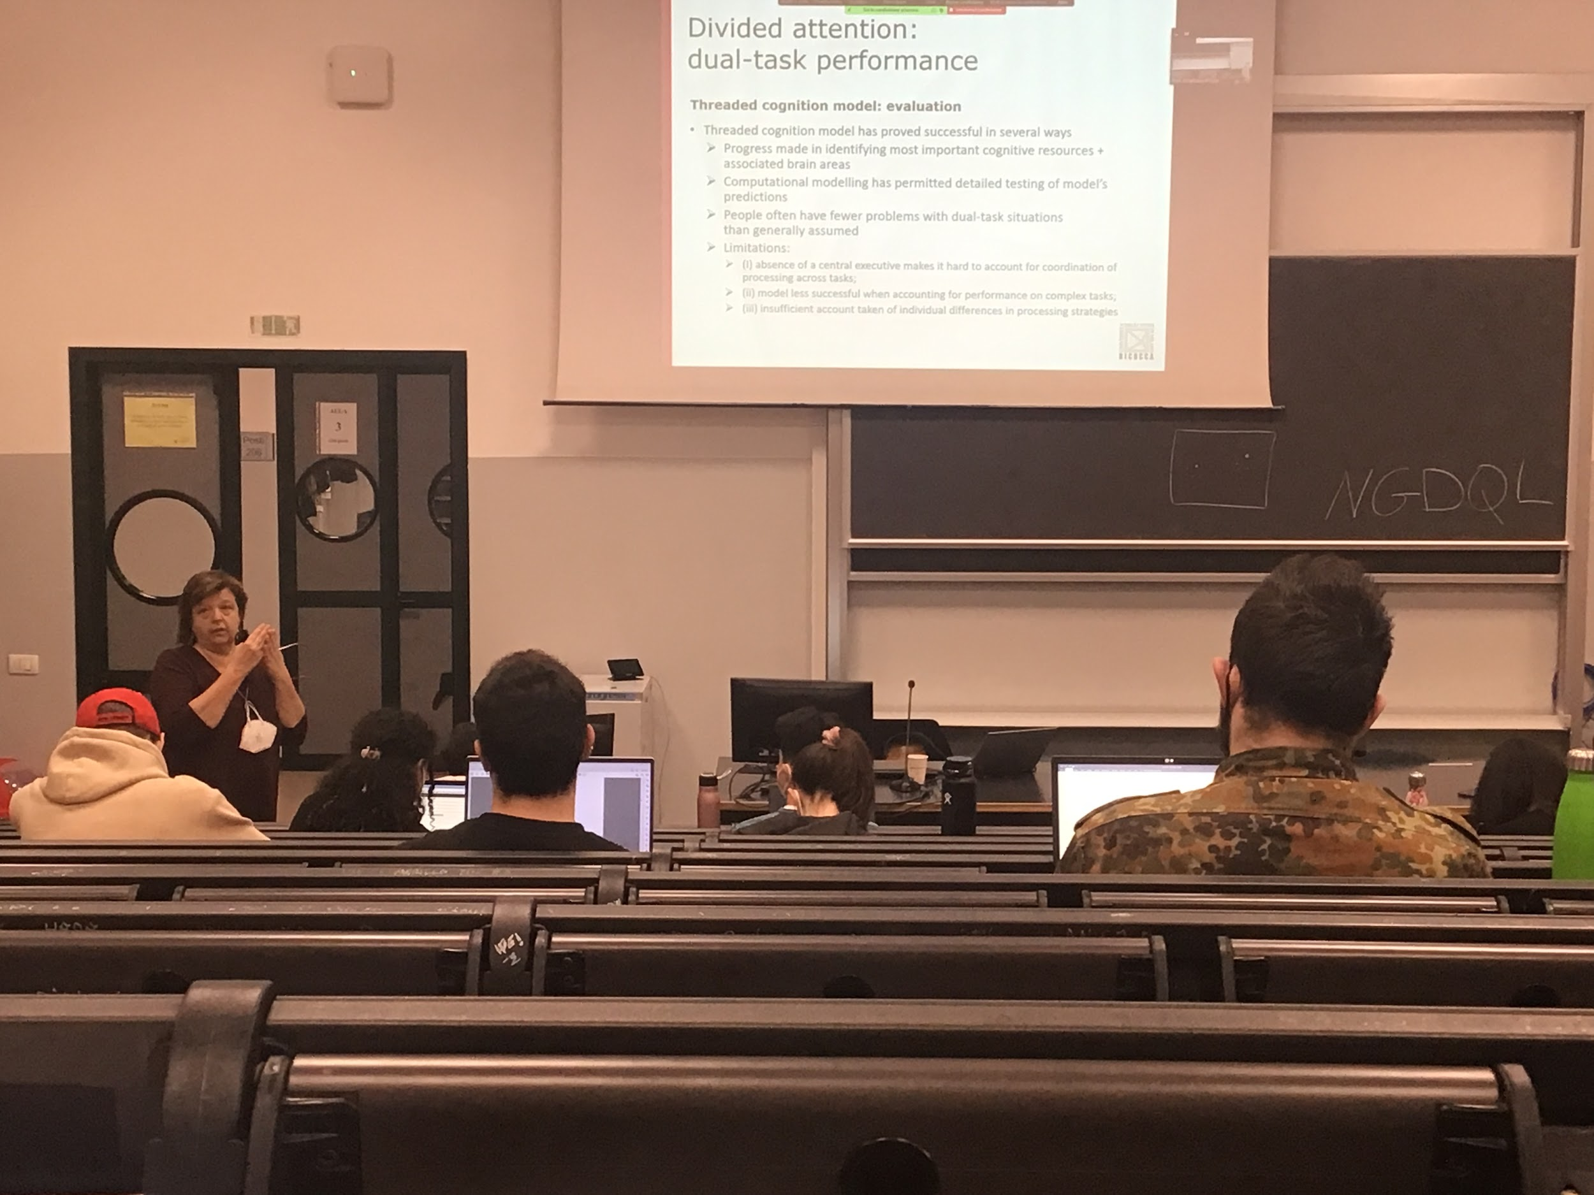

People have fewest problems with dual task in respect of the previous models

There is **no presence of a centre executive that decides what kind of process goes first**

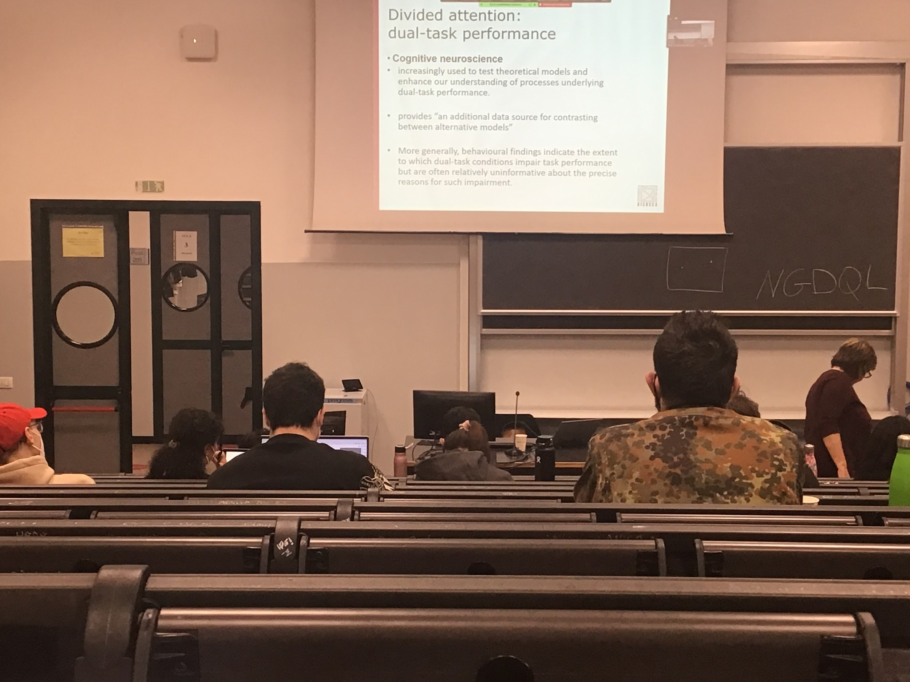

**Audio 3**

Cognitive neuroscience can help us stress some theoretical prediction

Predicting different areas were associated with different resources, using cognitive neuroscience techniques, using FMRI to see activation in different areas can help us to understand what is going on in our brain when we do different tasks. Can help us discriminate between different models

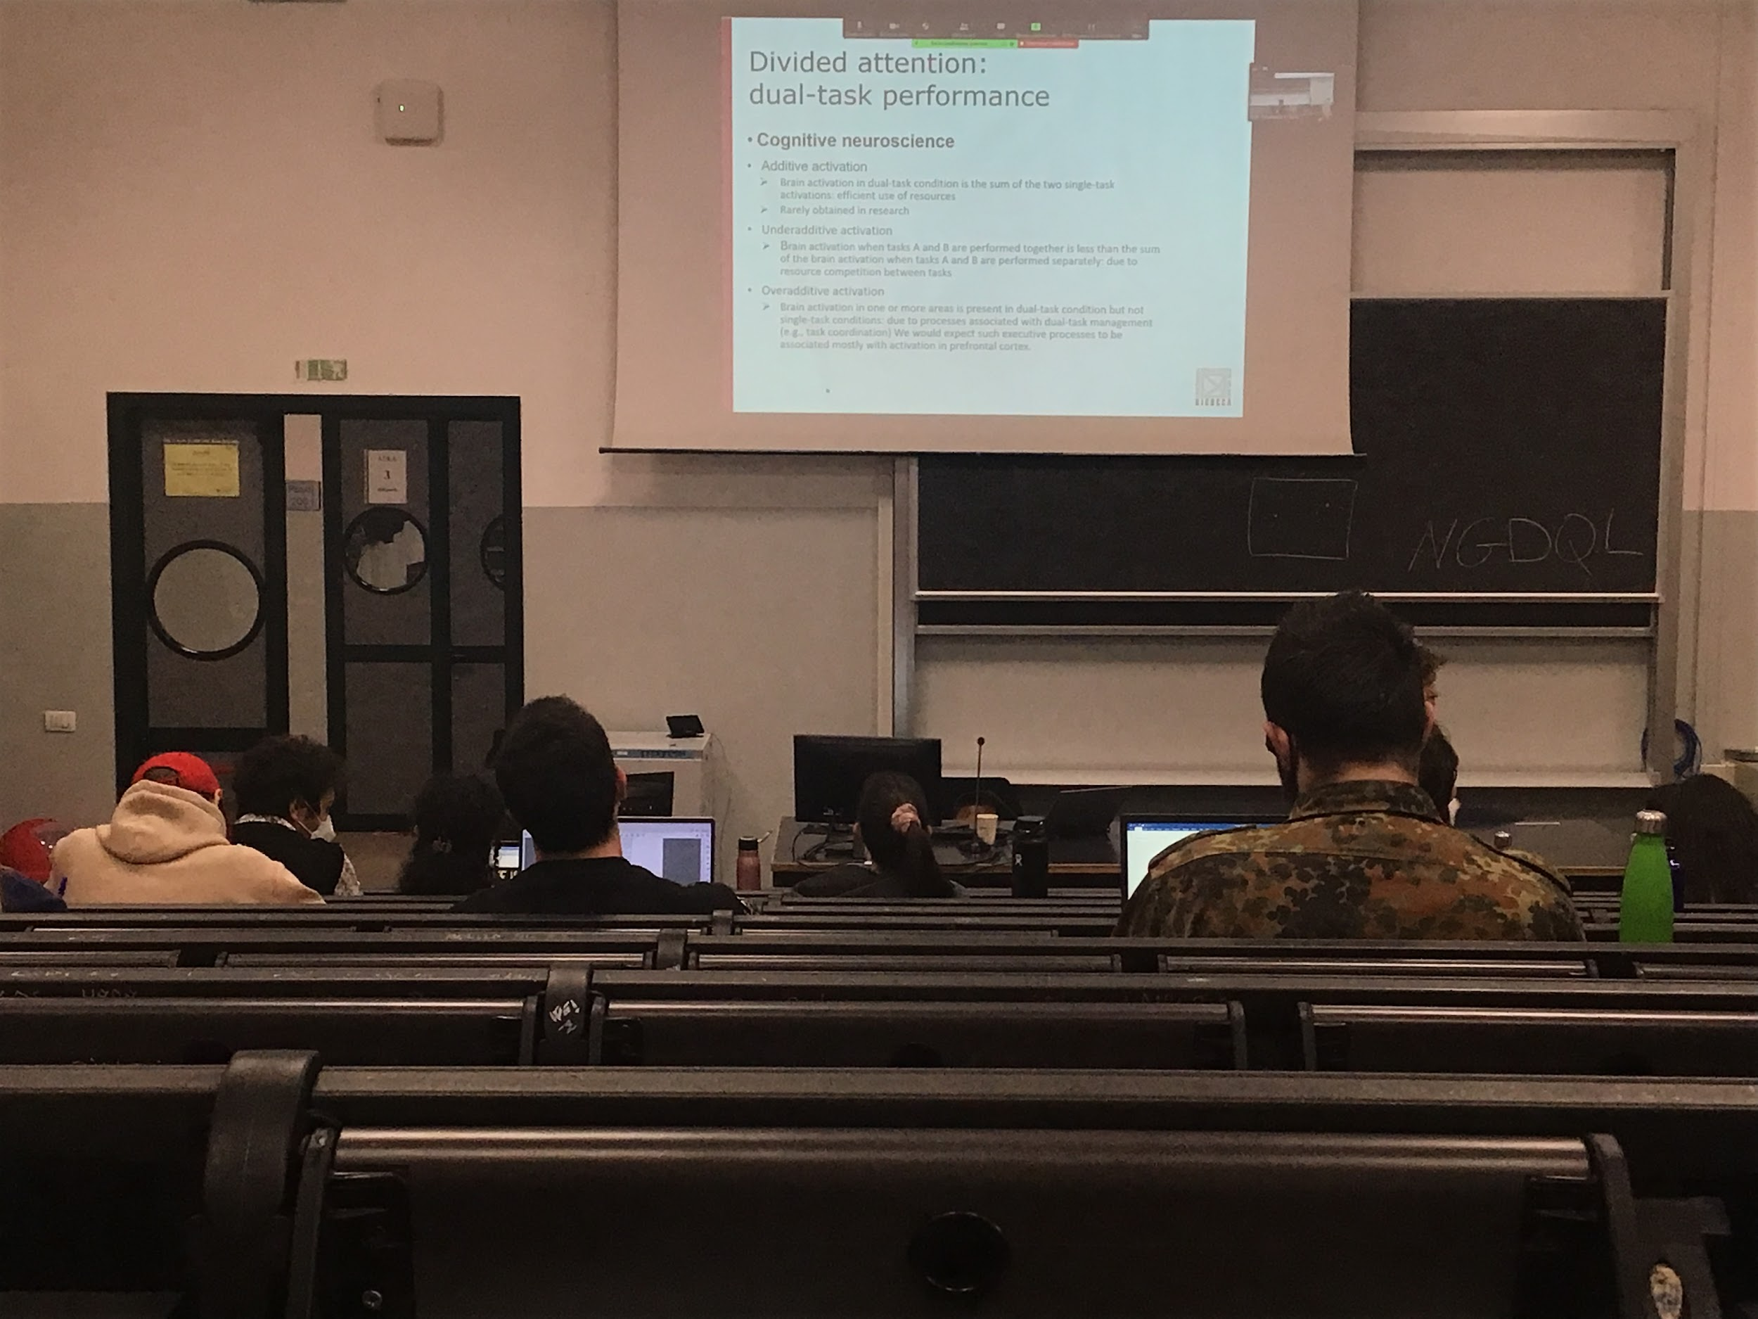

Cognitive neuroscience techniques

We have subjects in the scan doing single task alone and then try to do both task together

**Difference in the brain when doing one task singular and 2 together**. 3 possible activation that we can find

* **Additive activation**: single task there is some activation when both tasks together there is the sum of the two signal tasks. Most efficient use of resources, when we are doing two tasks together we are actually using the same brain that we are using when we do both tasks separately
* **Underadditive activation**: the activity is less than the sum of the two activities separate. There must be some **competition between resources**, one of the two is not optimally used
* **Overadditive activation**: find brain areas that are active only when doing 2 tasks at the same time, no activity when doing the tasks separately. We usually find activation in the frontal area (usually coordinate information and where we make decision)

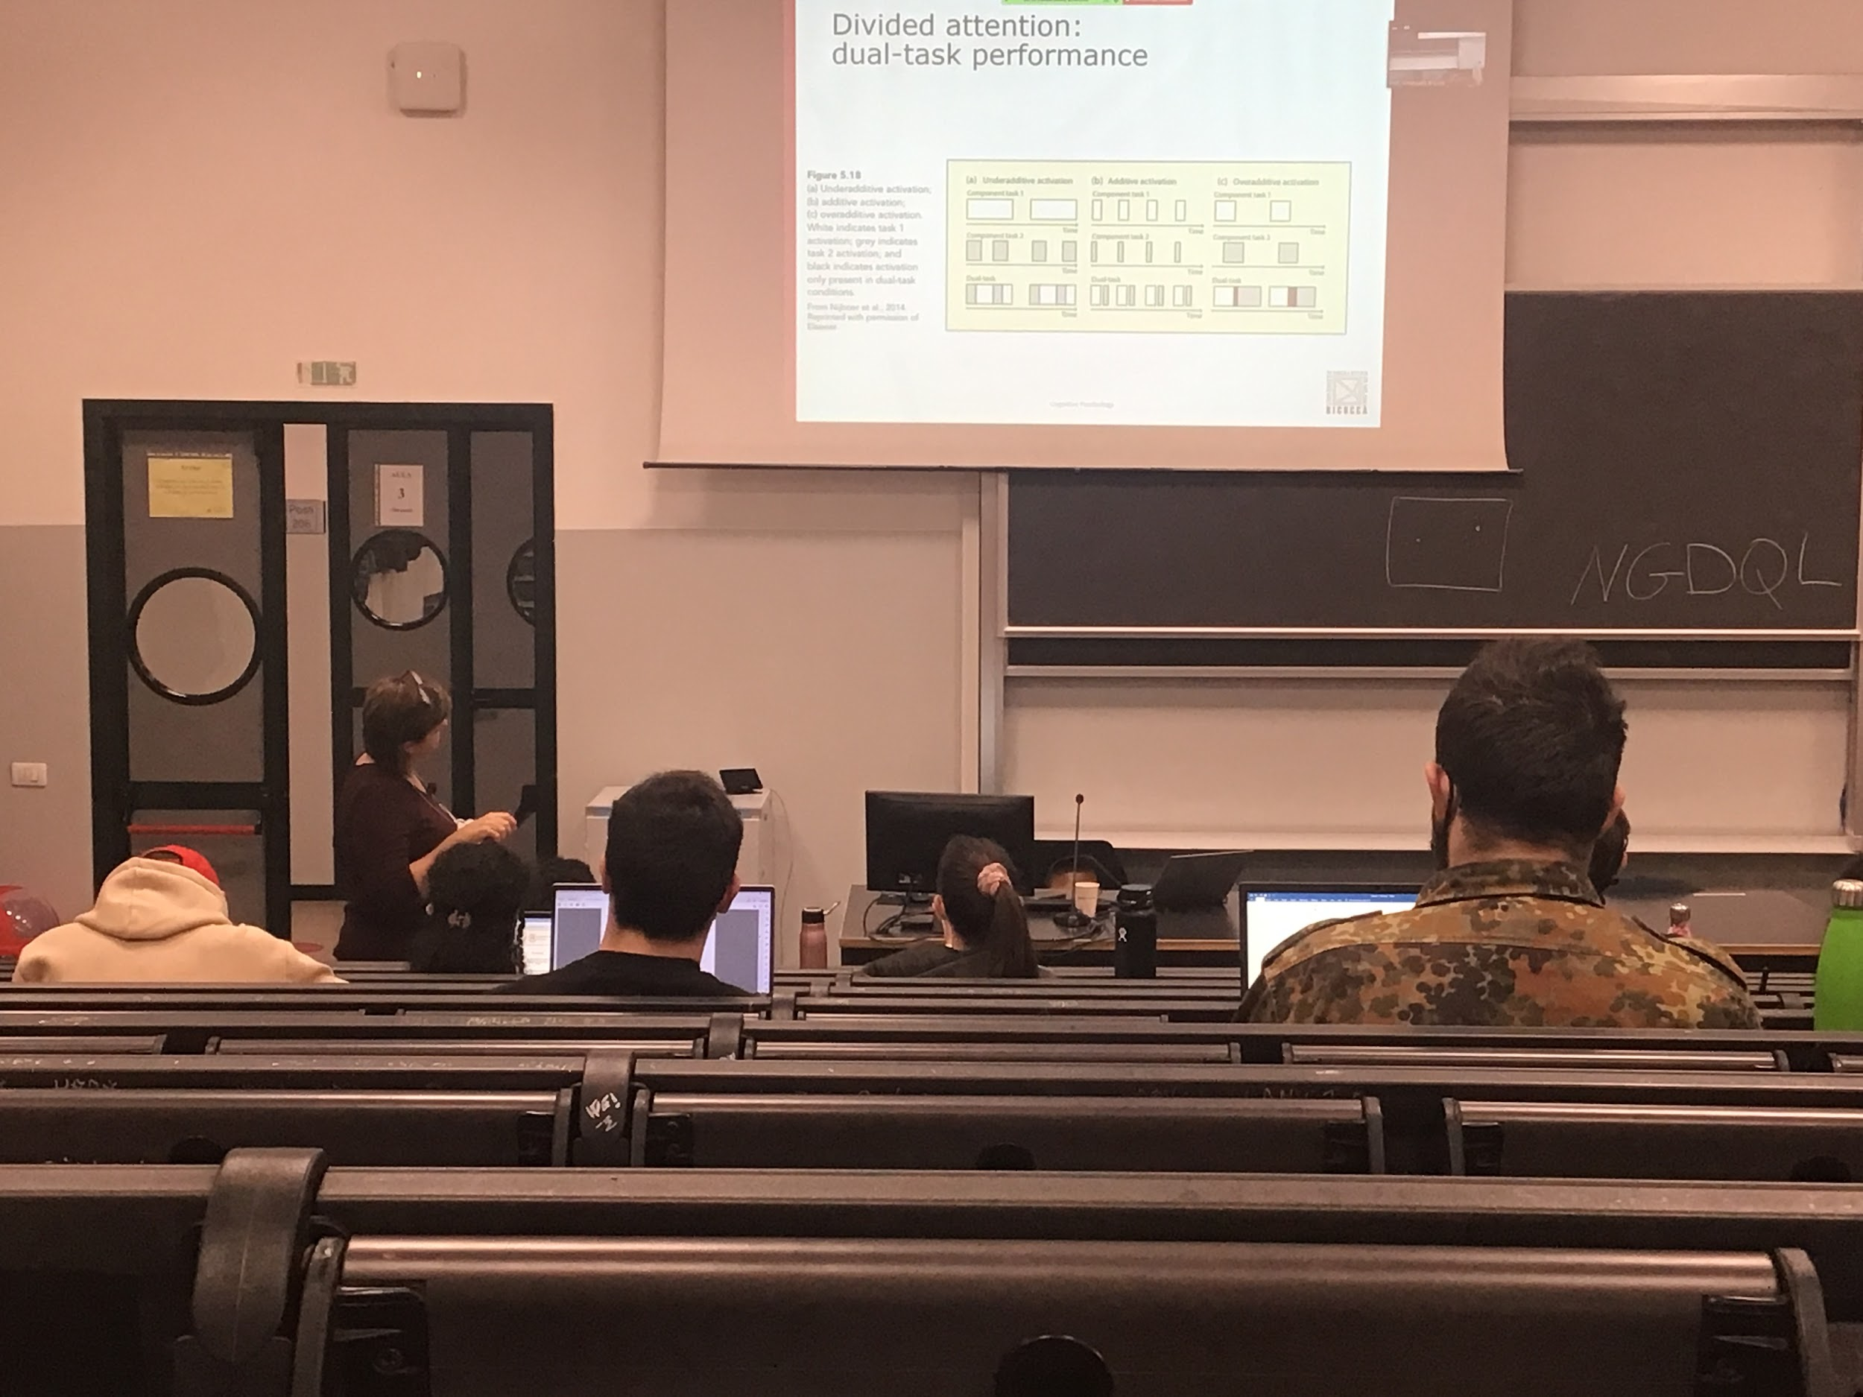

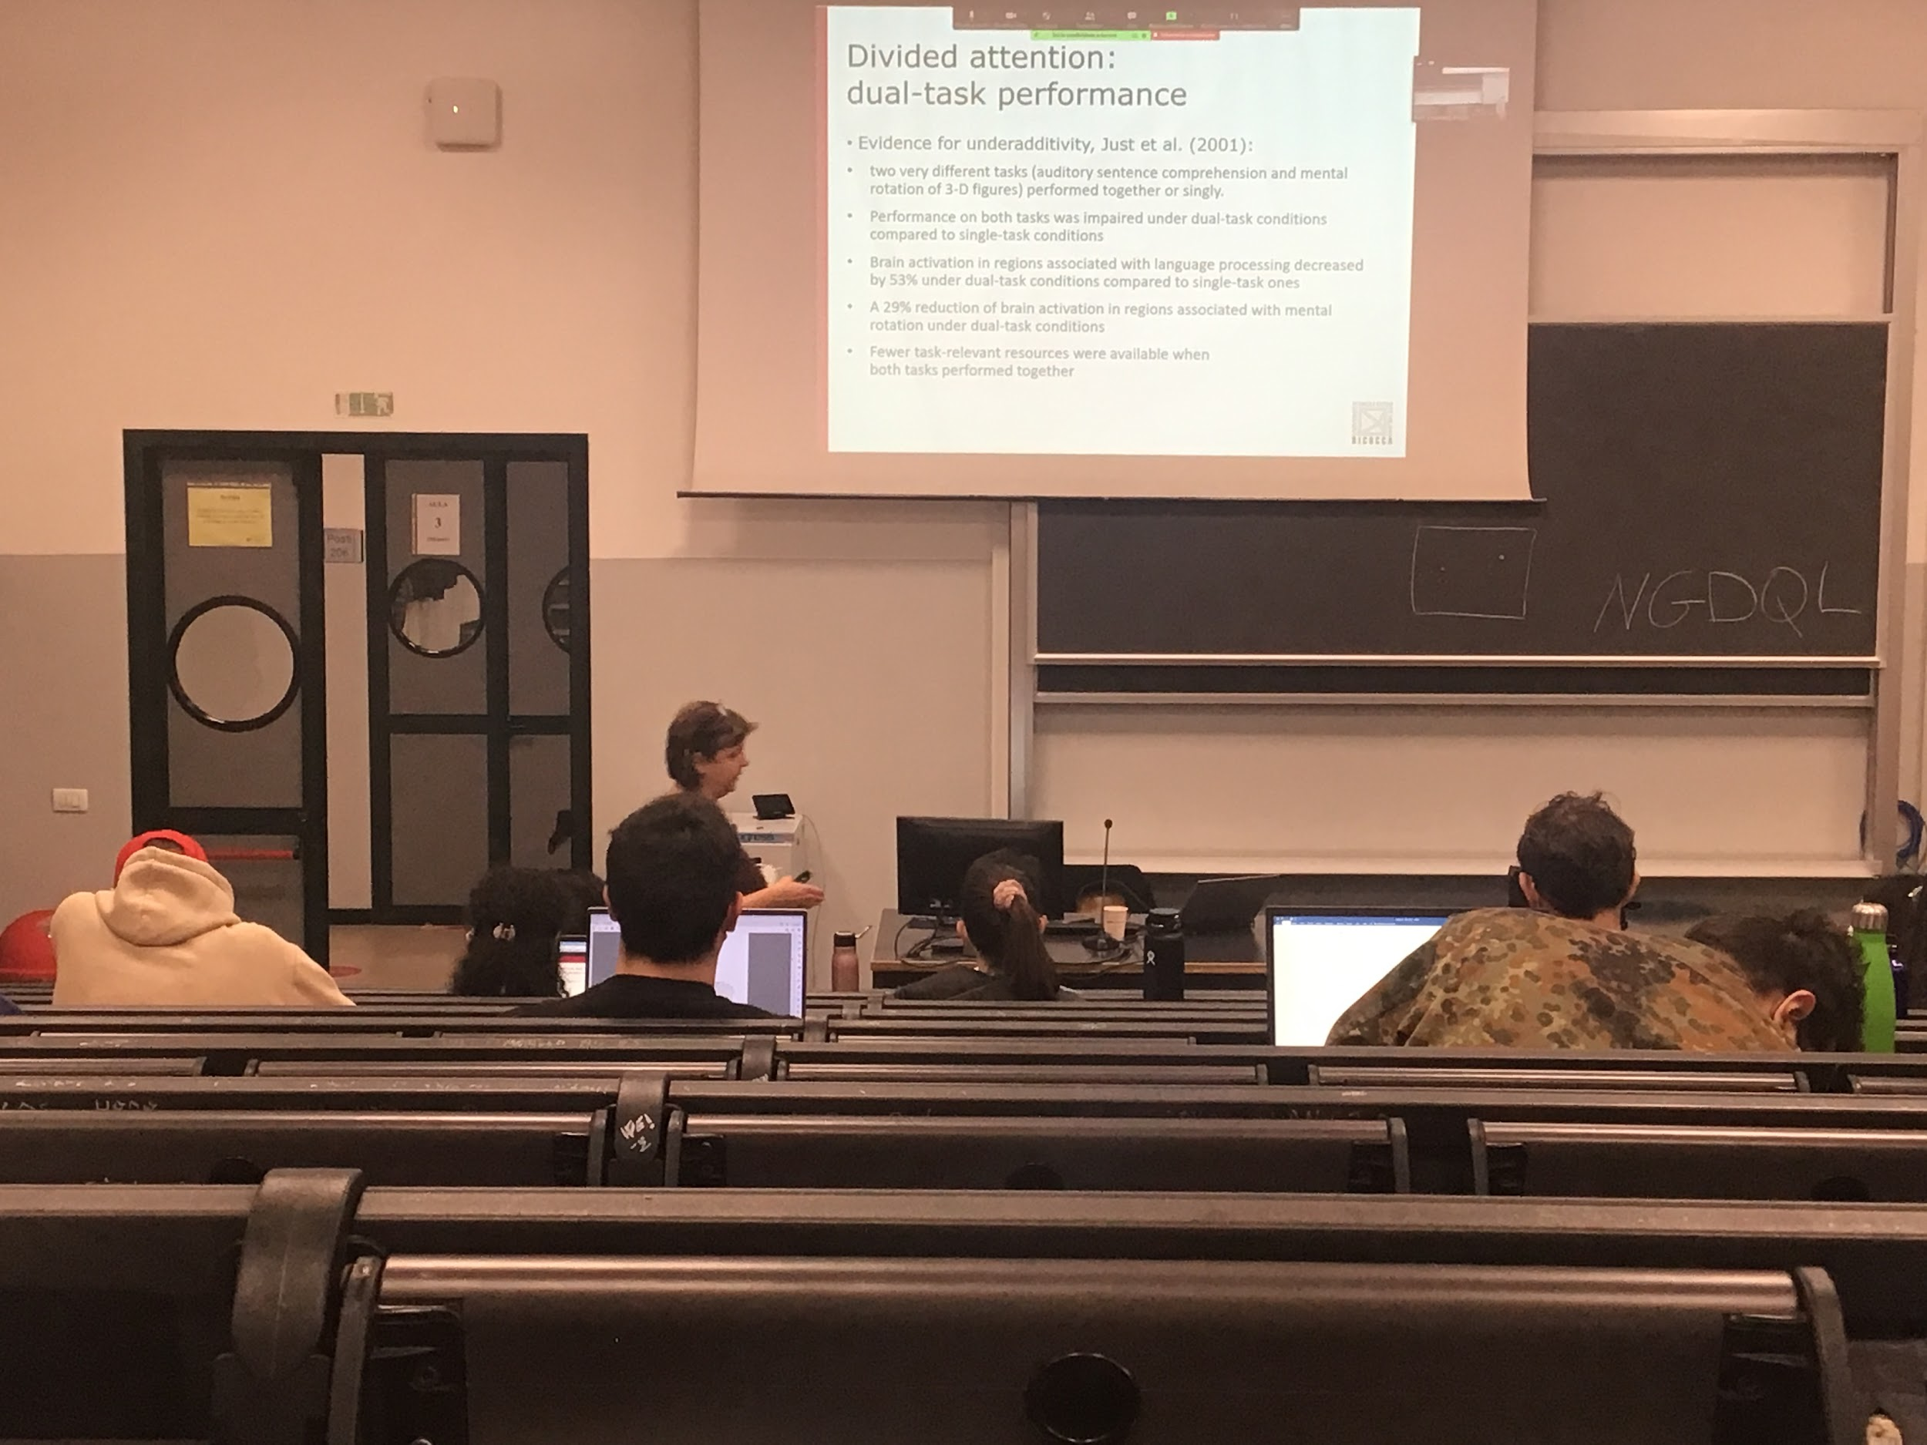

There is evidence for both under-additvity and over-additivity

Experiment: two different task

* auditory center compression, have to understand what they are saying
* rotation of 3D figures (answer if the figures are the same)

Seems completely different tasks but when we ask people to **perform them together they are worse**.

The behaviour results tells us that **there is interference**, 53% less activation in the area dedicated to language processing, and 29% less activation in the area dedicated to mental rotation

When performance together lower activation in both areas, underadditivity

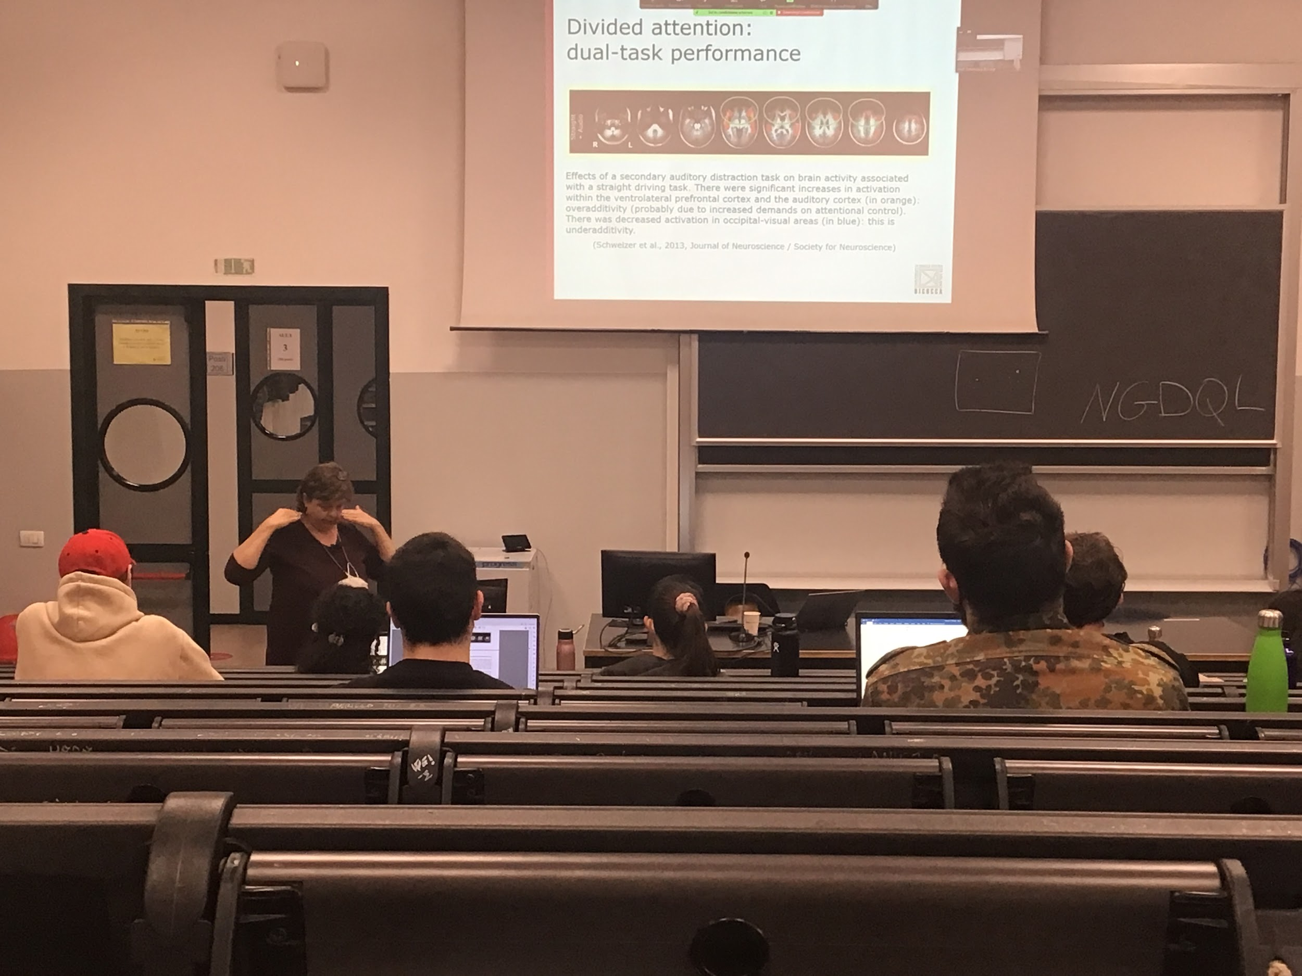

Orange parts: more active part in the dual task with respect of the single task

Blue areas: the area is less activity in the dual task than in the single task

**Experiment**: have to drive straight while they were doing an auditory task we see both underadditivty in the visual cortex and overactivity in the frontal cortex

Doing task together not only requires interference but also introduces others areas that are not active when the task is done singularly

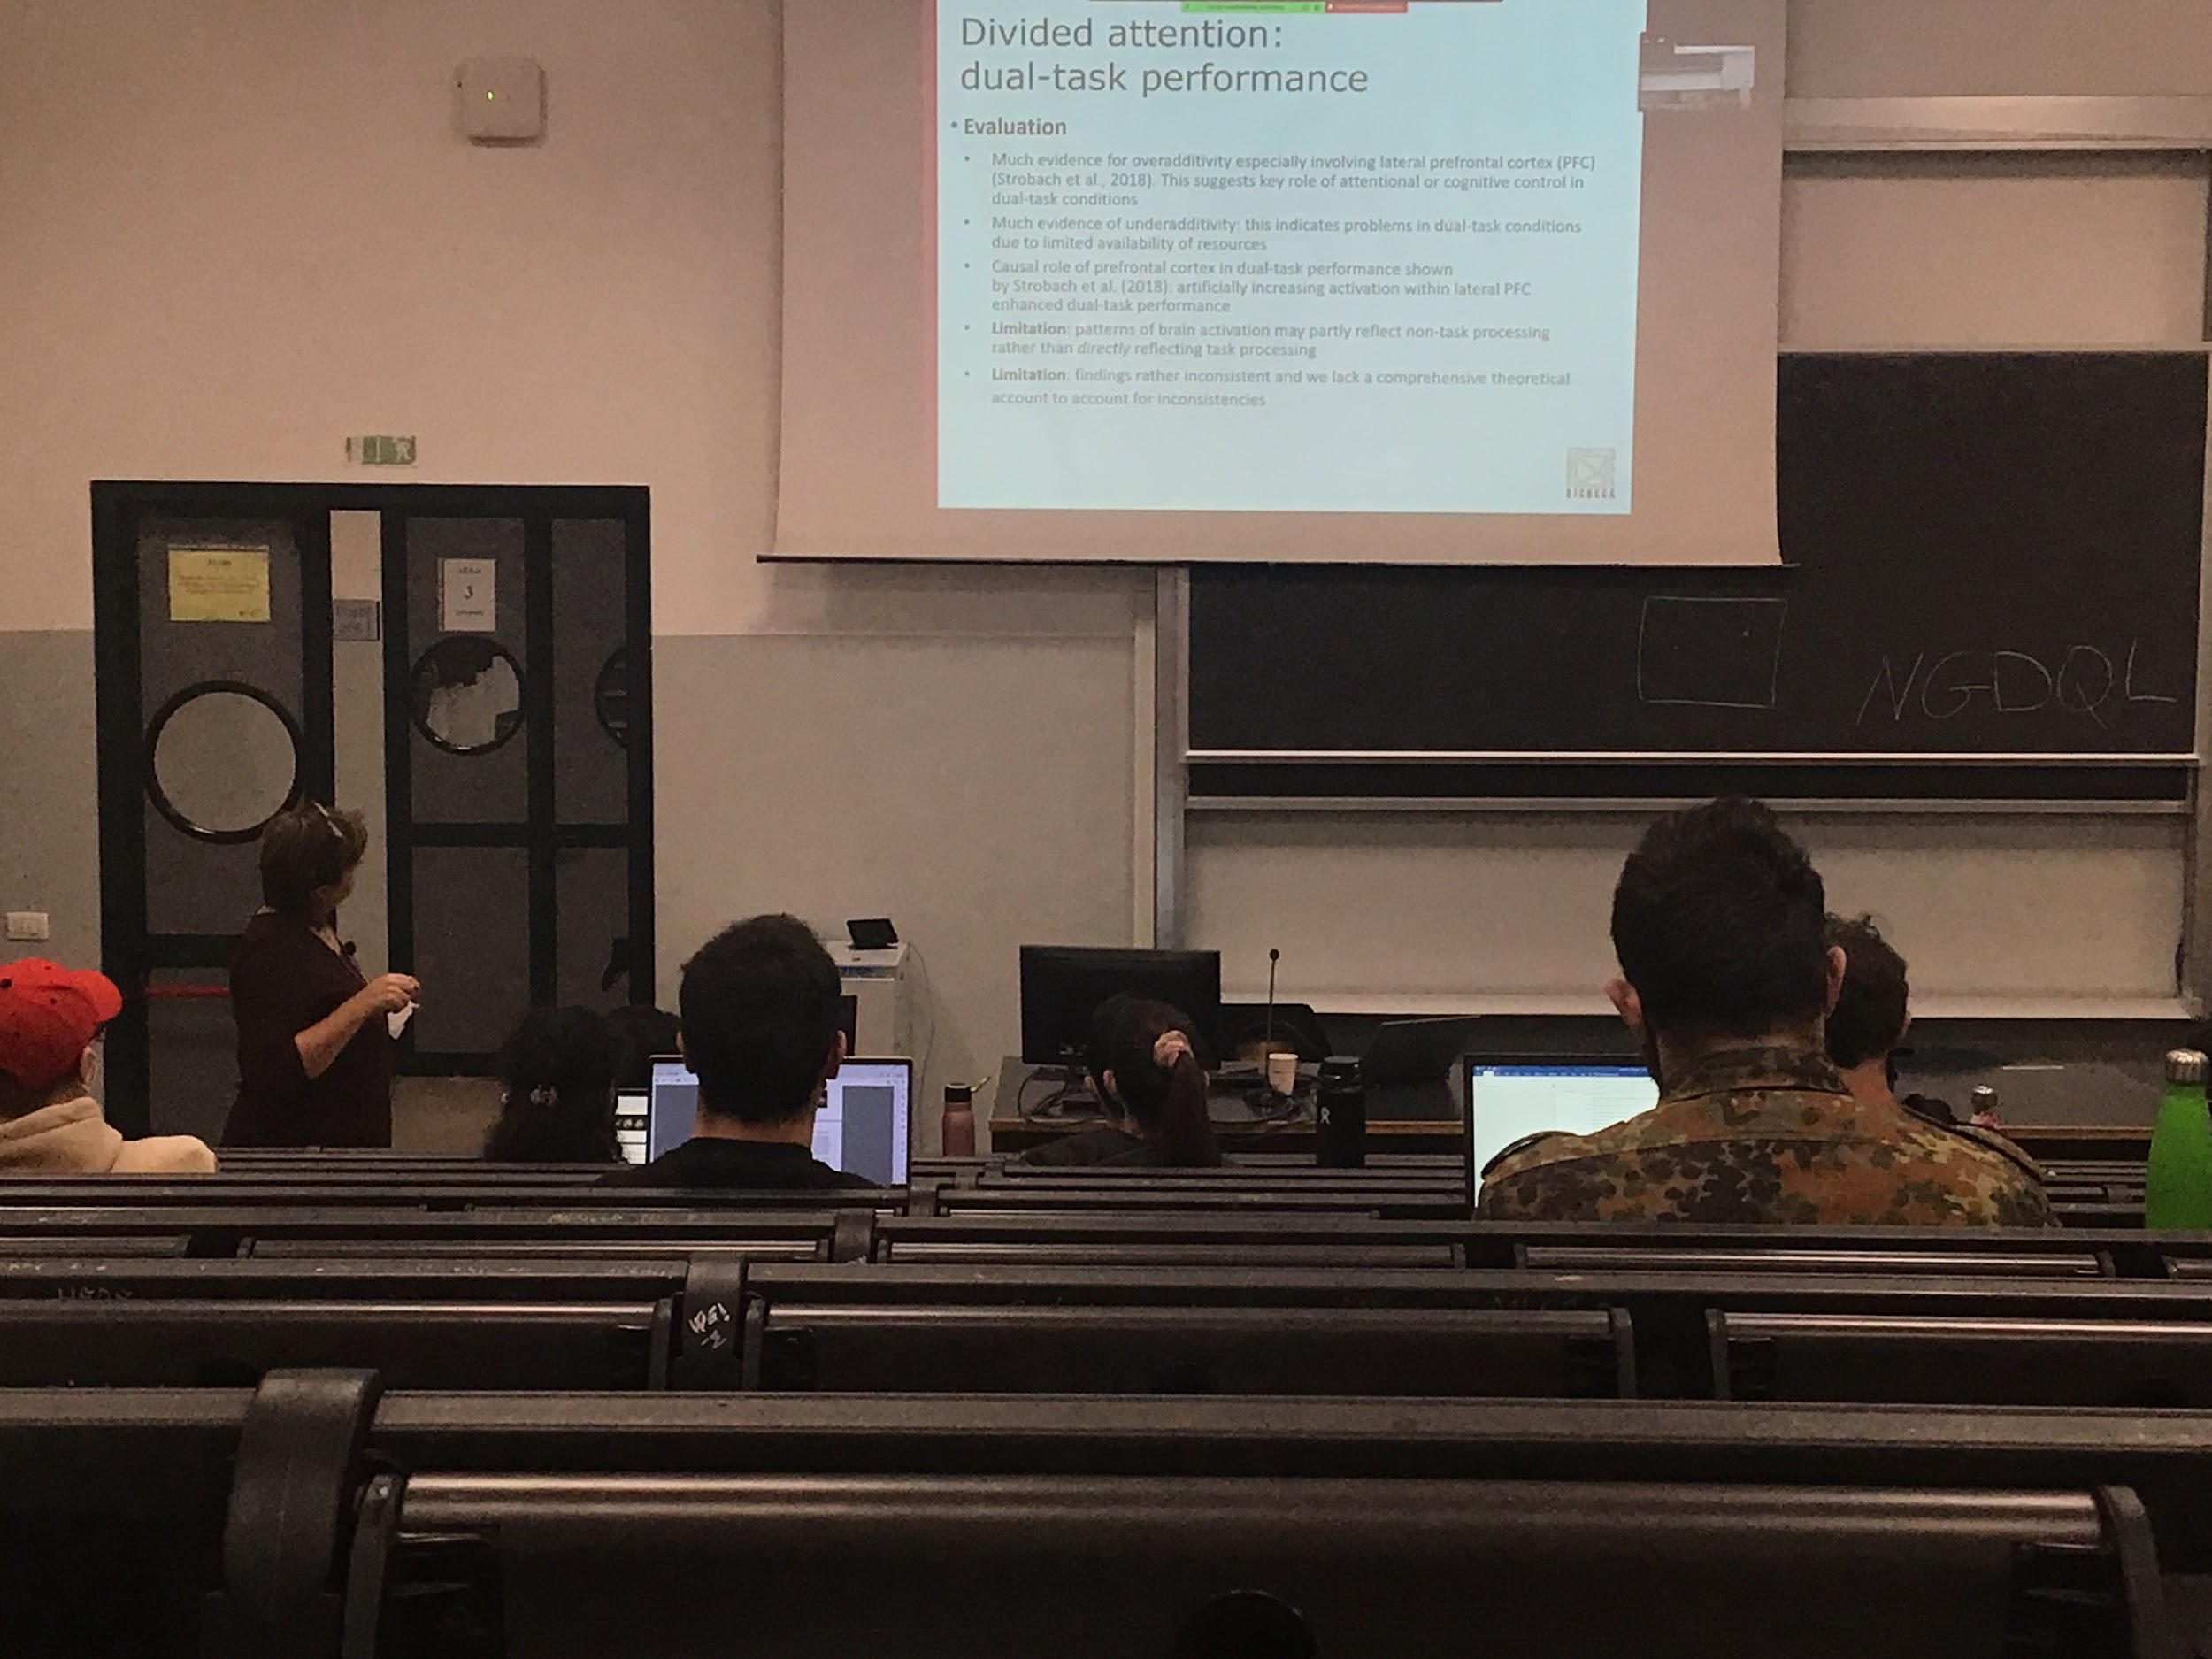

One problem of cognitive neuroscience: it is possible that you see activity not related to task performance but is related to the mood of the patient or what is thinking about. Don’t have a perfect association between the activity that we see and the task processing related

Also these differences in brain activity are computed using a statistical technique. Depends where you put the threshold between activity and no activity

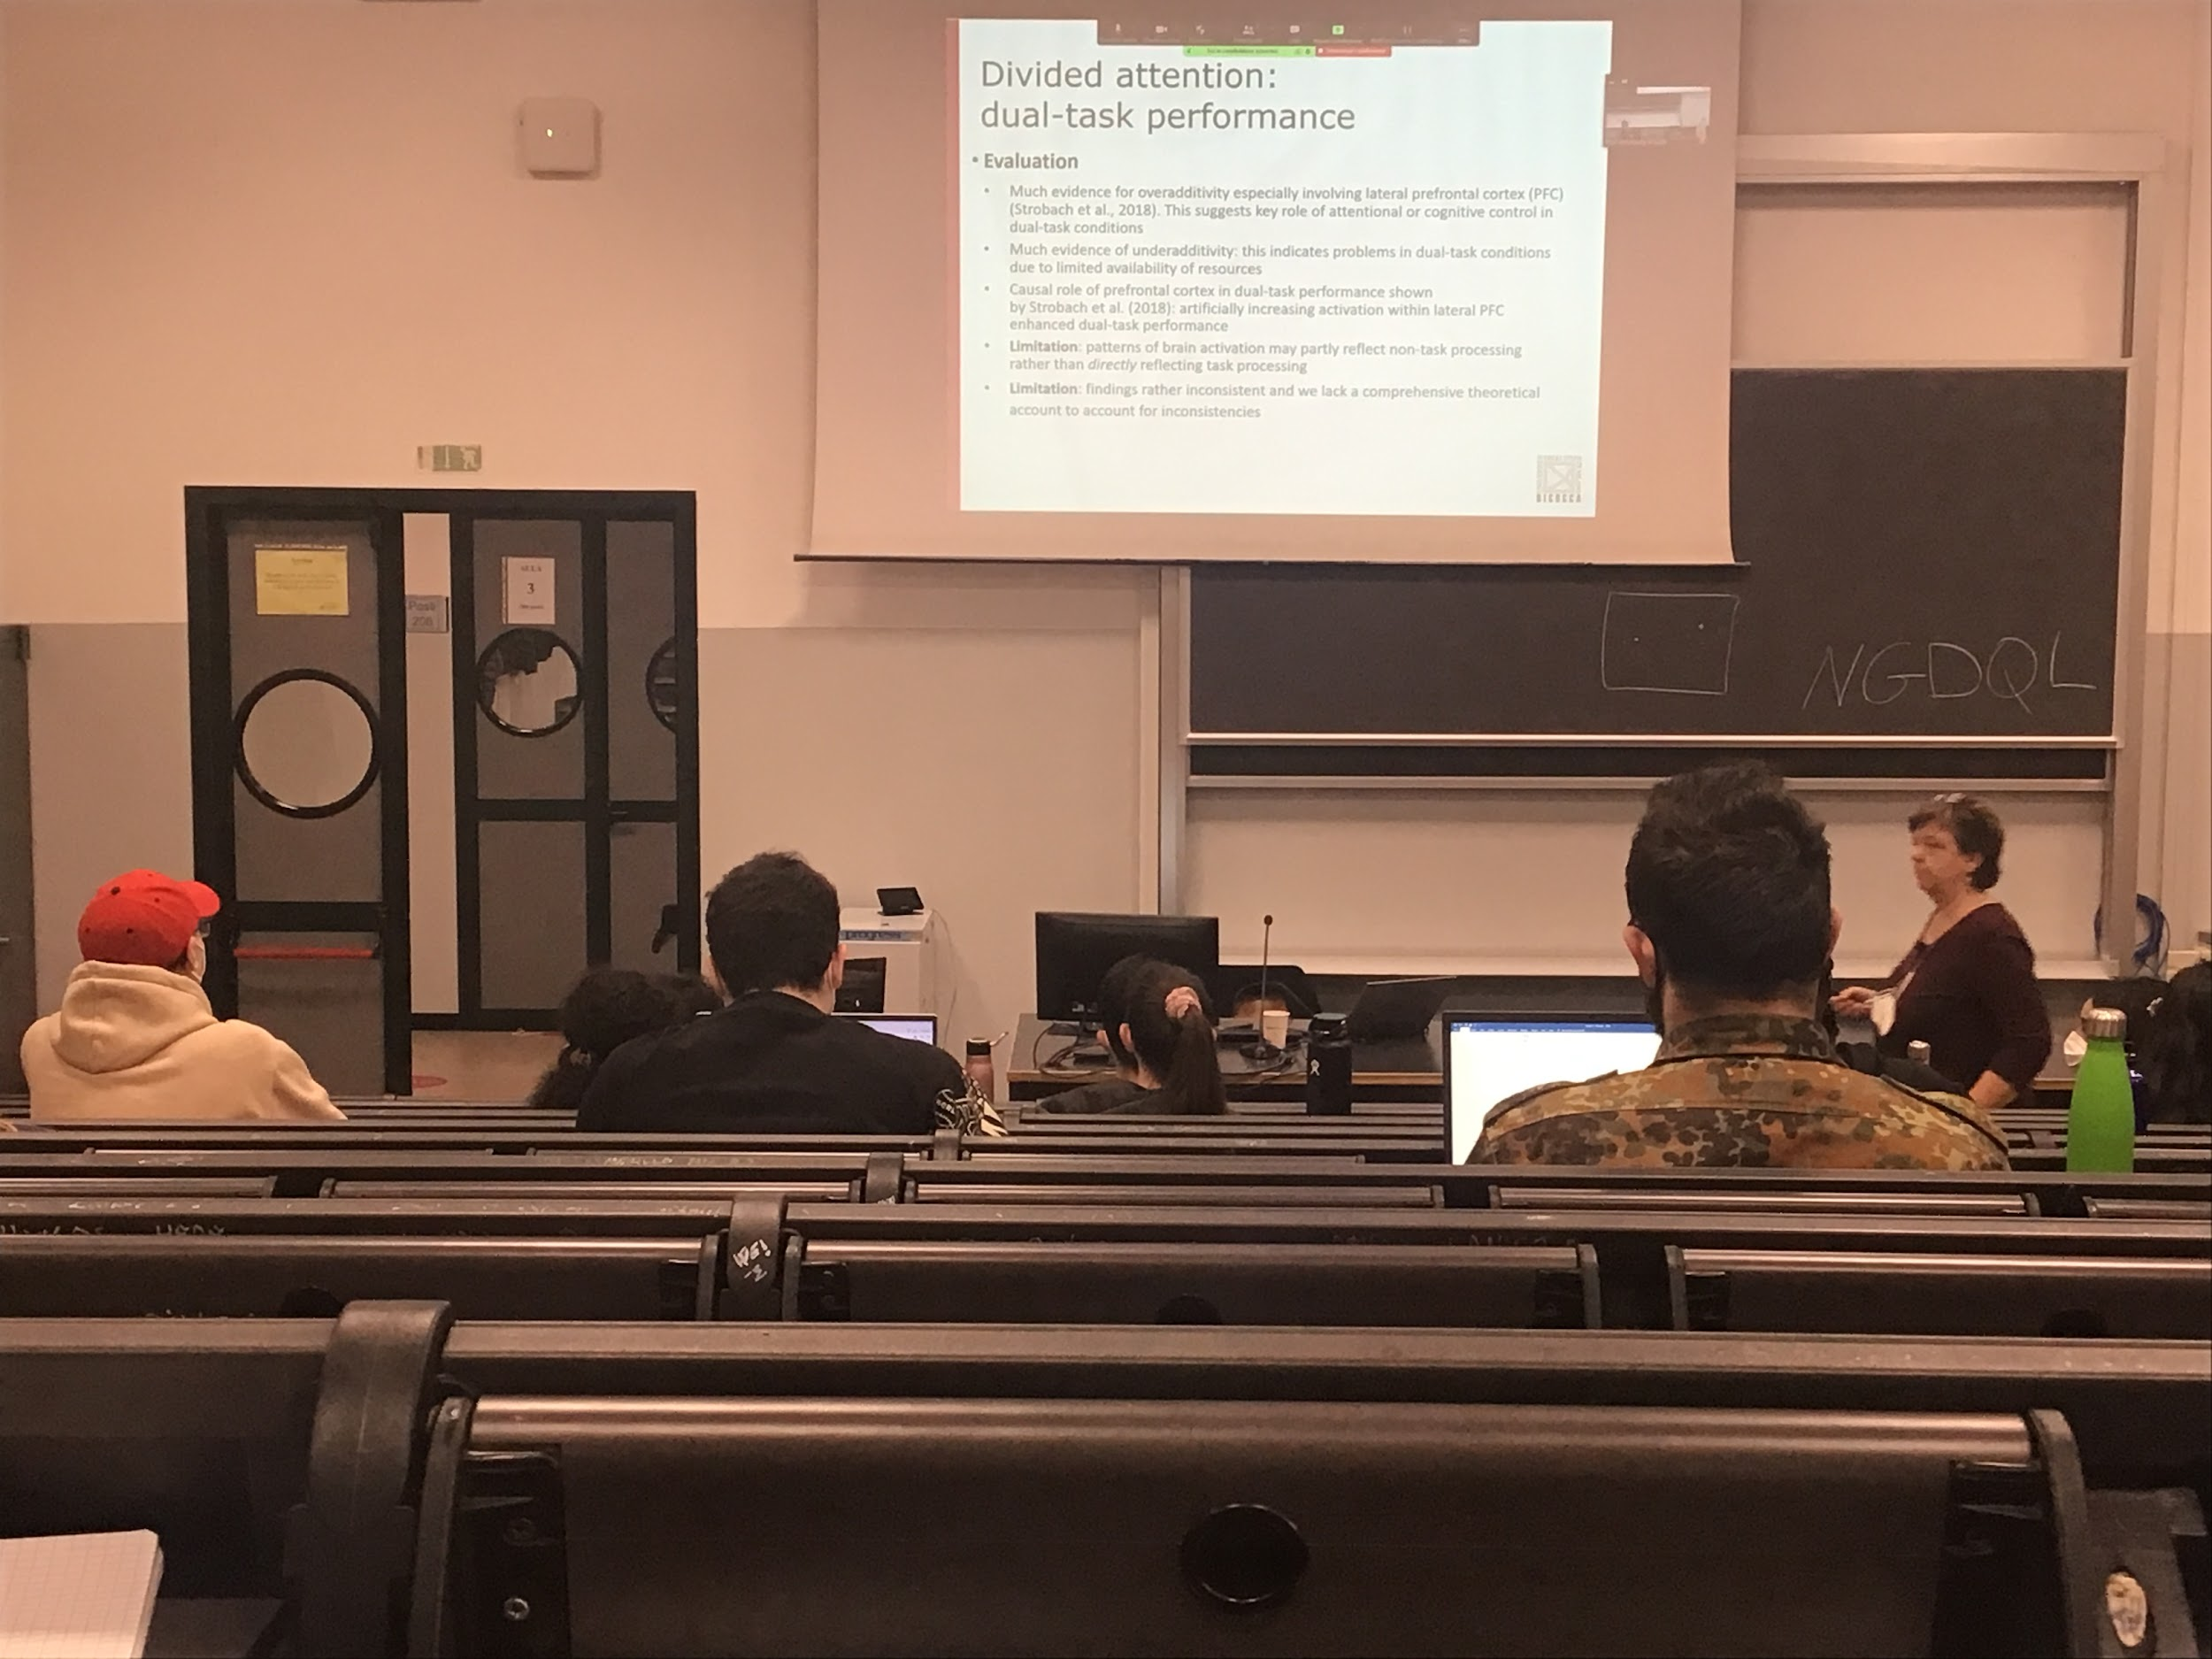

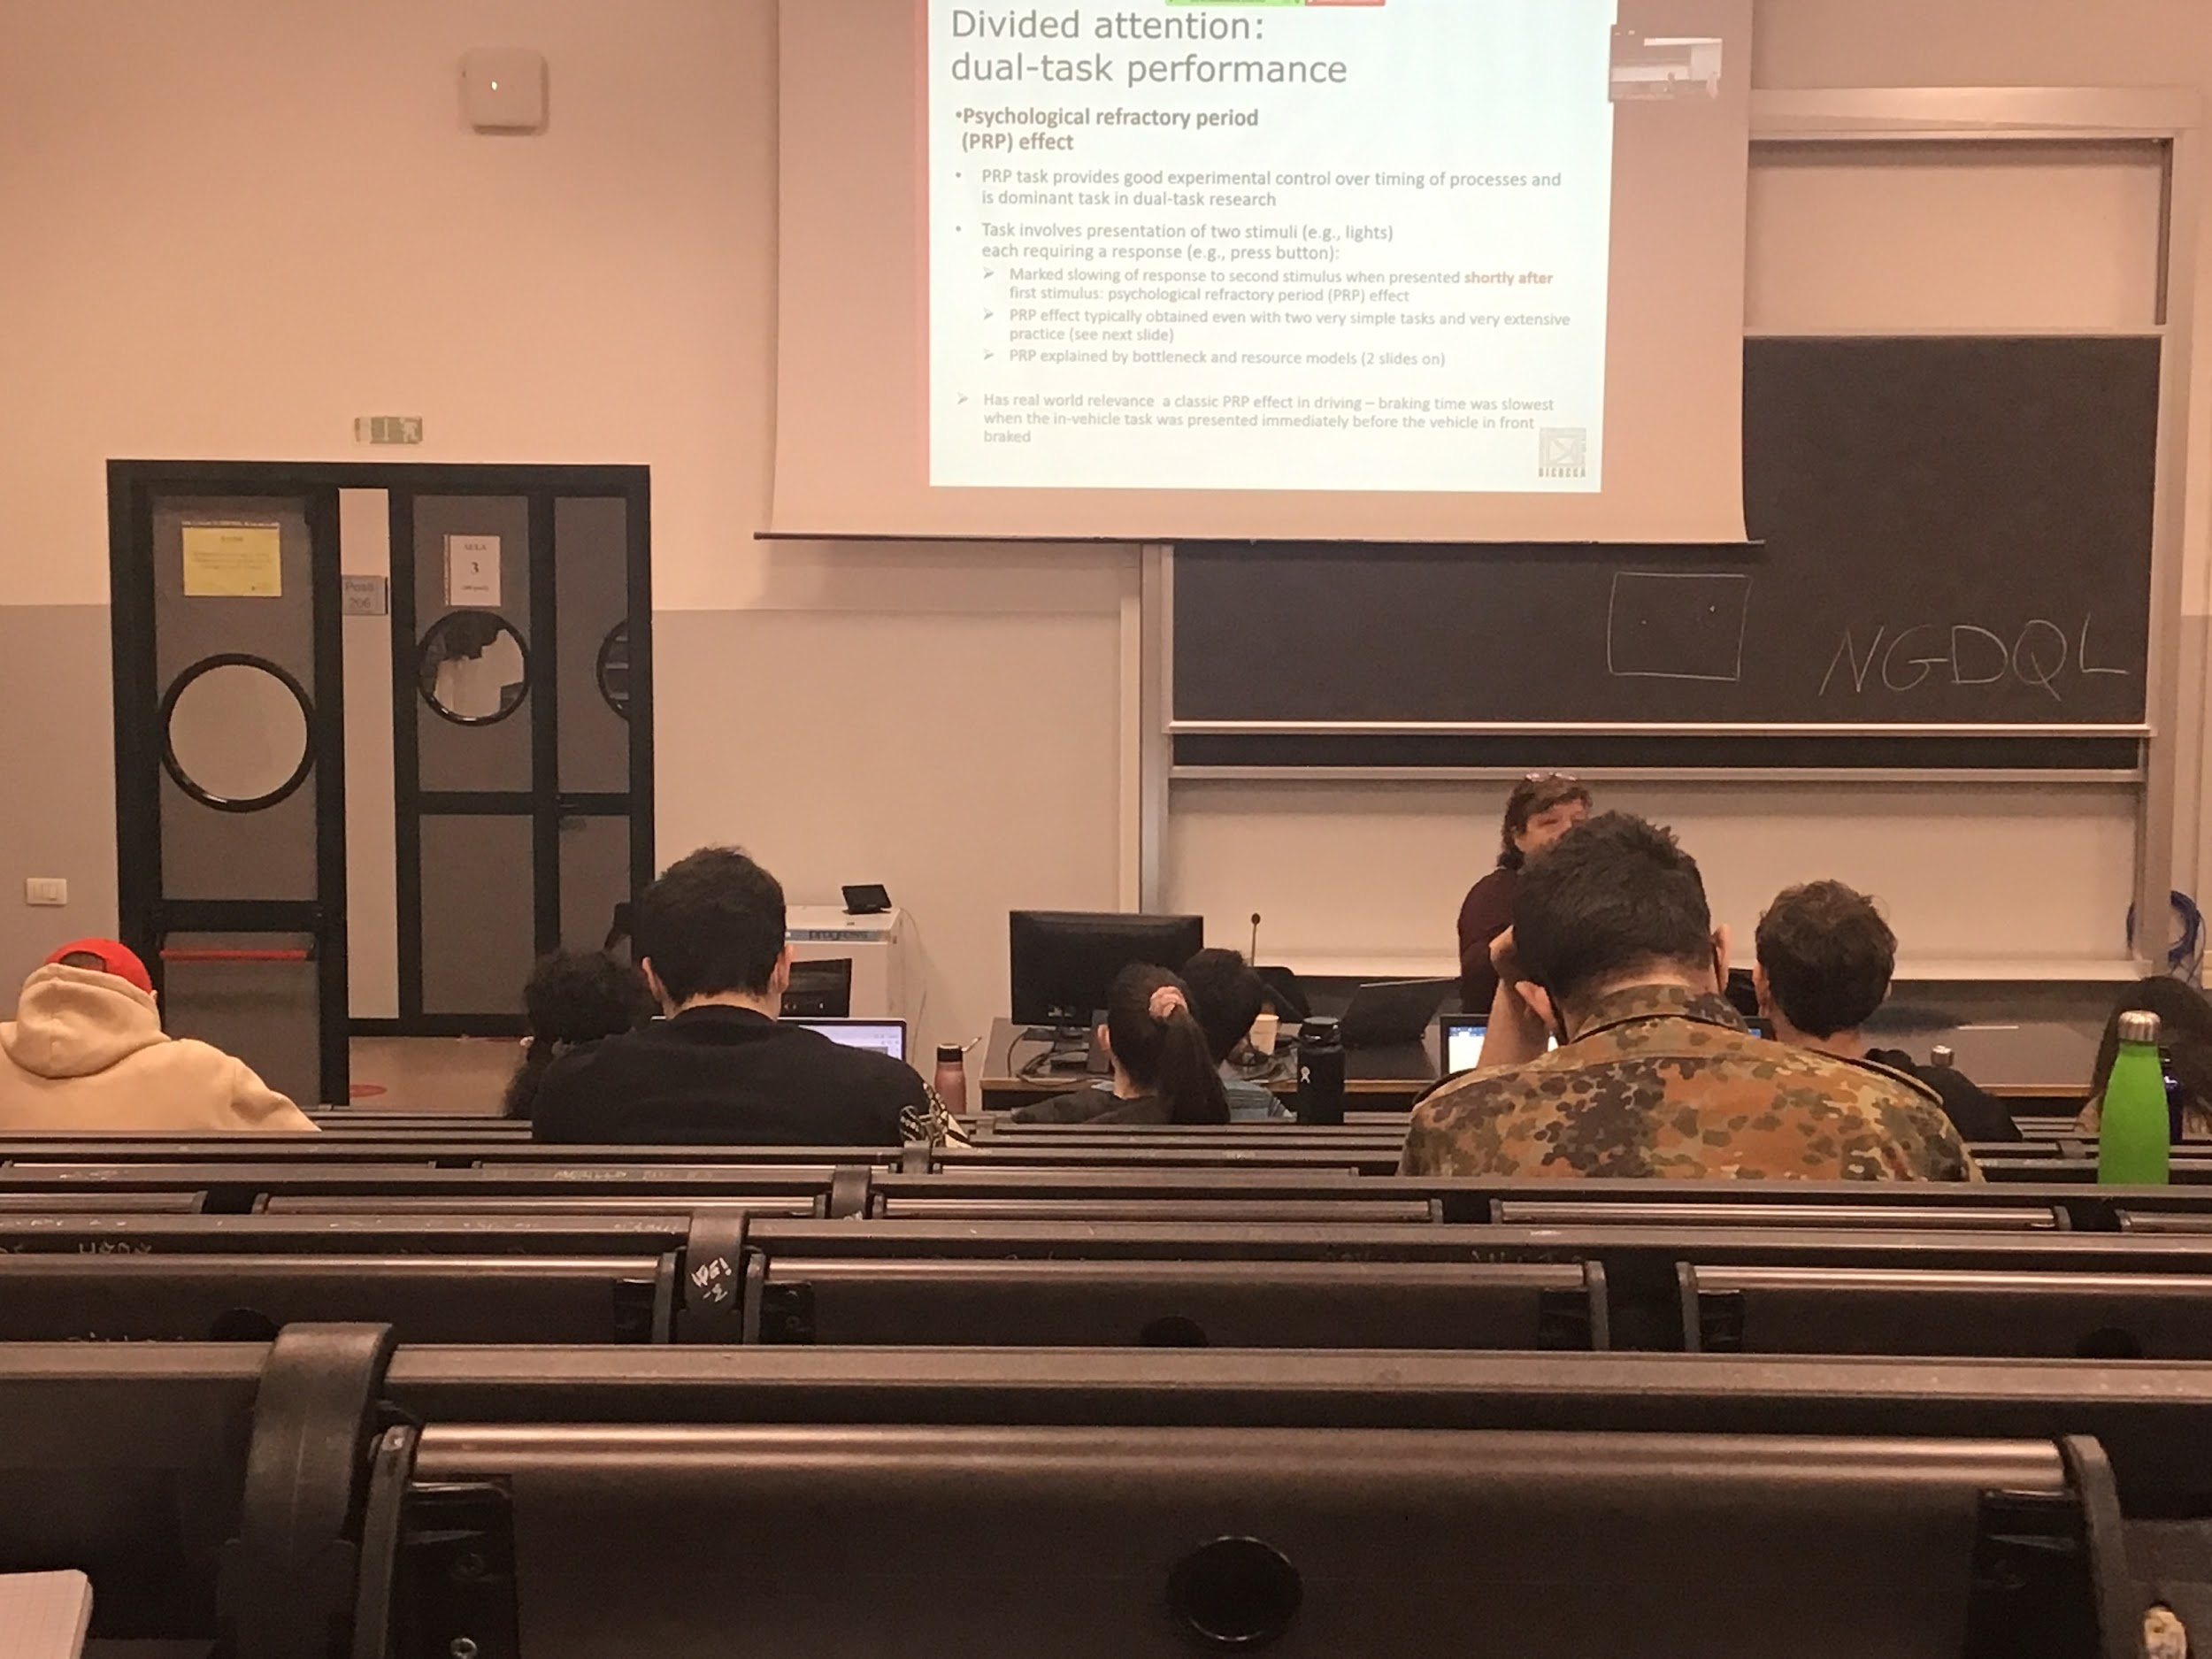

Psychological refractory period (PRP) effect

Even for very simple tasks that you try to do at the same time. There is a time, you take a decision for the first task and then you have to take a decision for the second task. **There is a time where you are unable to do the other task**

When you take a decision your system is completely focus on that decision nd does not allow you to take a decision for the second task, is a **timing problem**, usually the task is very simple

**Experiment**: Two lights and have to press two bottoms

If the two stimuli are very close to each other in time your response on the second press is delayed. Period in which you can not do nothing. **Once you made a decision there is a time you can choose anything**

Even if you do a lot of practice you can not reduce this time to 0. Is an effect that influence our life

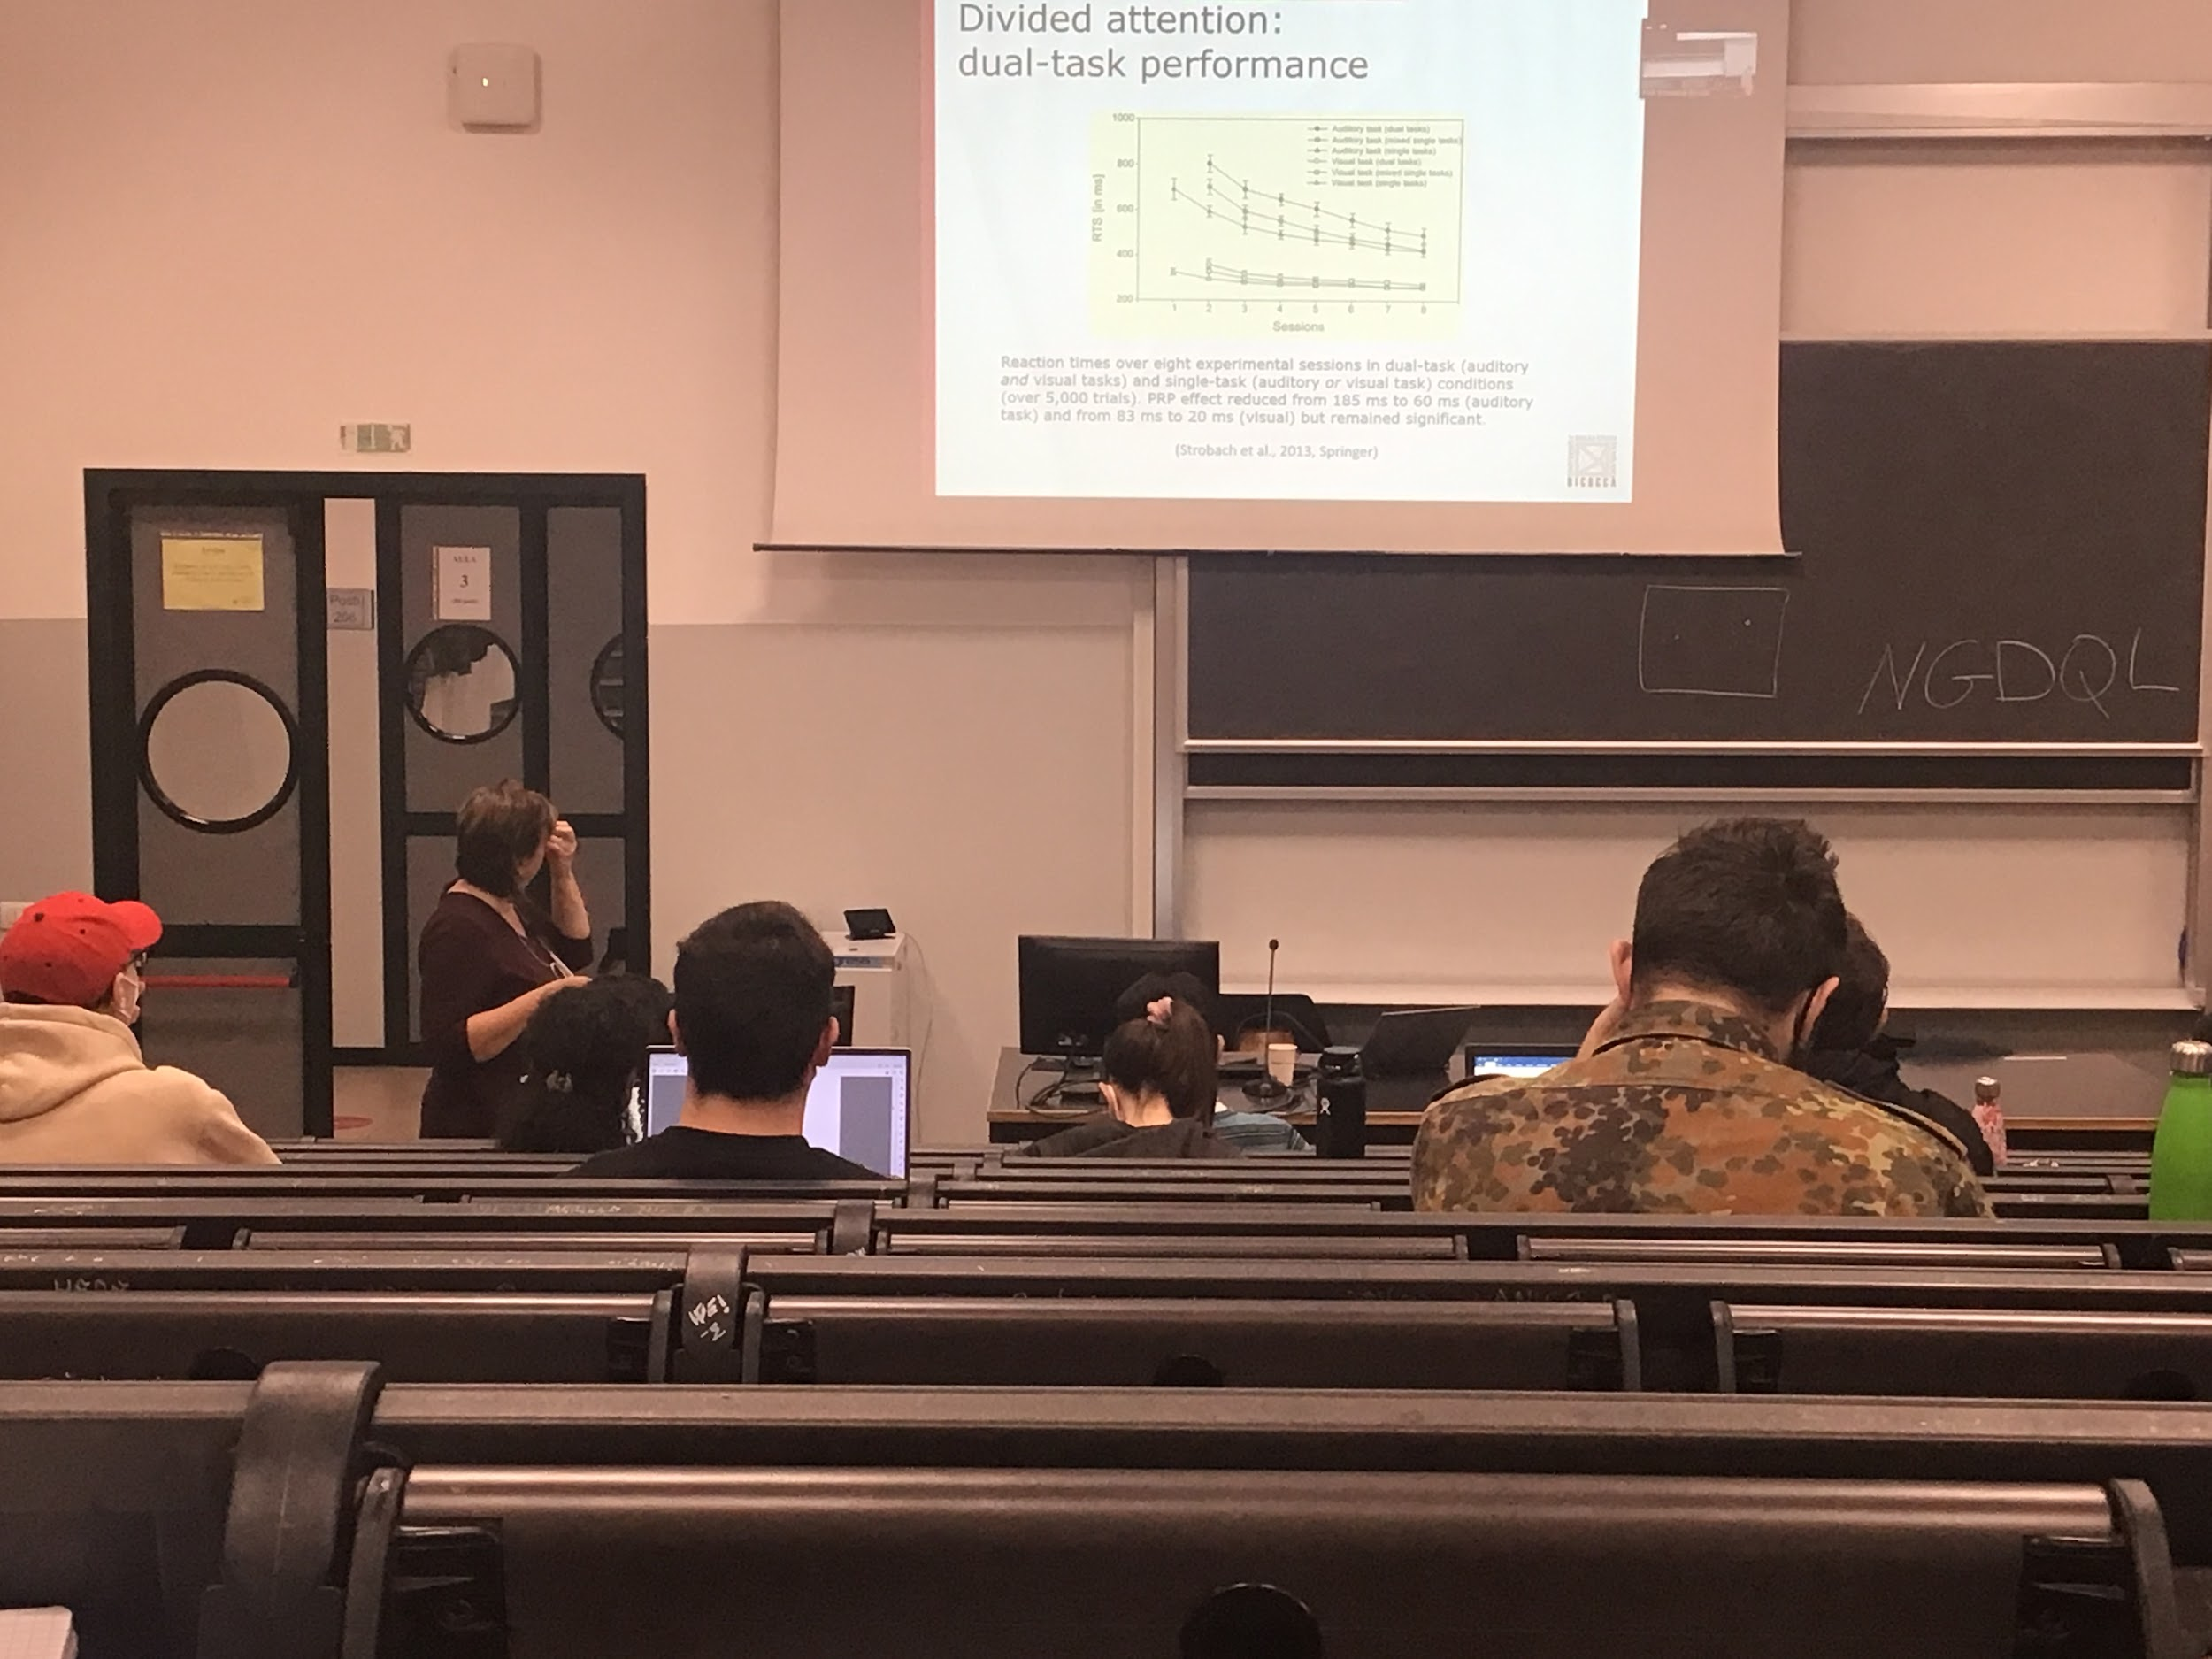

When I use the task alone or when I do a dual task there is always a difference in time. Even if I do it over and over again presenting two lights and detect the presence I am improving a little bit but not too much

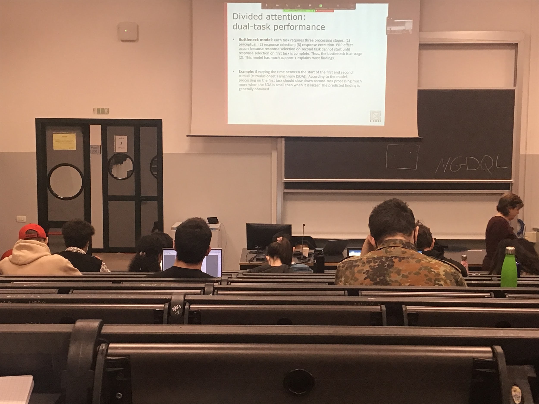

Two models that try to explain the existence of the refractory period

* **Bottleneck model**: to perform a task (pressing a button when a light is coming). First there is a perceptual step in which I understand that the light is on. Then I have to select the response and then press. According to this model the psychology refractory period is at the step 2, **once I am selecting the response for the first light I am blocking the system and I can not select a second response** for the second light

A lot of support for this model

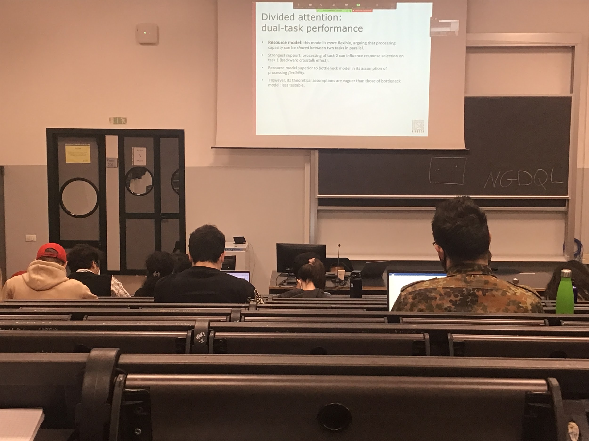

Second model of the psychological refractory period

* **resource model**: one result that can not be explained by the other model is the *backward crosstalk effect*. Sometimes the second light influences the first, if the process was serial this would not be possible

This model explain something that the other model can not explain

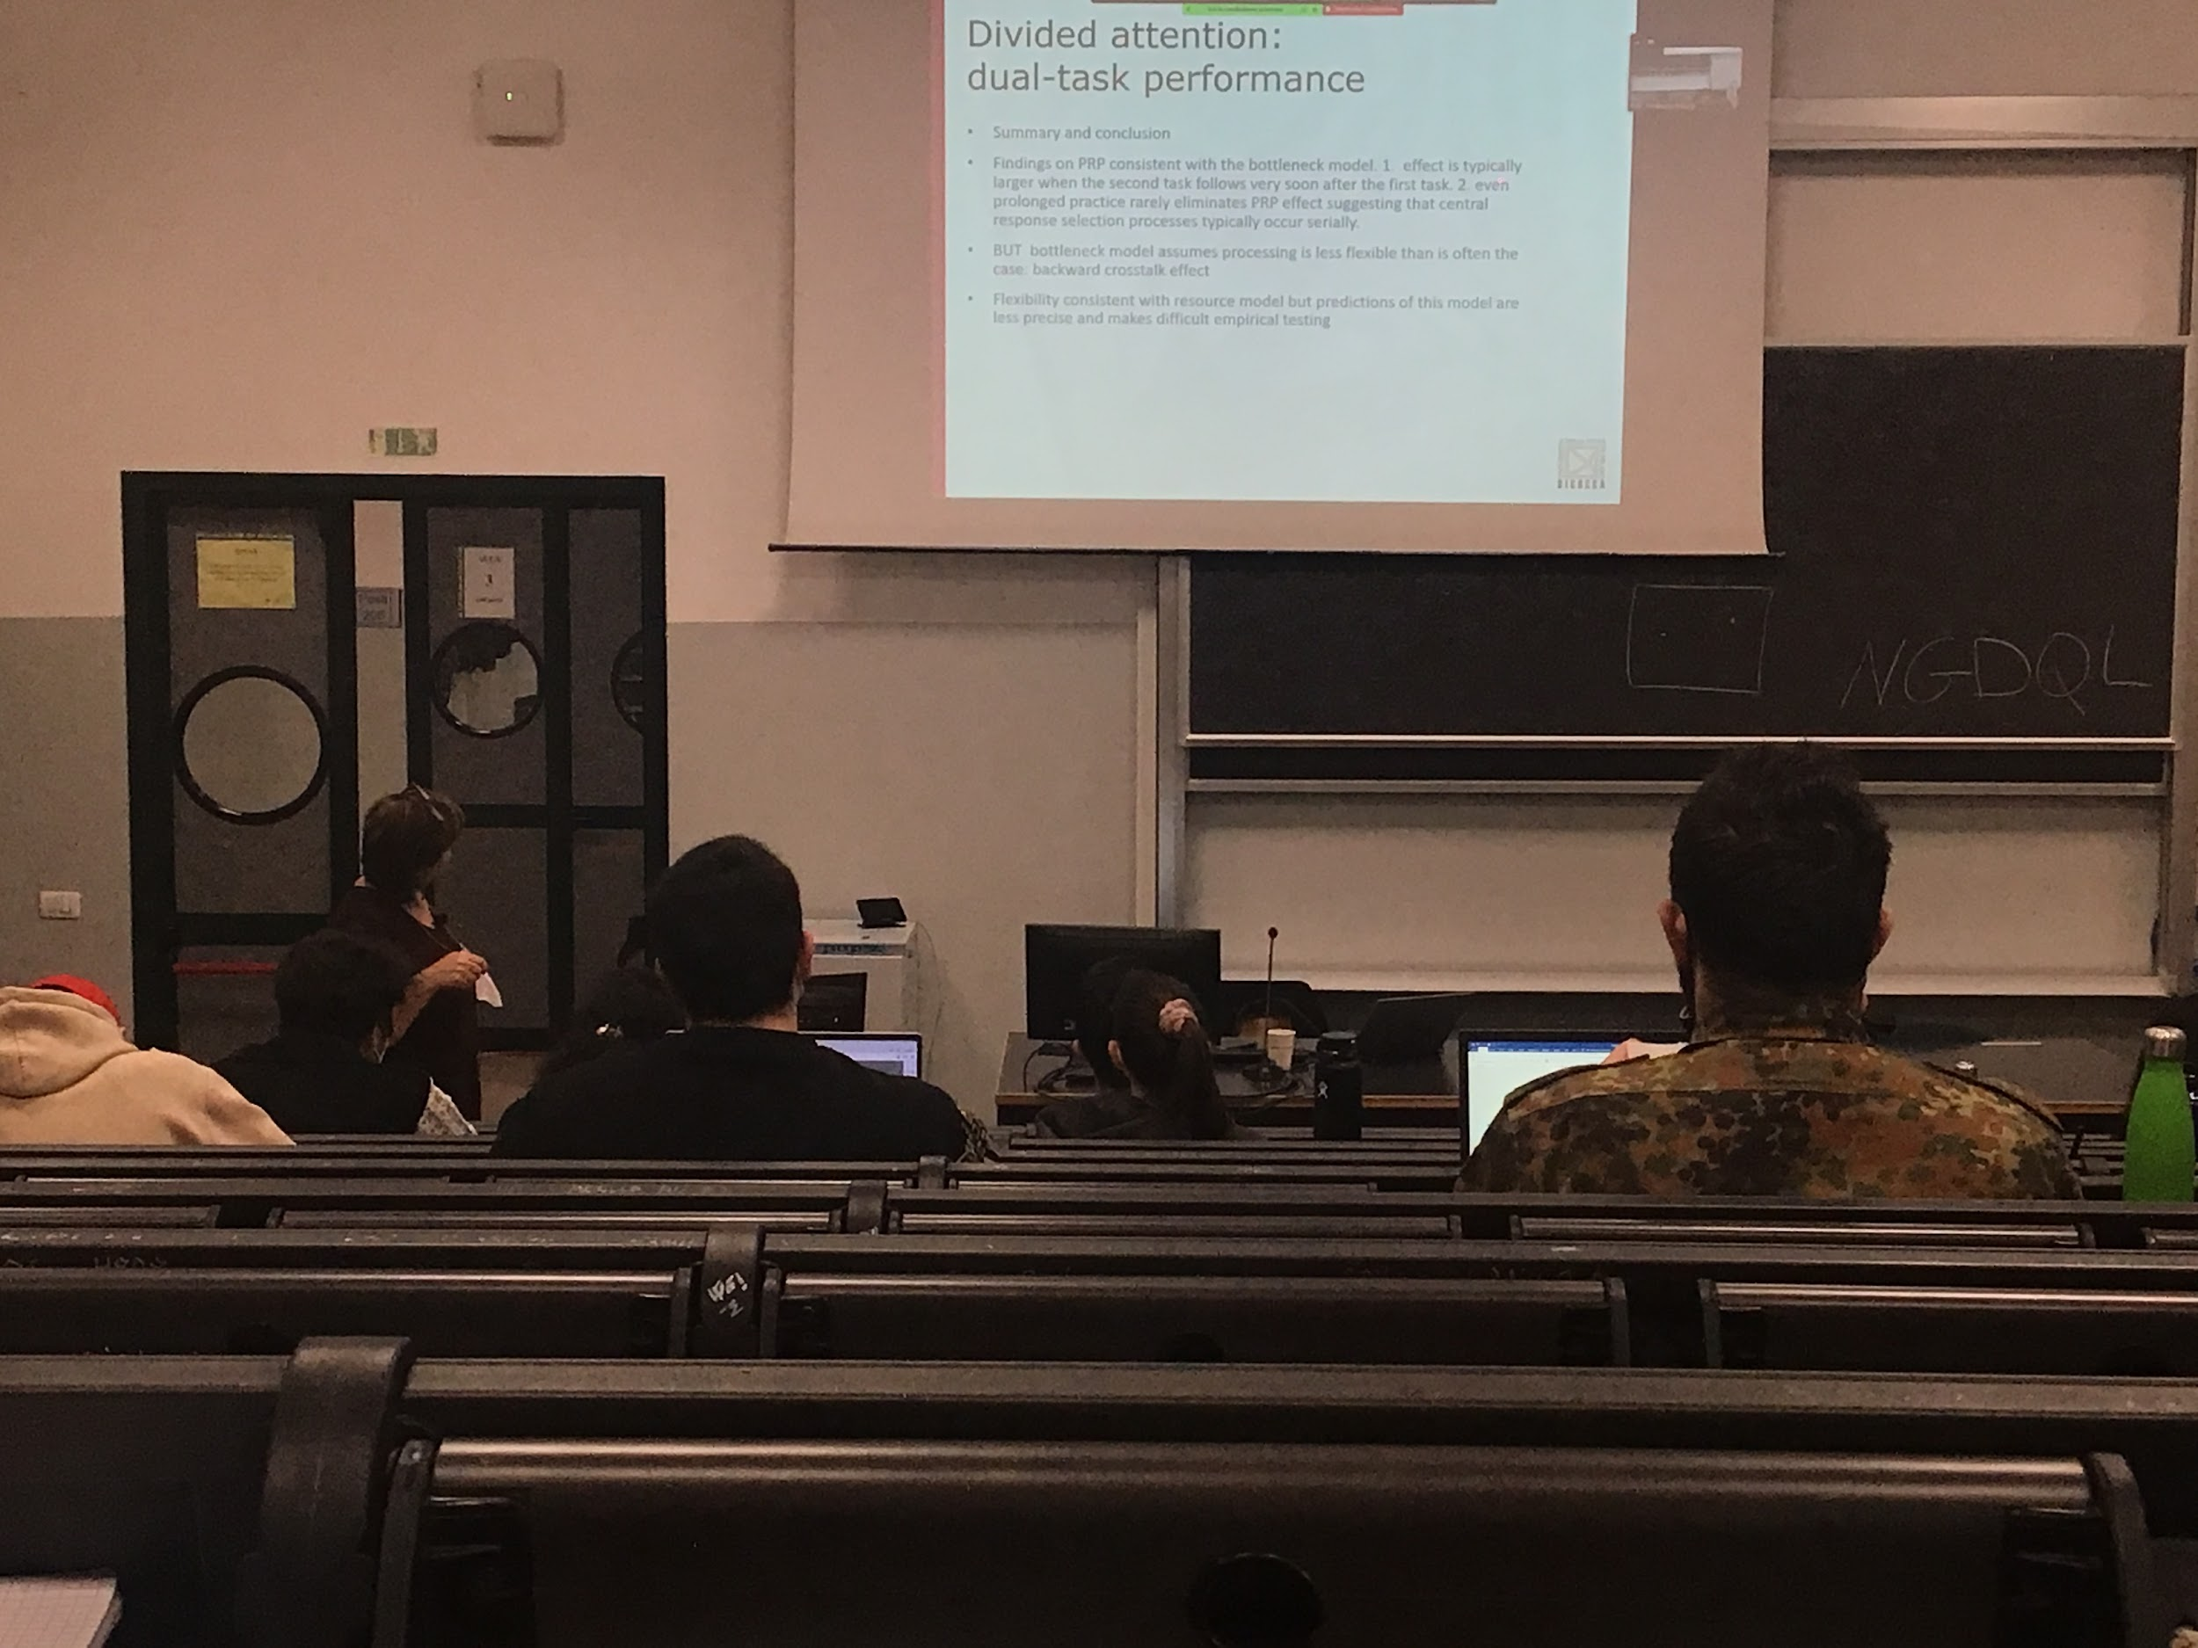

Chapter 5 - attention and performance

# Automatic processing

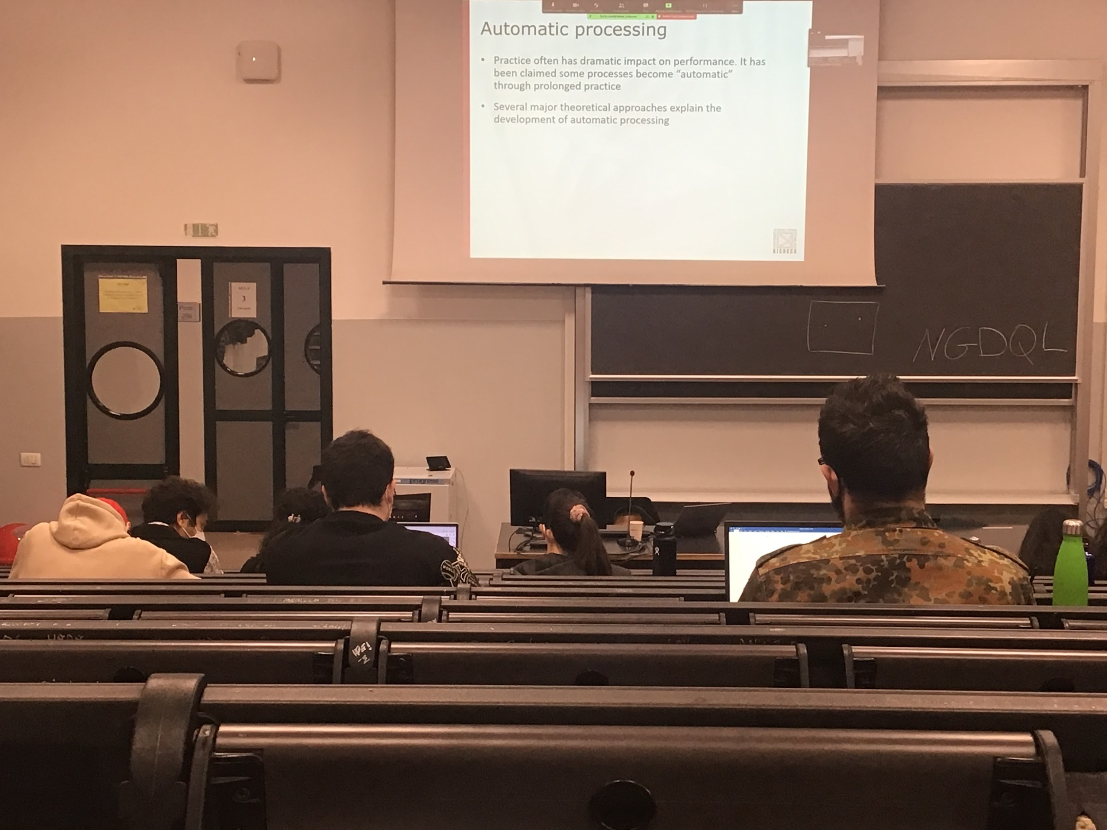

Practice make our life easier

After a while if you been driving for a 1 years or so you improve our performance

Some process become automatic with practice

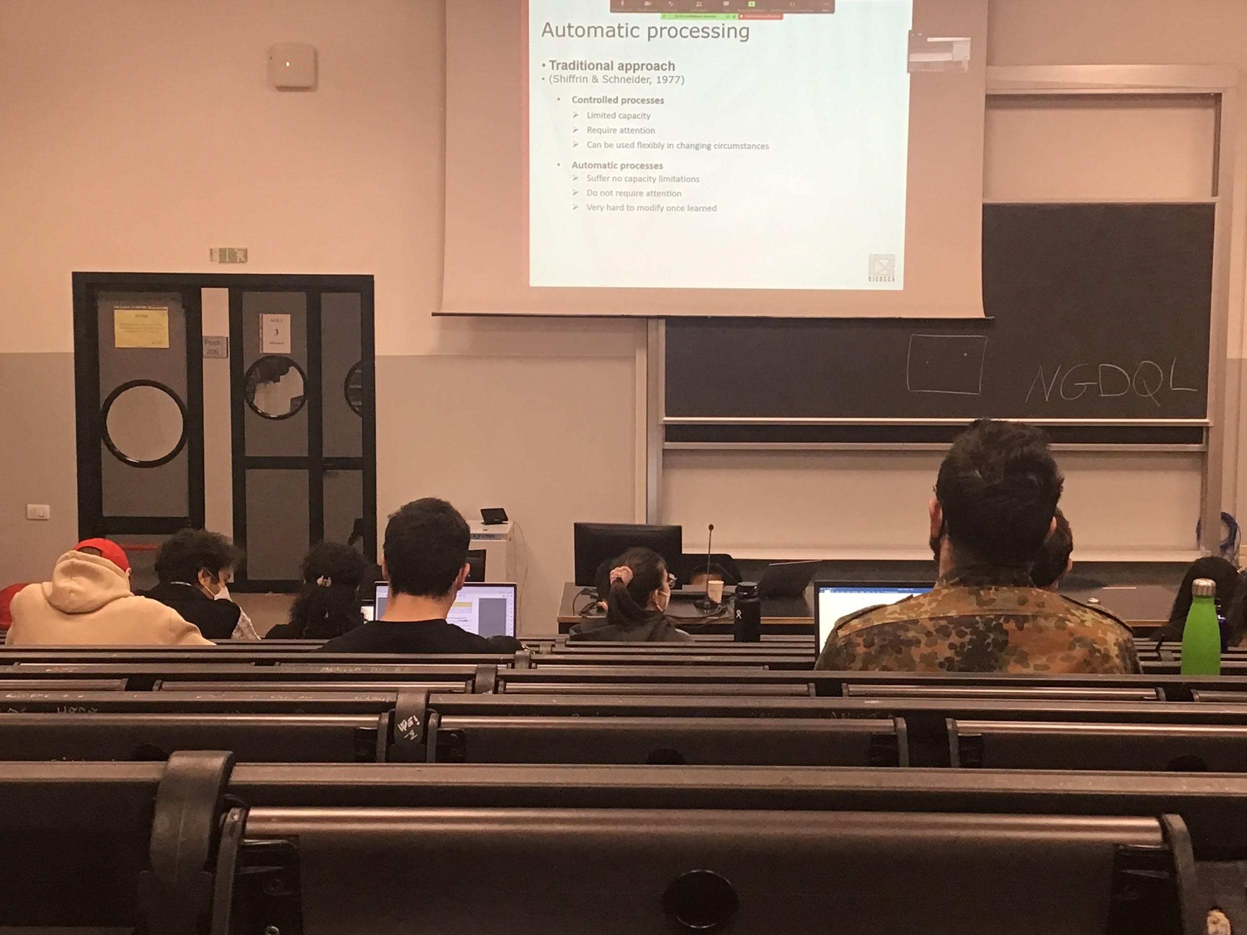

**Shiffrin & Schneider**: processing are automatic or control, no between

* **Control**: we can do one process at the time. Can not do many control at the same time, need attention, if I need to adapt my behaviour I can do it easily
* **Automatic**: can do many processing at the same time, very hard to modify once I learn, not requires attention to do an automatic process

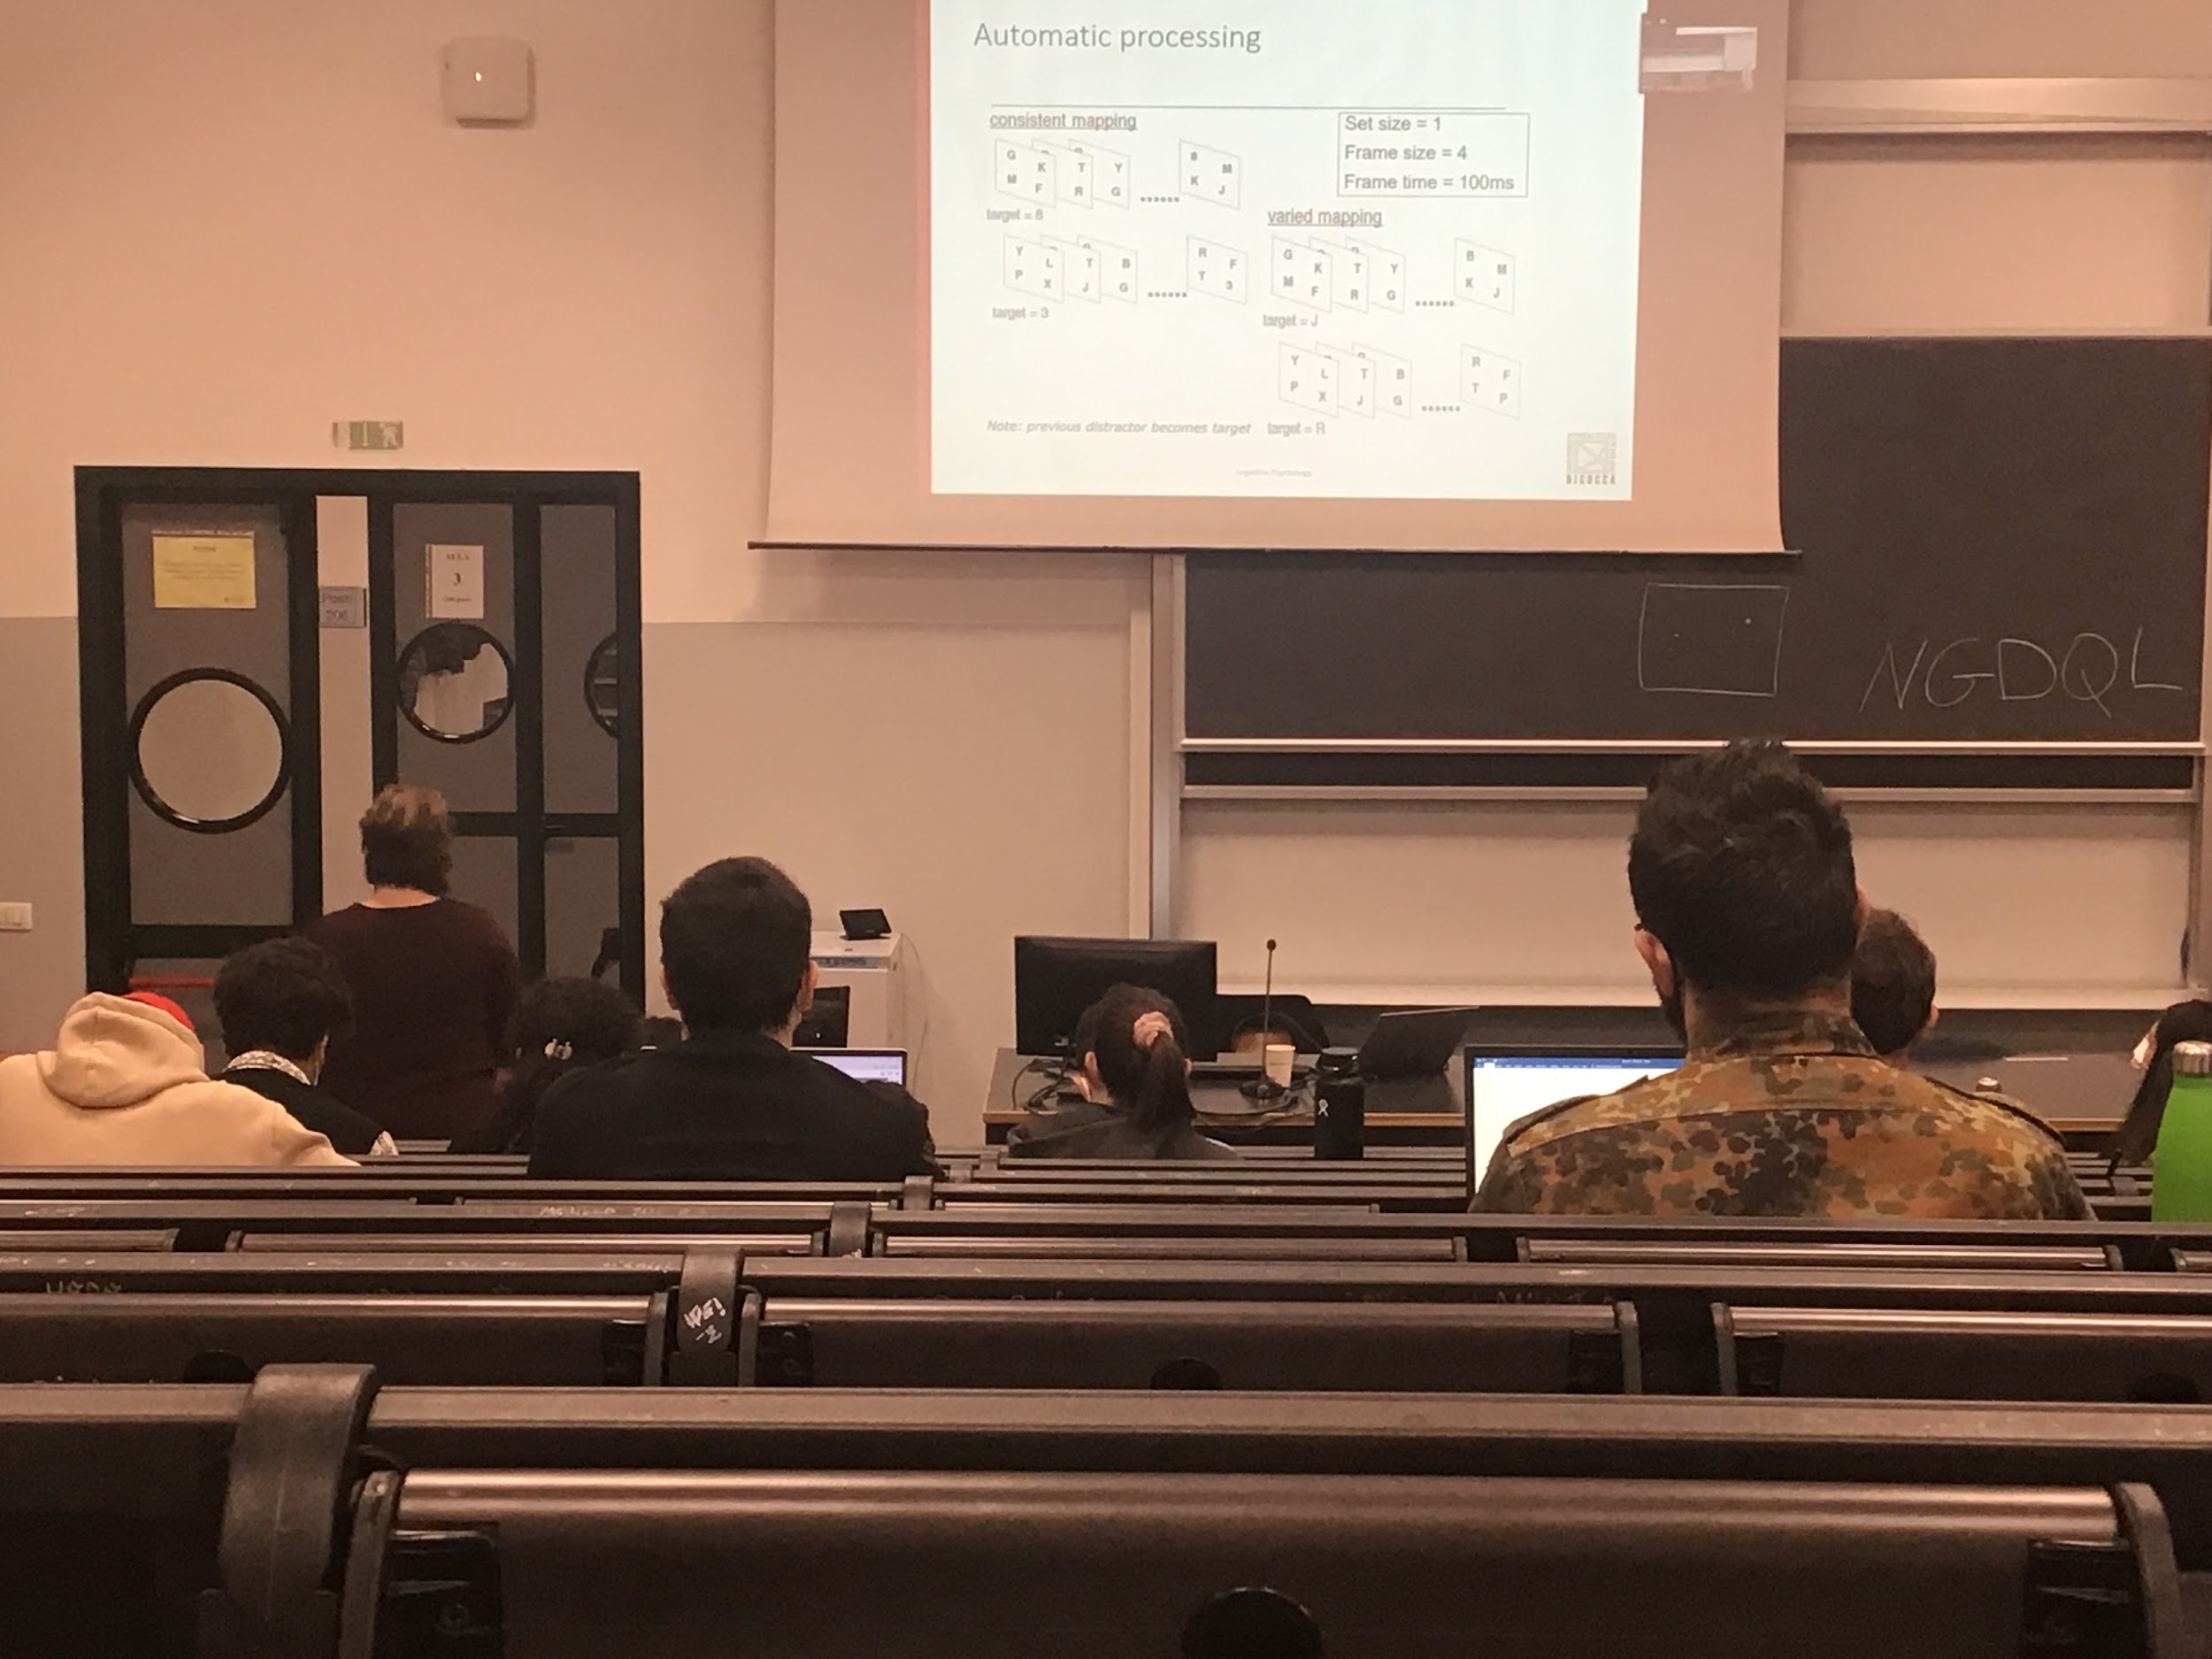

People have to look for targets, show different screen with different letters and you have to tell when you see the number 8

In the consistent mapping task the target where always number and the distractor were always letters. Very easy, whenever you see a number you say yes

In the variant mapping task the target and the distractors were all letters, the task is different, every time you have to check everything

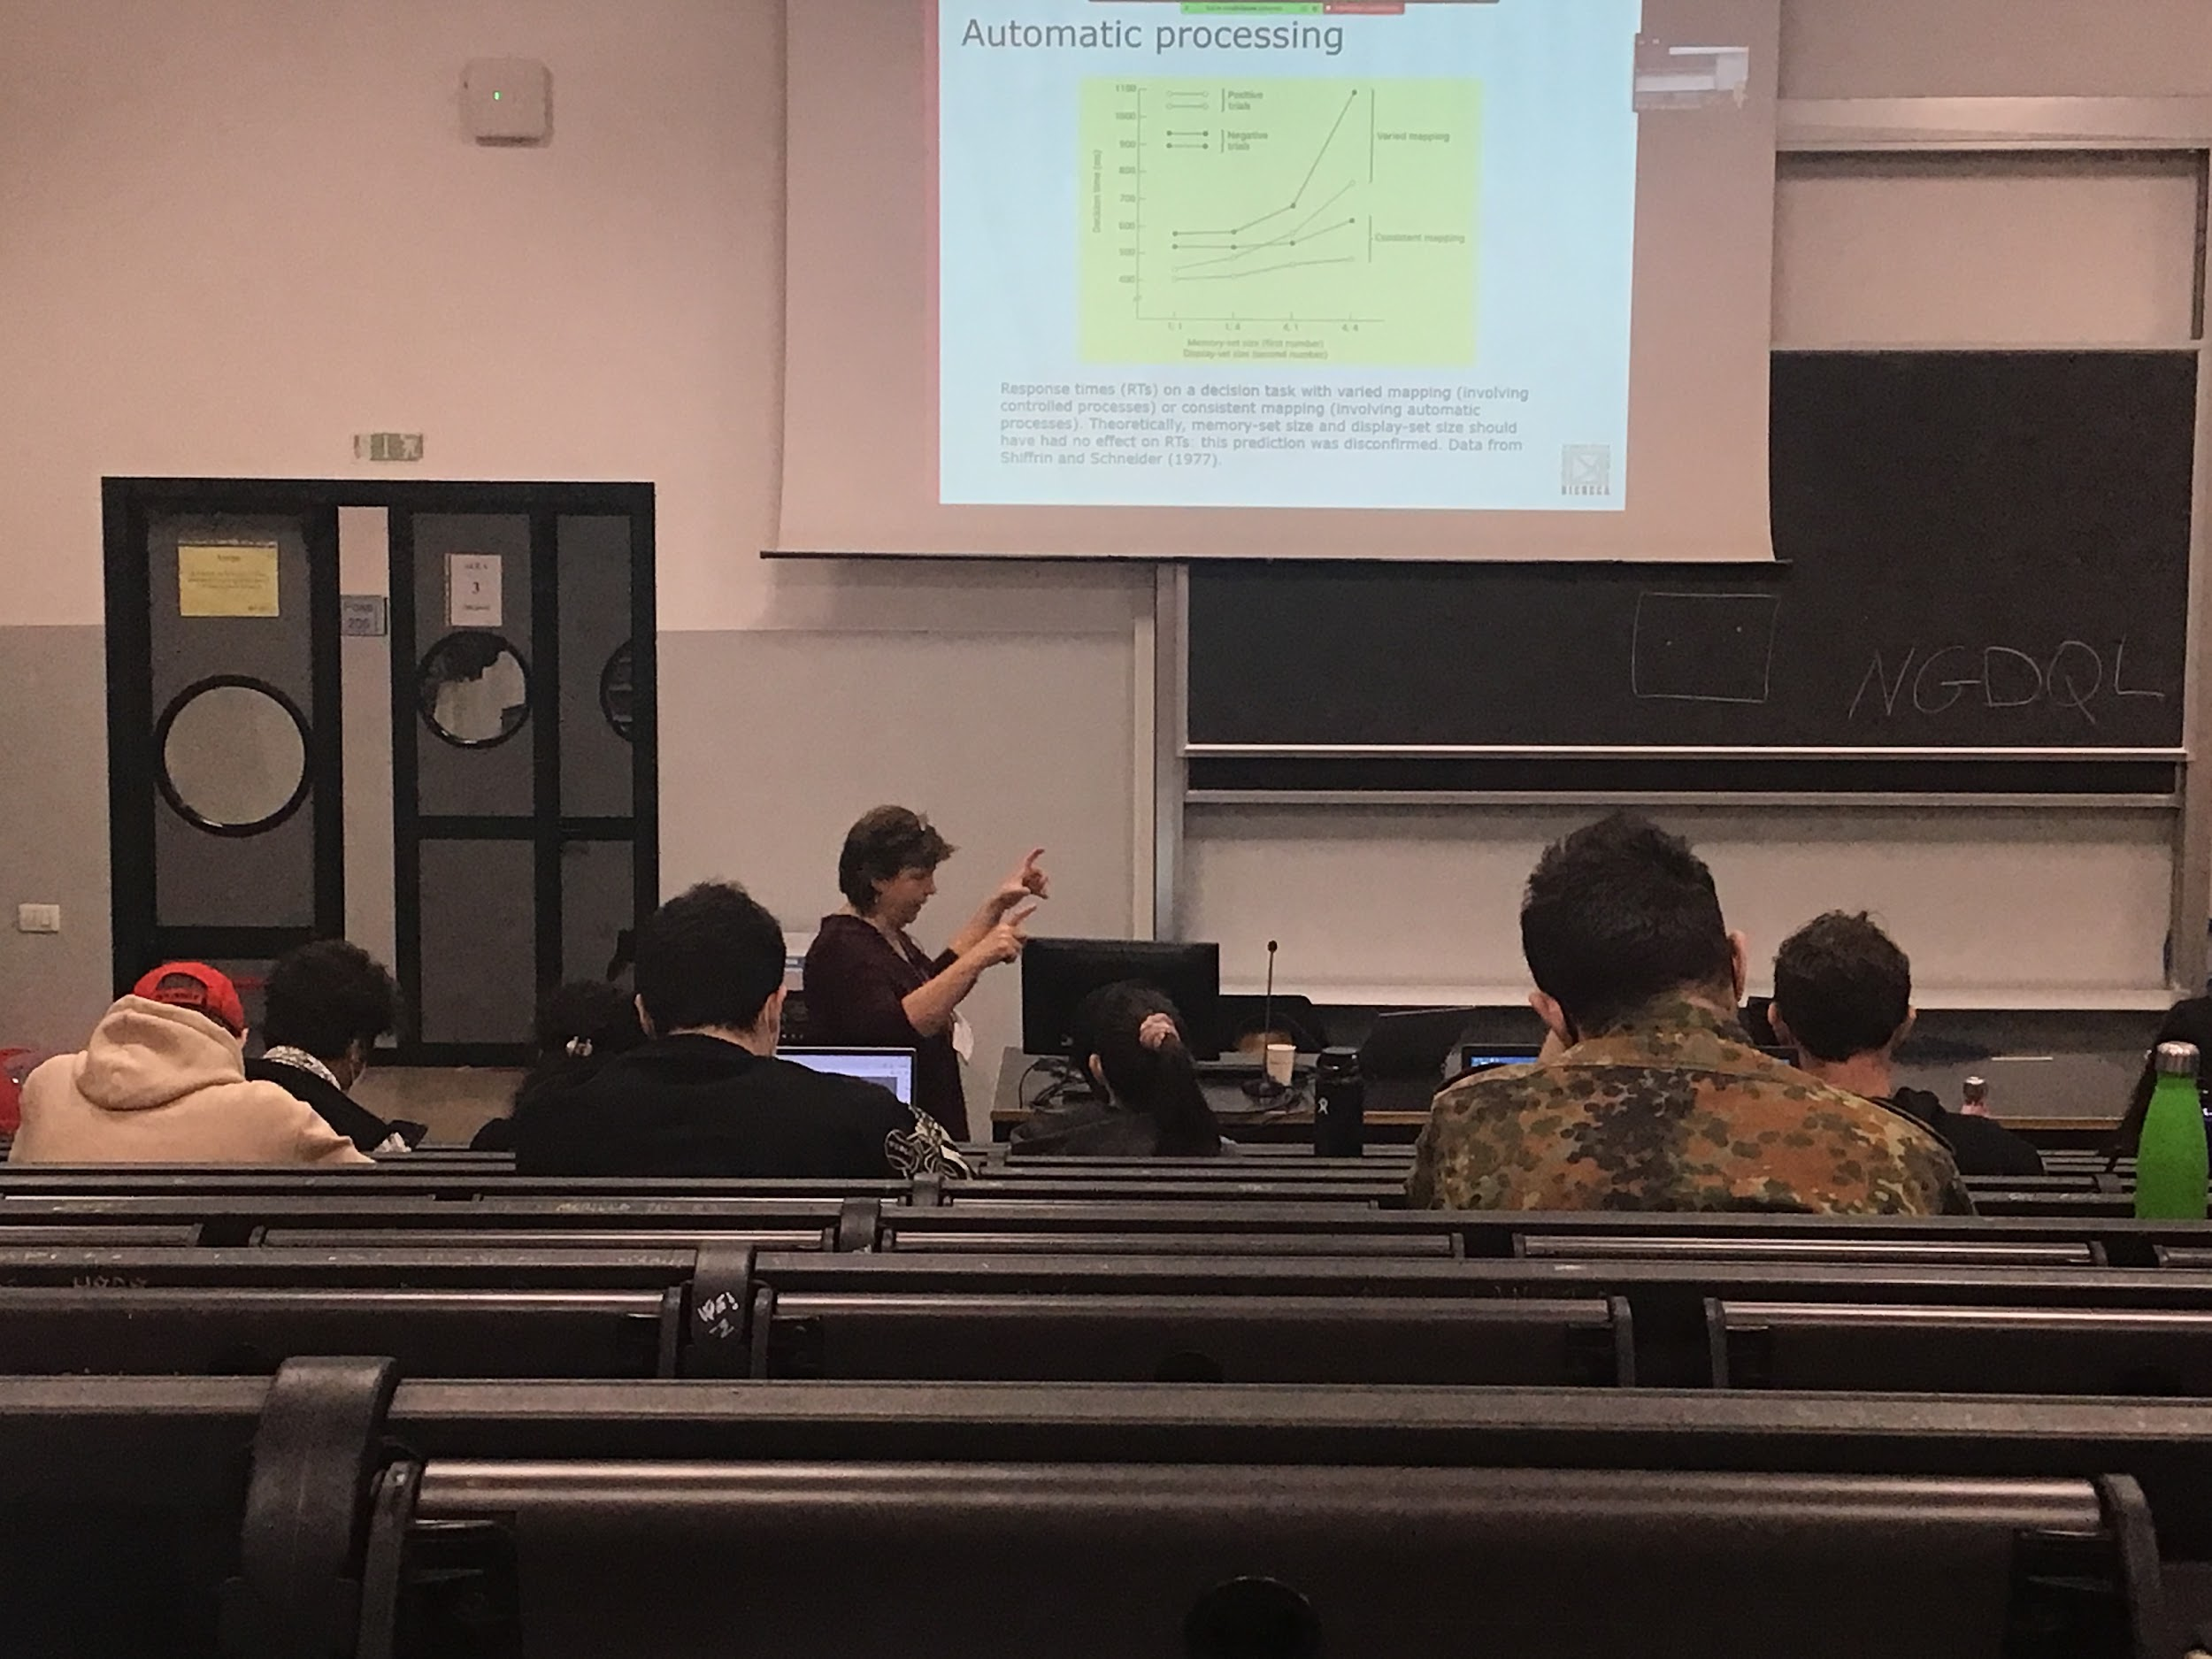

Response time with variant mappings increases with the number of stimuli you have to check. In the other case you can do it automatically.

**Difference between automatic (you can do things in parallel) and control (keep checking)**

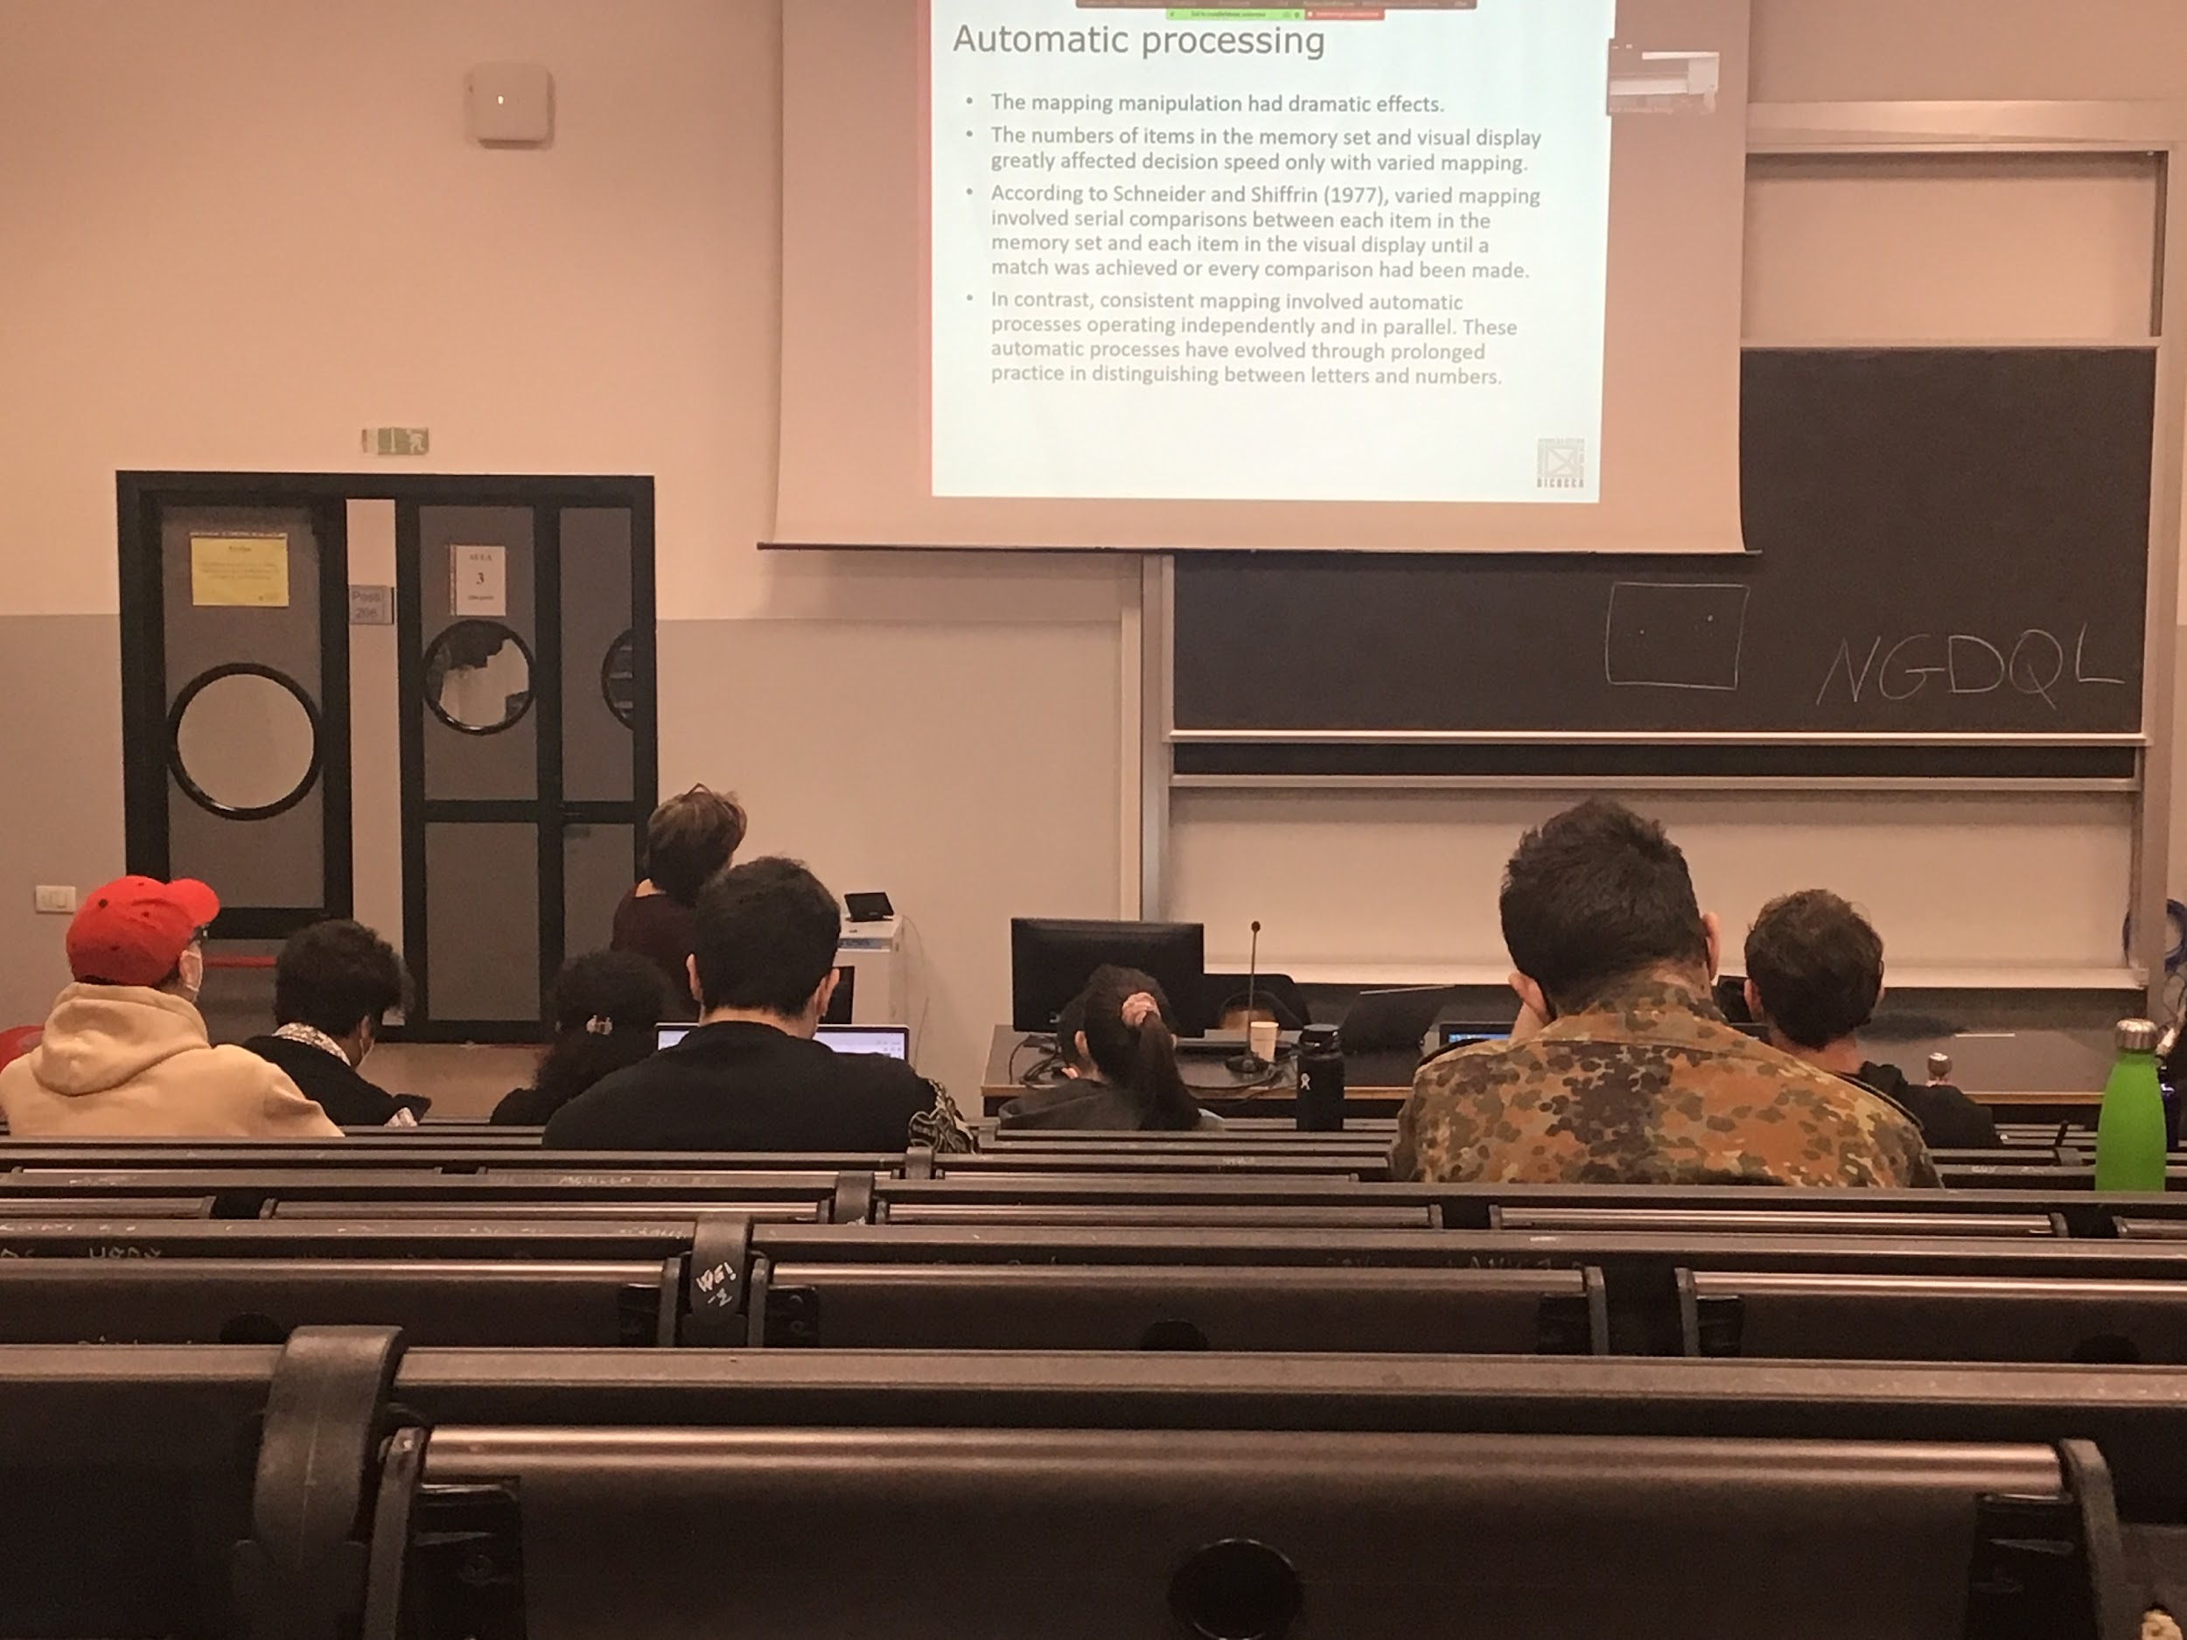

In one case there is serial comparing in the other there is parallel.

We have automatize being able to read the difference between letter and numbers, in their hypothesis if you use letters or number that are not the one that we are used to we should see a difference between variant mapping and consistent mapping

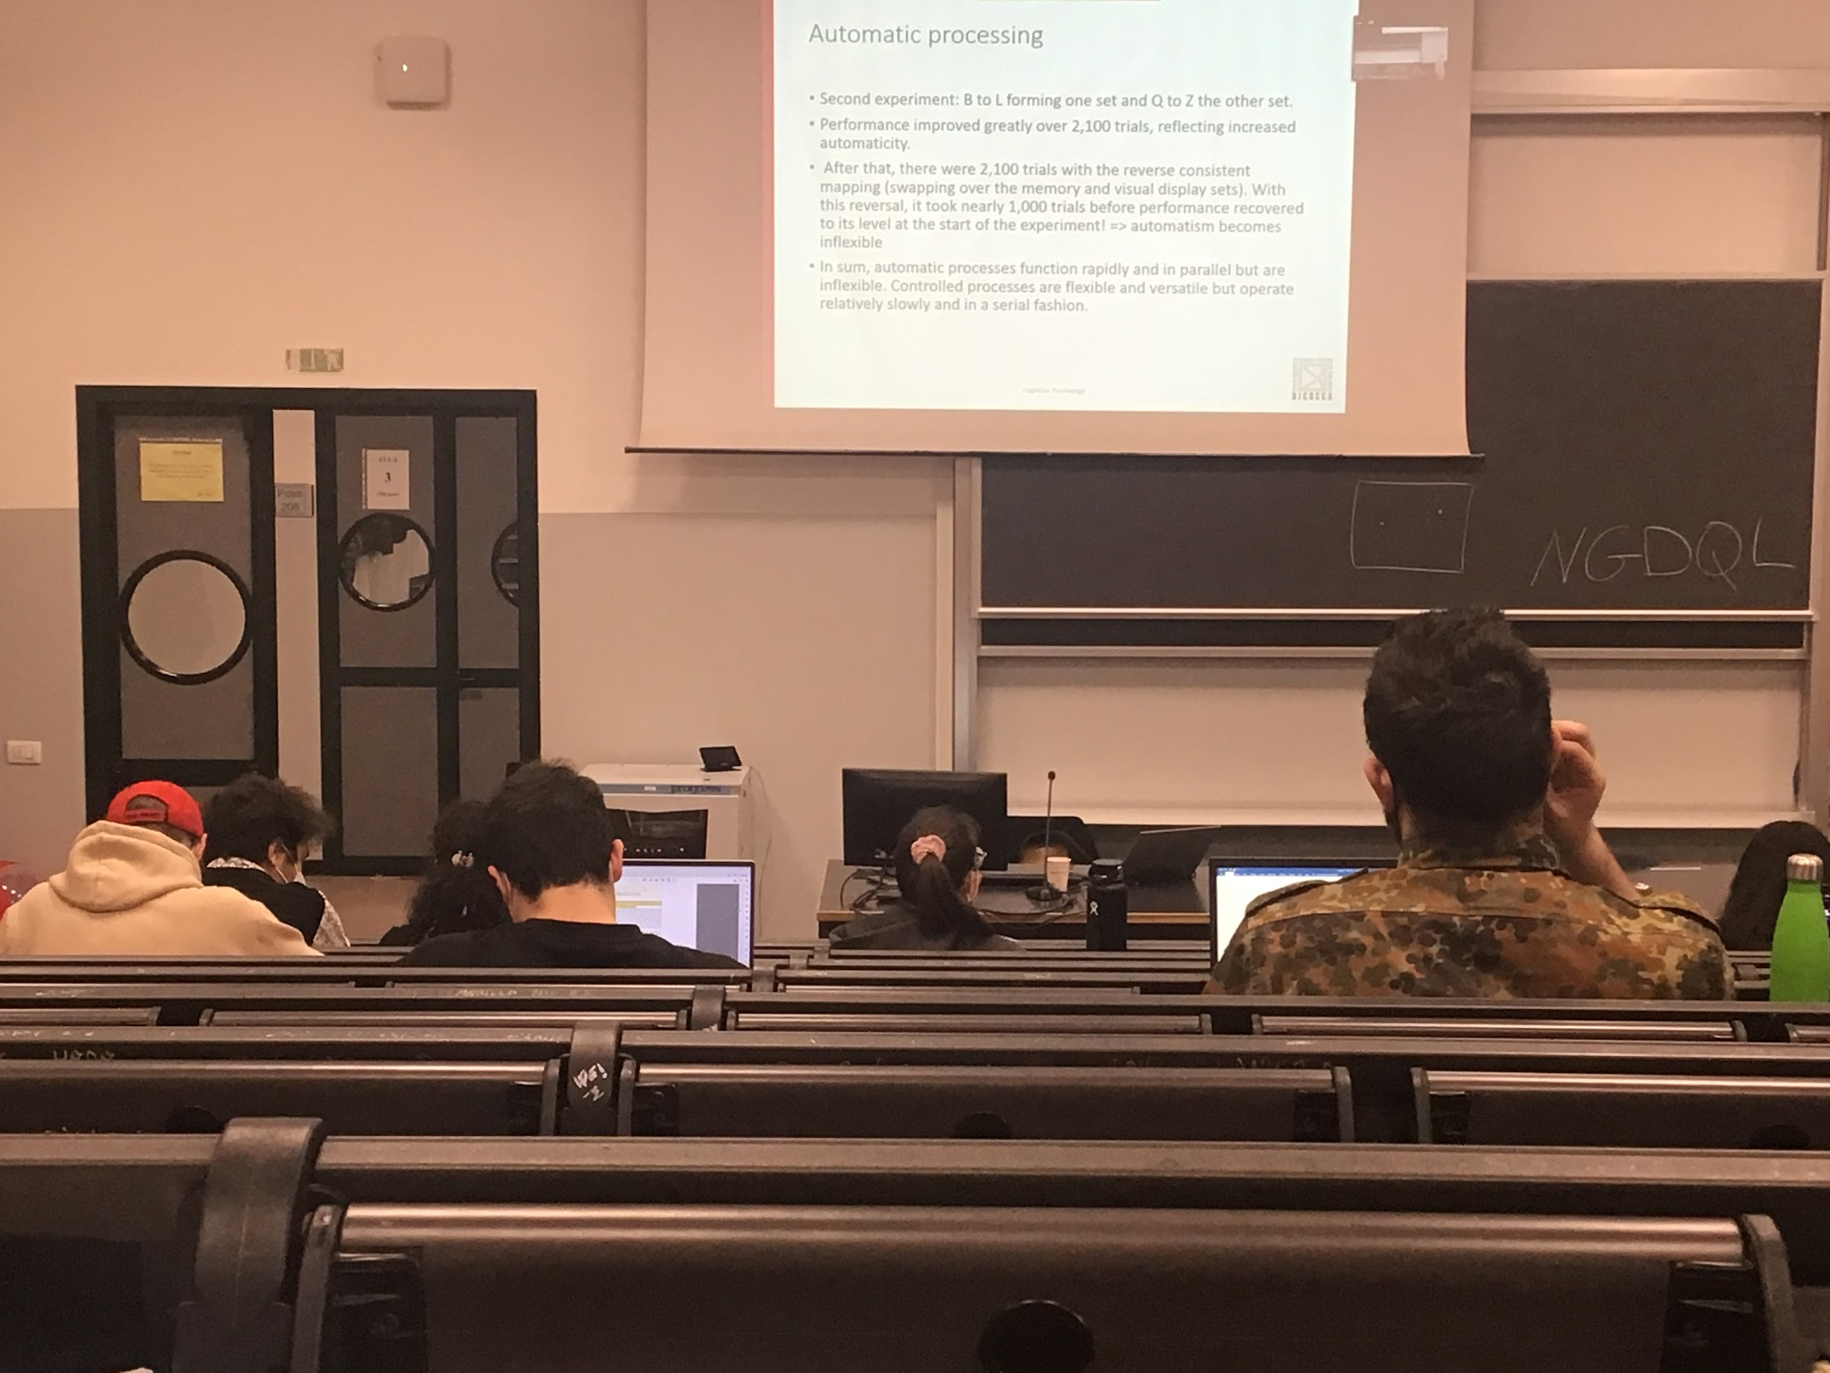

**Second experiment**: automatic classification is inflexible

If I use letters among letters, B and N targets and Q and Z are distractors, after 2100 you automatise the task, you are relatively good

After 2100 trials I switch target and distractors it takes 2100 trials to take away the automaticity, once you render something automatic it becomes difficult to de-automatize it, typical problem with automatic behaviour

When it becomes automatic it is faster but at the same time it is not flexible. Sometimes automatise a behaviour can create problems

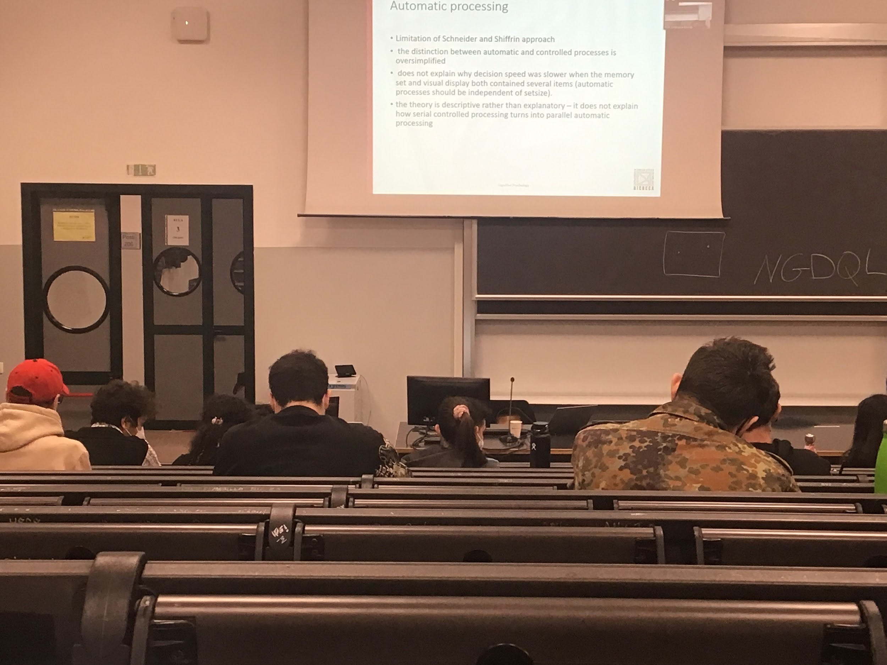

In reality there are intermediate level of control and automatic, and it does not explain how something turns from controls to automatic. There are different approaches that try to solve this problem

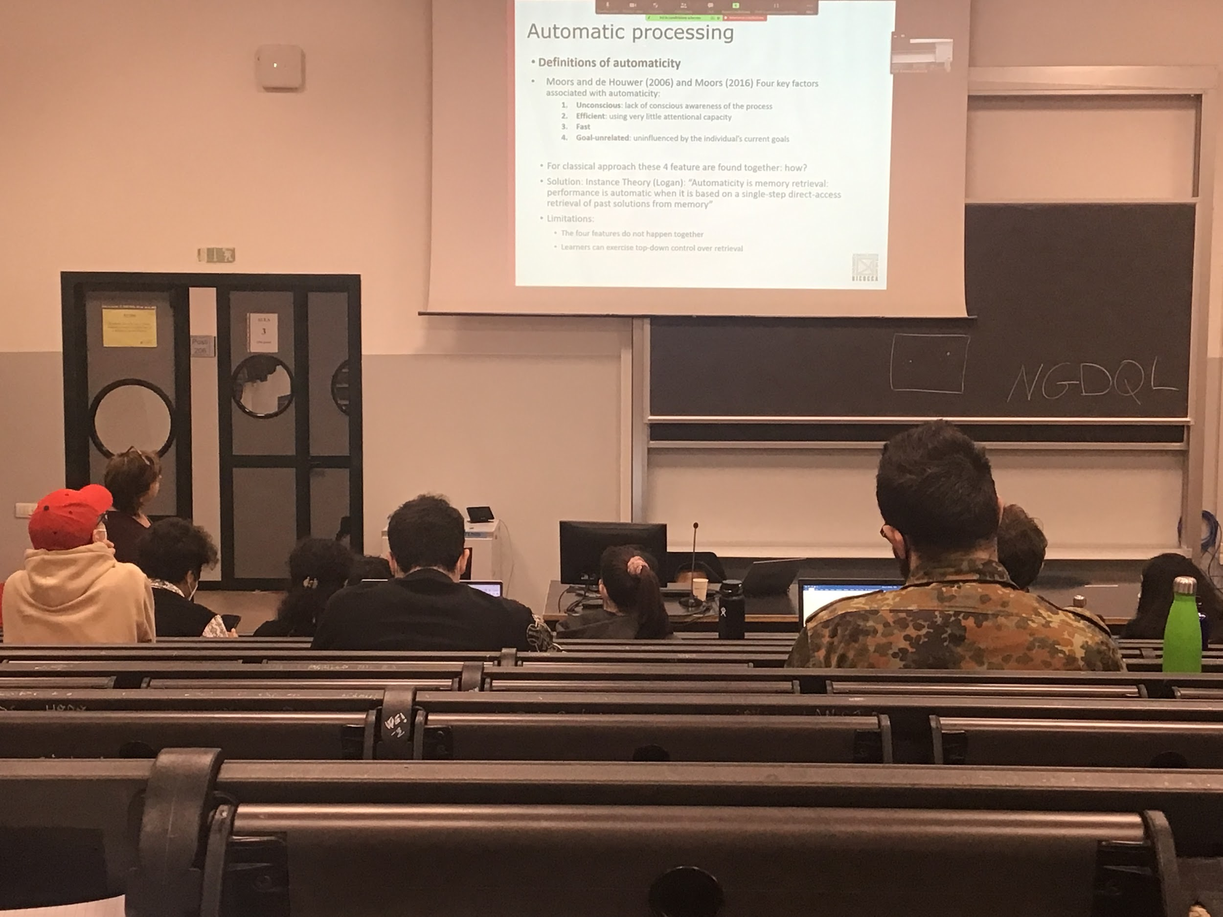

4 key factors associated with automaticity

1. **Automatic**: have no conscious awareness, you are doing the thing without thinking
2. **Efficient**: you can do it while doing something else
3. **Fast**
4. **Goal-unrelated**: does no matter what is your goal, given a stimulus you automatically performing the task

**Logan instance theory**: how does a task become automatic? Becomes automatic through practice, every time I try the same movement, your brain associates the arrival of the tennis ball with a specific movement. If I do it right over and over again this movement gets stronger in your memory. And at a certain point it becomes so strong that you see the ball arriving you perform the movement in automatic

In your memory there is a sequence of action that is directly extracted from the memory

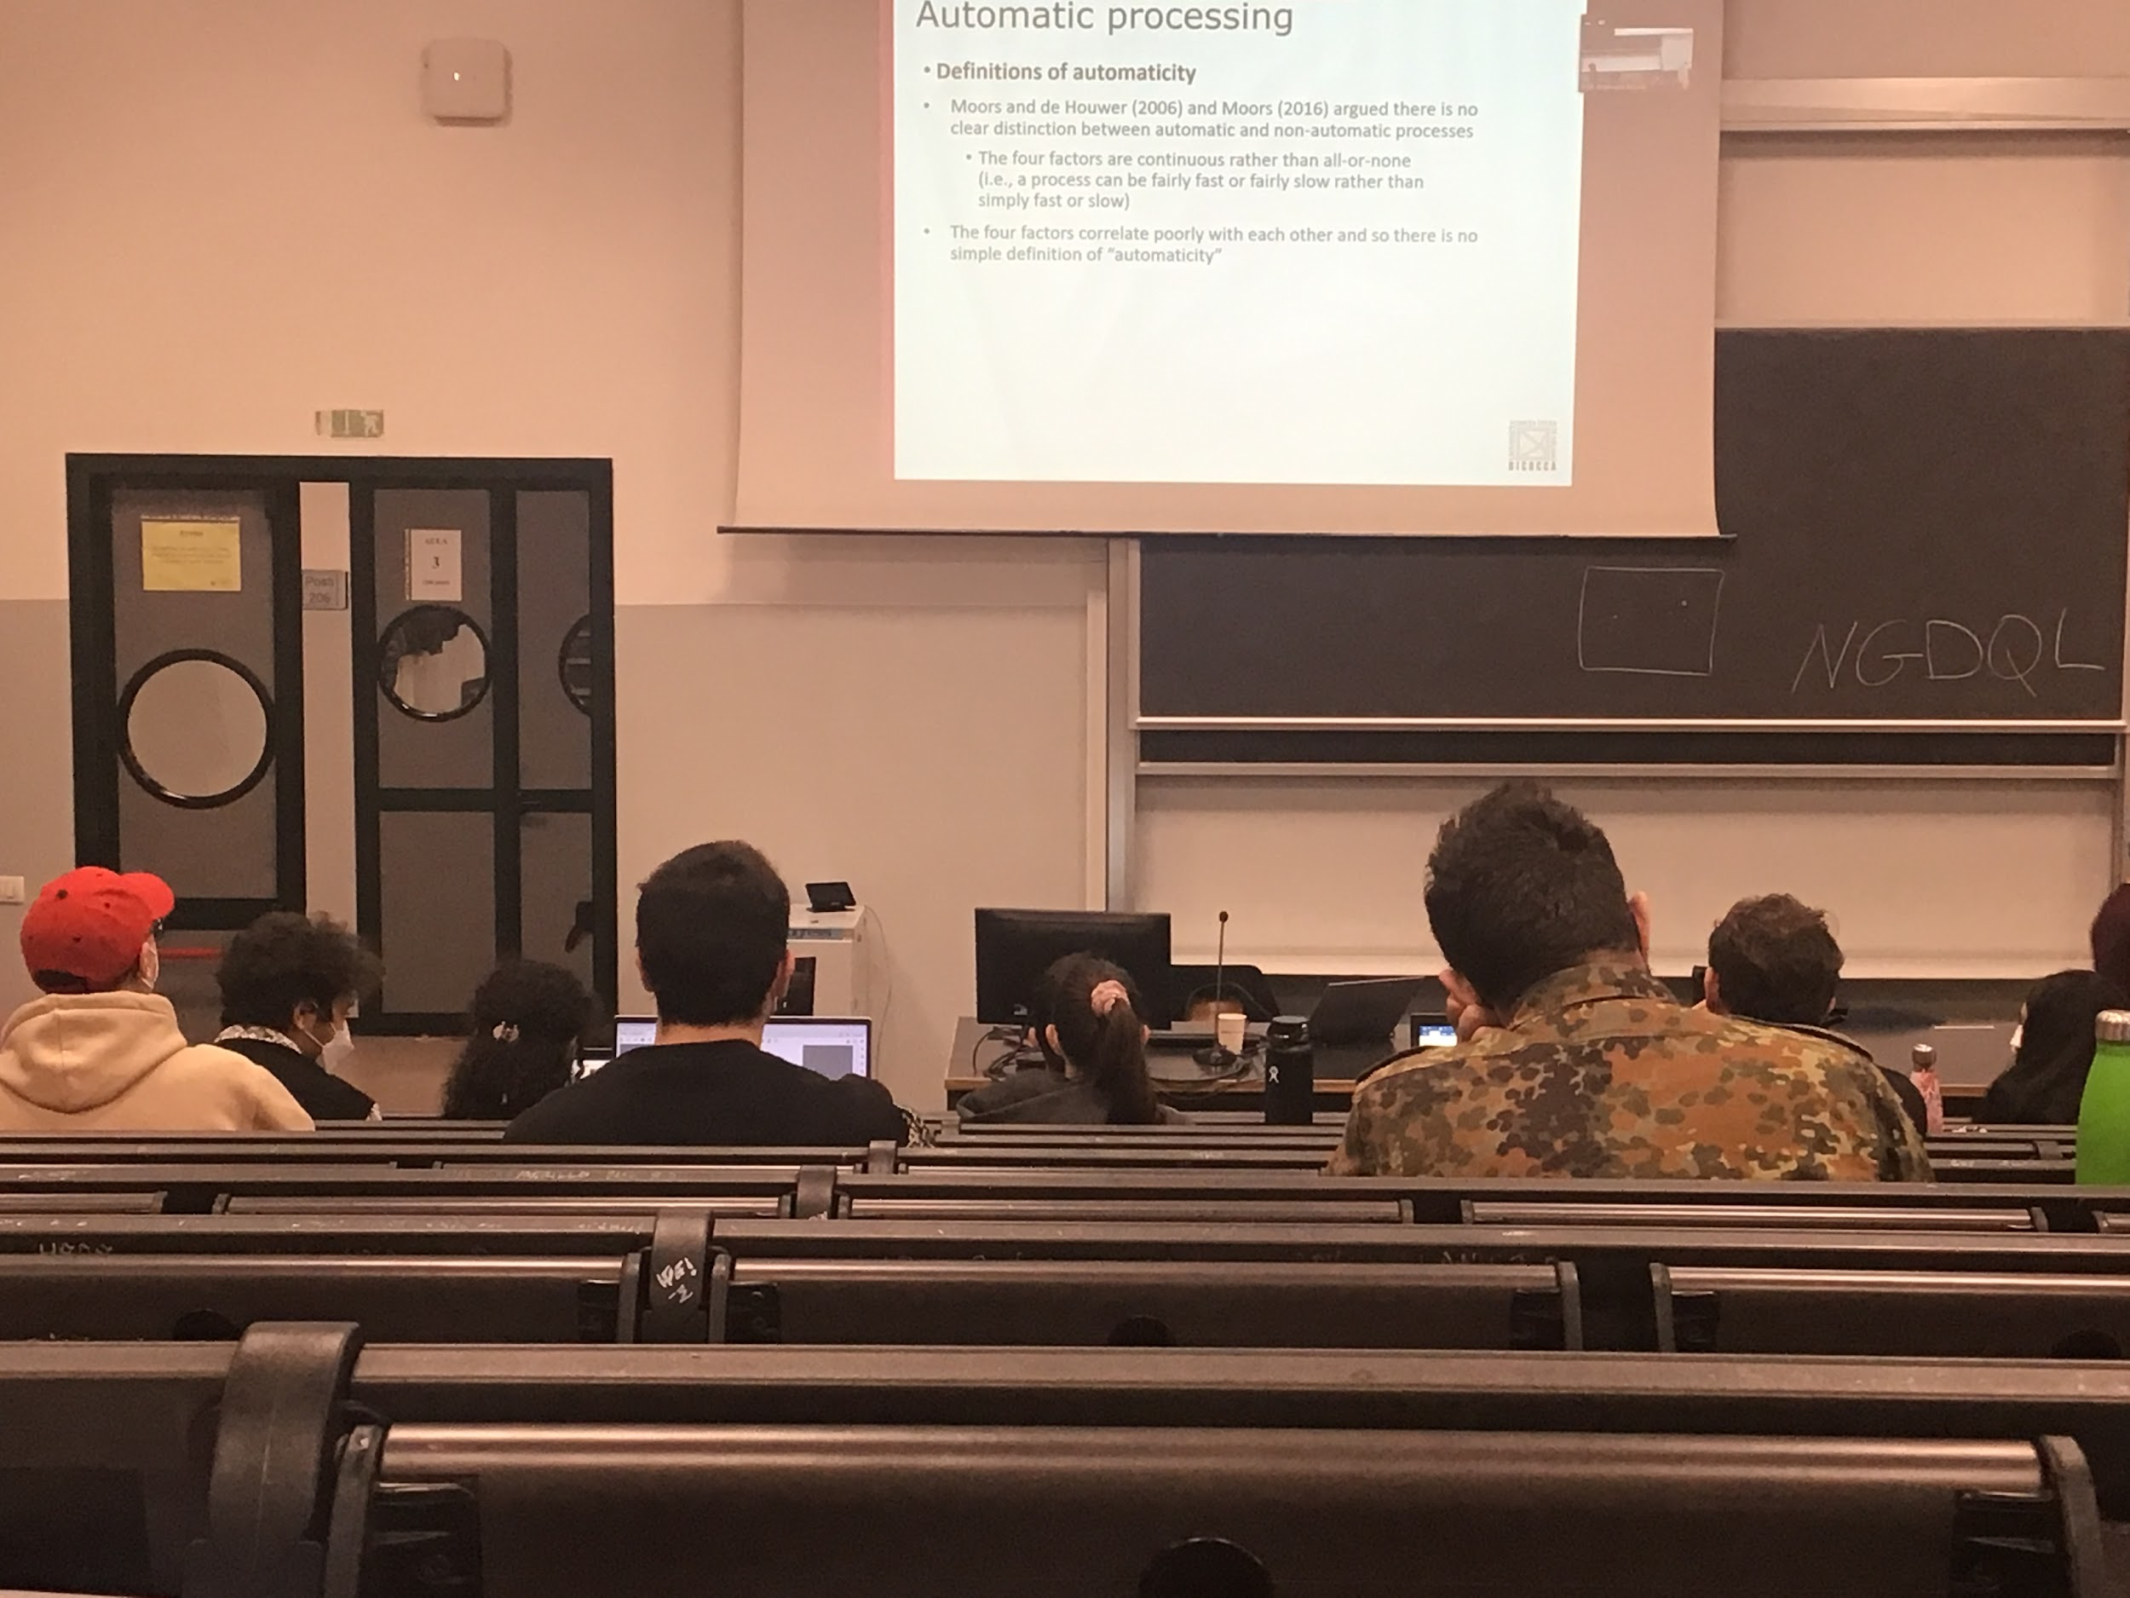

Sometimes automatic processes start to become fast but not necessarily efficient or still conscious. The 4 features might not happen together

There is no clear distinction between automatic and non-automatic. Continuous fluid change between becoming automatic and not automatic

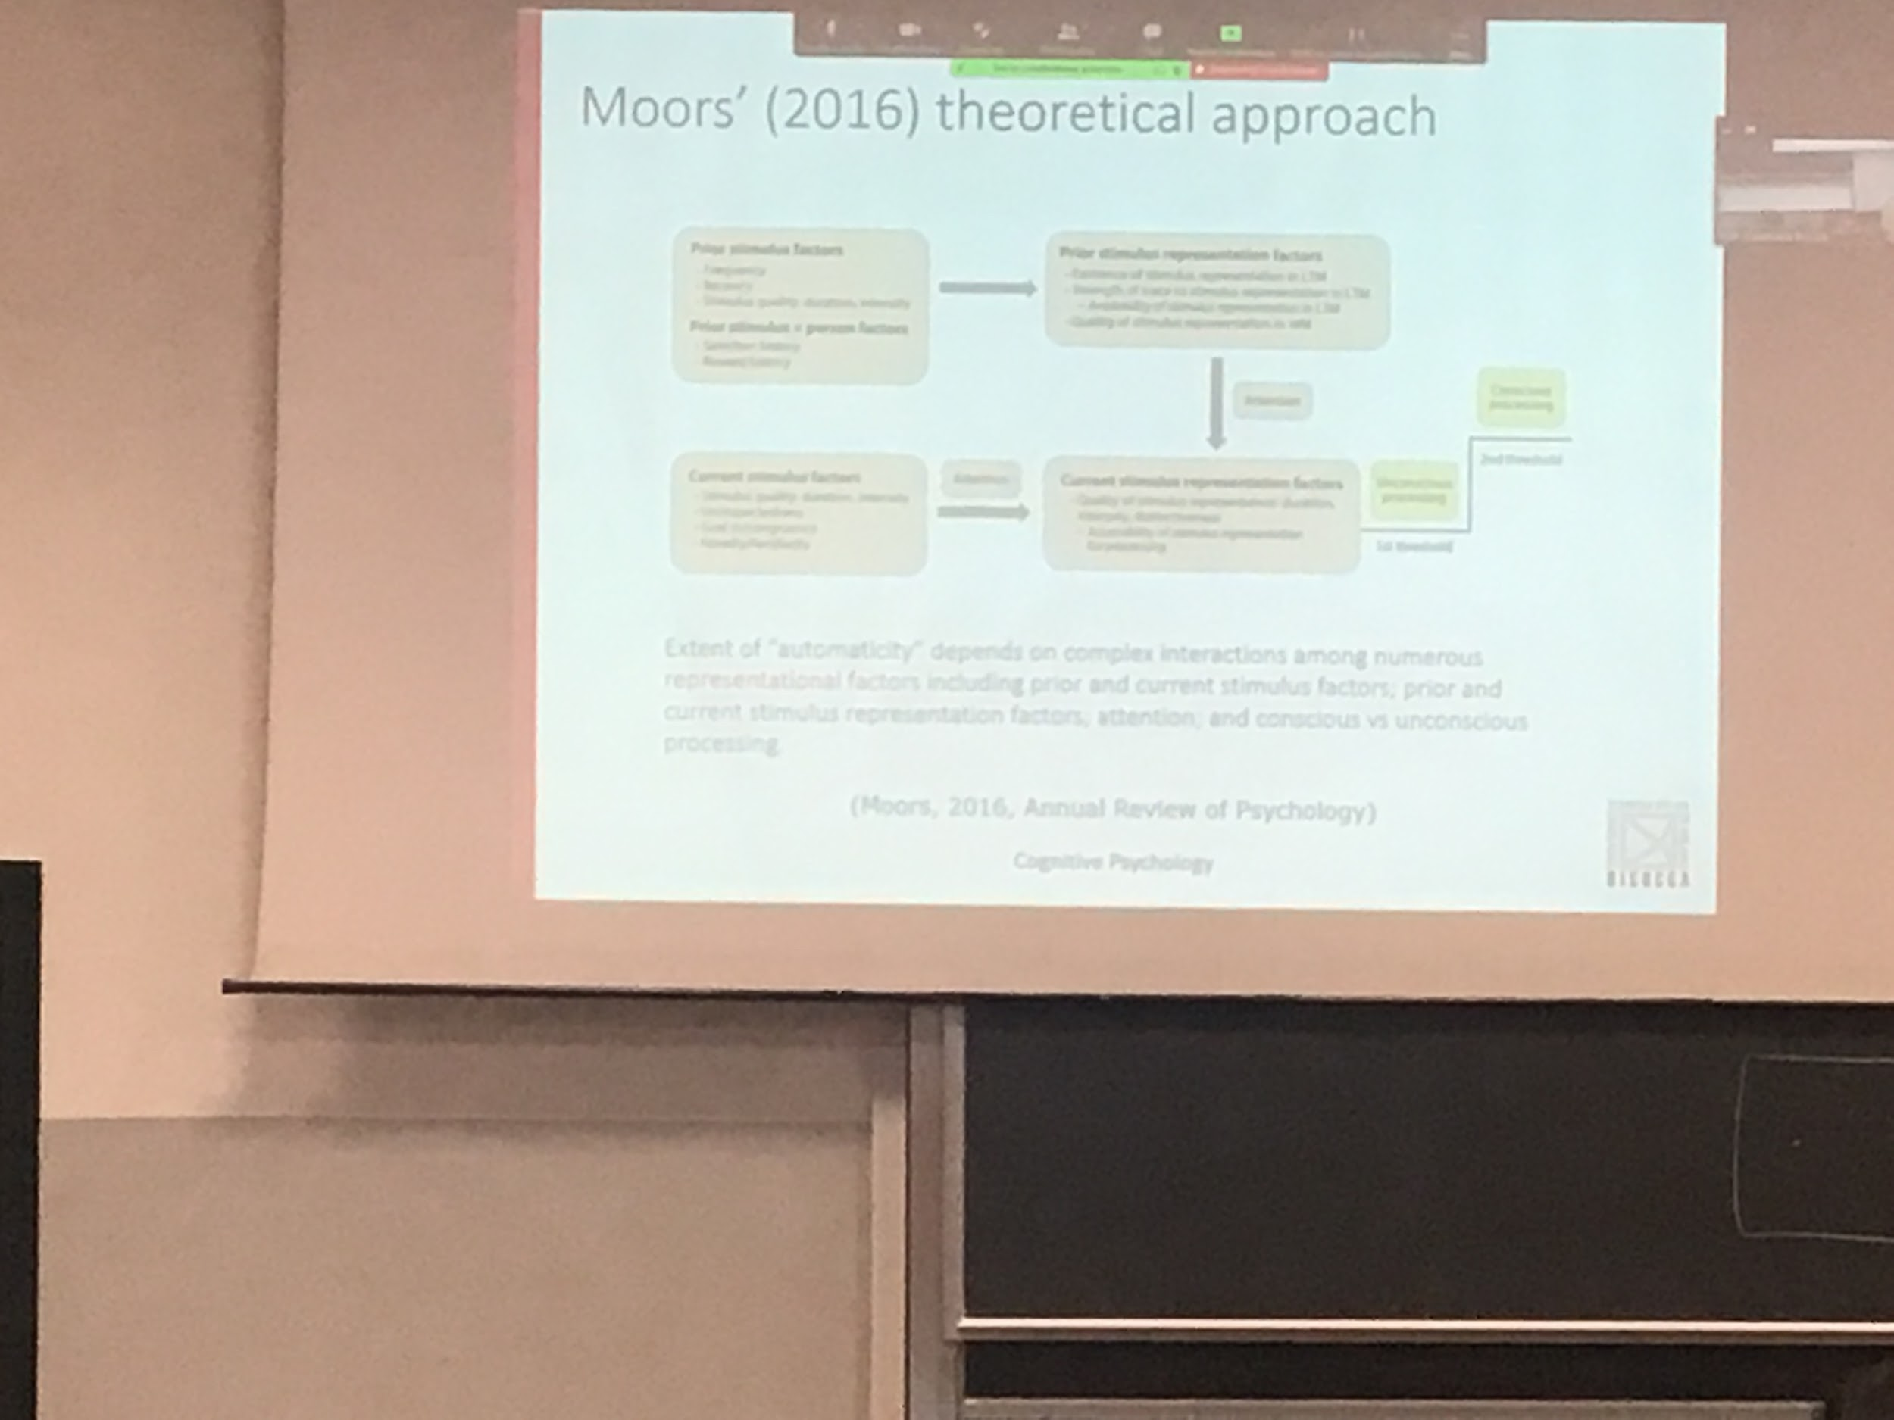

We have to take in consideration many different characteristics that can define what is automatic and what is not. There are many different factors and only the combination of the factors can decide what is automatic

The theory overcome the idea of having either automatic or not automatic

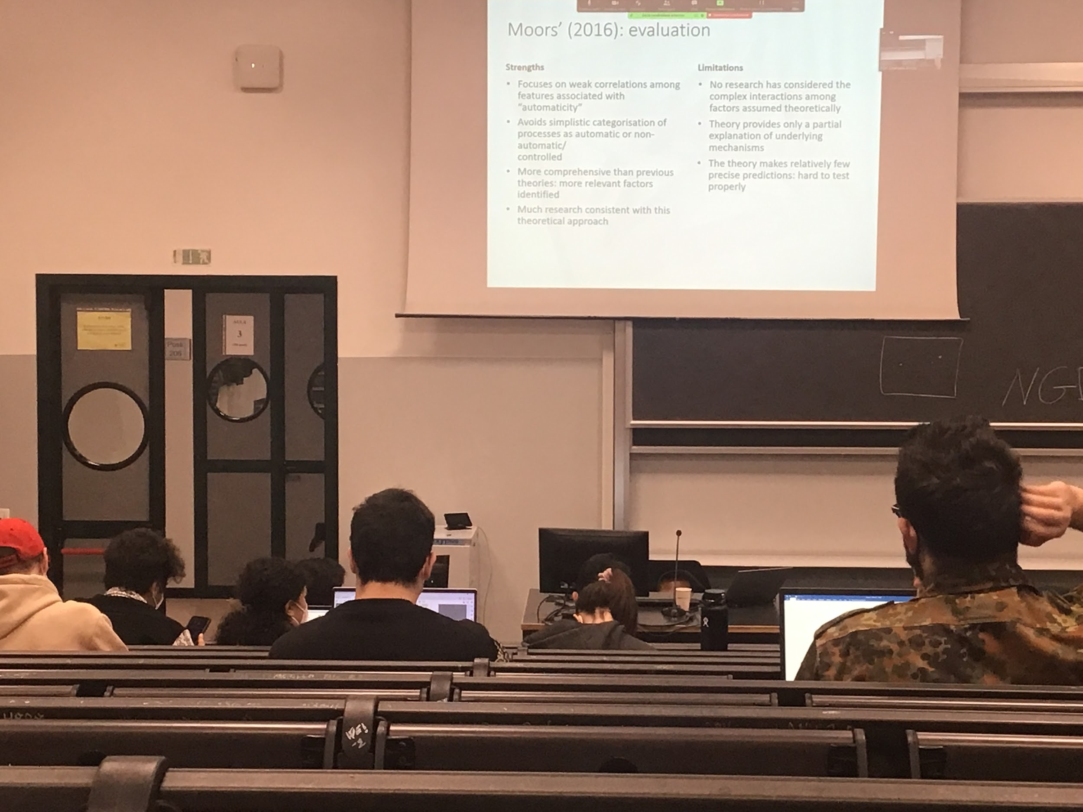

There are different features associated with automaticity that not always happens together, we can not classify a task completely automatic or not

The problem is that is too complicated, very difficult to get it truly and to understand which factors are important and which are not